1. **INTRODUCTION**
   1. Company Profile
   2. Project Profile
   3. Company Profile

Credence Technologies is a software development company based in Surat, Gujarat, India. We currently specialize in Web Designing and Web Development,

Mobile Application Development,Desktop Application.Our team consists of dynamic and curious people who work hard and smart. We also constantly try to learn new things; be they in our field or outside of it, thus upgrading both our skills and lives.

|  |  |
| --- | --- |
| Our team has members with experience in, |  |
| * Web Development and Design * Web based Recruitment Management System * ERP Softwares |  |

* 1. Project Profile

|  |  |
| --- | --- |
| **Project Title:**  **Project Definition:** | Quick Search  This website aims to provide the user to search for their daily needs.It allows Vendor to add their products and services and select the theme to make their own website. |
| **Organization:** | Credence Technologies |
| **Project Category:** | Web Based Application |
| **Team Members:** | 2 |
| **Duration:** | 75 days |
| **Internal Project Guide:** | Dr Pushpal Desai.  Mr Tejas Shah |
| **External Project Guide:** | Shashank Bansal |
| **Submitted By:** | Dinal Chauhan(010)  Smit Patel(081) |
| **Submitted To:** | M.Sc. (IT) Programme, J. P. Dawer Institute Of Information Science & Technology- VNSGU – Surat. |

2.1 Introduction

1. **CURRENT SYSTEM**

2.1 Introduction

In Quick Search, Admin provides theme structure to vendors (shopkeeper), as per the requirement of the vendor they can select and unselect. Vendors have choice to insert data into the theme or not, if any tab like service or product is not necessary then he/she can ignore. User can visit the site of selected shop and also see location of the selected shop. It provides online searched solution to user and also provides themes to vendor.

The overall goal of this website is that it is available for anybody and anywhere.This saves a lot of time and money of the user and as well as vendor.

1. **PROPOSED SYSTEM**

3.1 Scope

3.2 Objectives

3.3 Purpose

3.4 Feasibility Study

3.5 Advantages

3. Proposed System

The proposed system of a website that of a website has an online platform, or site that focuses on shop details according to the needs of users, tracking the site by category and location.

It is difficult for the user to find the shops of his/her needs near by his/her area.He/she has to contact that person who has information about the shops.The user can not directly contact to the vendor for inquiry.To get the information about the product and service user must has to visit the shop.So it is quite costly and time consuming.

The system is design in such a way that the vendor who can not afford his/her own website can register in this website.The user can easily find the shops for his/her needs.If user is loged in than he/she is able to get all the information about the particular shop from its website.So it save money and time of the user as well as vendor.

**3.1 Scope**

User can search vendors as per their need and based on that search user are able to see the related shop.User can see only that shops which are registerd by the vendor.User can see the website of a vendors only after he/she is login into the website.

Vendor allow to register his/her shop and add the details of product,service,shop logo,slider image,testimonials,team,contact,about and search details.If the vendor is approved by the admin then he/she is able to select the theme for his/her website.

Admin are authorised to approve or disapprove the vendor.The password is send to the vendor on his/her email id when admin approve the vendor.

**3.2 Objectives**

1. **Admin Module**

The Administration can perform following tasks.

* Login
* Admin can change his/her password.
* Manage Vendor
* Admin can add vendor.
* Admin can approved vendor and mail them password for login.
* Manage Theme
* Admin can keep updating the theme when new theme are launch.
* Manage Business
* Admin can keep updating the business category and business type.

1. **Vendor Module**

The Vendor can perform following tasks

* Login/SignUp
* Vendor can SignUp as well as login with authentication.
* Vendor can change his/her password.
* Vendor can manage the logo,slider details,about,products,services,social media,team,testimonials,contact and search details by adding,updating and deleting the information.
* Vendor can update their profile.

1. **User Module**

The User can perform following

* Login/SignUp
* User can create new account in website.
* User can create their own password.
* User can visit the site for the selected shop and also see the location of the selected shop.
* It provides online search solution for the user.

**3.3 Purpose**

Purpose of the Quick Search is to promote the vendor who can not afford to make their own website.so he/she can register and if he/she is approve by the admin he/she can select the theme for his/her website.

It also provides help to user by easily searching for the shops based on their requirements.

It saves a time and money of the user as well as vendors.

**3.4 Feasibility Study**

A feasibility study was conduct to select the best system that meets performance requirements and this was entailed an identification description, an evaluation of candidate systems, and the selection of the best systems.

In deciding on this system to design, three key considerations are involved in feasibility analysis: technical, economical and operation. It was found that the proposed system is technically, economically and operationally feasible as per following grounds:

**3.4.1** **Technical**

The system was developed using HTML, PHP, and JavaScript, CSS, Jquery.

1. The application was developed with window as operating system.
2. The application is interactive i.e. user friendly, thus viewing information and the related features is easy retrieval and access of data is provided.

According to the definition of technical feasibility the compatibility between front-end and back-end is very important. In our project the compatibility of both is very good. The speed of output is very good when we enter the data and click button then the response time is very fast and give result very quickset. The speed of transaction is always smooth and constant. This software provides facility to communicate data to distance-location.

**3.4.2** **Economic**

Economic analysis is the most frequently used technique for evaluating the effectiveness of a proposed system. More commonly known as cost/benefit analysis: the procedure is to determine the benefits and saving that are expected from a proposed system and compare them with cost. If a benefit outweighs cost, a decision is taken to design and implement the system.

Otherwise, further justification or alternative in the proposed system will have to be made if it is to have a chance of being approved. This is an ongoing effort that in improves accuracy at each phase of the system life cycle.

This application required less money, it is better for the company because, as the system is being developed with less money and already available resources. Also time and cost for set.

**3.4.3** **Operational**

The proposed system is beneficial only if they can be turned into information system will meet the organization operating requirements.

As the application is user-friendly, throughout the application is also well liked & approved by the user showing no resistance what so ever at all. If the user wants mare facility, it can be provided.

The proposed system without causing any harm to the organization will enhance the results in better respect of the new system and will avoid the confusions and resistance by catching the user’s attention.

**3.4.4** **Schedule Feasibility**

Time evaluation is the most important consideration in the development of project. The time schedule required for the project is very important since more development Time effect machine time, cost and cause delay in the development of other systems. A reliable Web application can be developed in the considerable amount of time.

**3.4.5** **Social**

The system does not disturb the working style of any other systems of the company, contrary it become a separate module. Thus it fully satisfies Social Feasibility.

**3.5 Advantages**

* To find any Shops with their path easily.
* Vendors can able to make website without coding, they only wants to entered their details.

1. **SYSTEM ENVIRONMENT**

4.1 Technology Description

4.2 Hardware and Software requirement

4.1 Technology Description

|  |  |
| --- | --- |
| **Front End** | : PHP |
| **Back End** | : MY-SQL Version 8.0.12 |
| **Framework** | : Core PHP with prepared statement |
| **Operating System** | : Windows 10 |

4.2 Hardware and Software requirements

**4.2.1 Hardware Configuration**

|  |  |
| --- | --- |
| **Processor** | : 2.5 GHz Intel Core i5 7th Gen |
| **Hard Disc** | : 1.00 TB |
| **RAM** | : 8.00 GB |
| **CD Drive** | : PLDS DVD+-RW DU8A5LH DVD/CD-ROM |
| **Key Board** | : Chiclet Key Board |
| **Mouse** | : Microsoft Optical Mouse |
| **Monitor** | : 15.6”HD DELL Color Monitor |
| **Networking device** | : Lan Card (Must be internet connection) or modem |

**4.2.2 Software Configuration**

* XAMP 7.2.1
* Google Chrome,Mozila Firefox

**4.2.3 Server Configuration**

* + - Apache version:
      * Apache/2.4.39
    - PHP version:
      * PHP 7.0.0
    - MySQL Version:
      * MySQL 8.0.12

1. **SYSTEM ANALYSIS AND MODELING**

5.1 Software Requirement Specification

5.2 Flowchart

5.3 Entity Relationship Diagram

5.4 Data Flow Diagram

5.5 Data Dictionary

5.6 Process Specification

5.7 Usecase Diagram

5.8 Class Diagram

5.9 Sequence Diagram

5.1 Software requirement specification

**Requirements of client describe as follow:**

* System should provide secure and accurate data.
* System should easy to operate.
* System should provide information related to firm.

**Requirement of different users can be describe as follows:**

* **Admin**
* In this section, Admin can login to his/her account and can access data.
* If admin forgot password then he/she can receive new password through email.
* Admin can also change the password if he/she know his/her current password.
* Admin can view user.
* Admin can manage business category and business type.
* Admin can add vendor and has rights to approve or disapprove vendor.
* Admin can view report categorywise and business typewise.
* **Vendor**
* In this section, Vendor can register his/her shop on the web.
* Vendor can login to his/her account and can manage the data to make his/her shop website.
* If vendor forgot password then he/she can receive new password through email.
* Vendor can also change password if he/she know his/her current password.
* Vendor can also update his/her profile.
* Vendor can manage about, logo, product, sevice, slider,

followus, team, testimonials, contact and keyword details.

* Vendor can view themes and apply any one theme for his/her website.
* **User**
* In this section, Users must registered and followed by login to show the website of selected shop.
* Users are able to search shop by the category or keyword.
* Users can also send the messages through the email.

5.2 Flowchart

* **Admin**

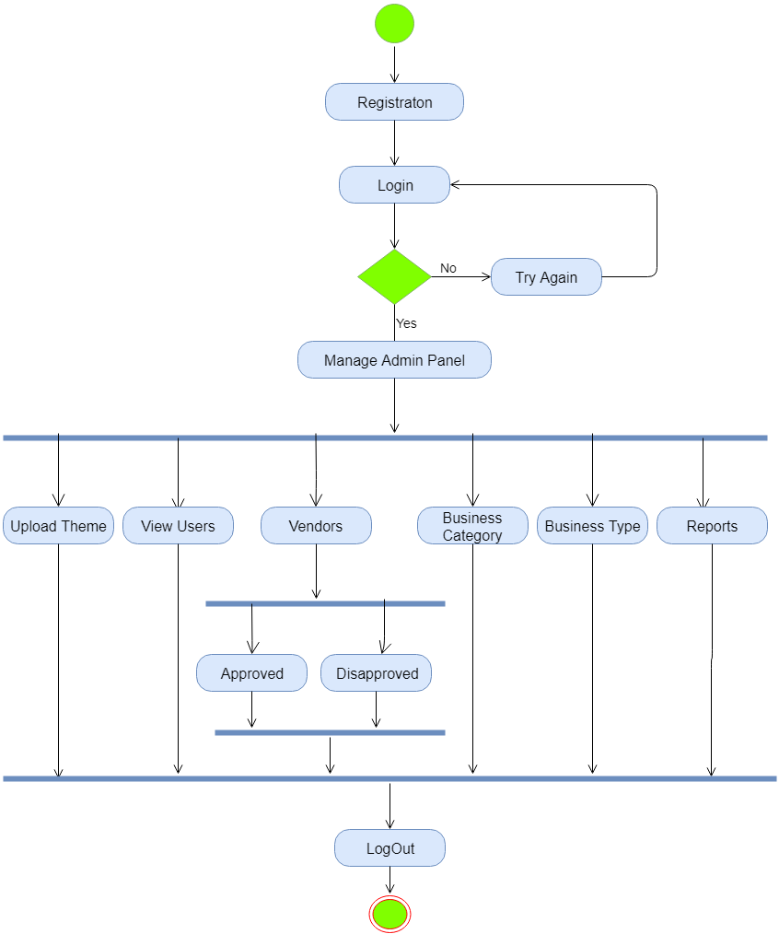

* **Vendor**

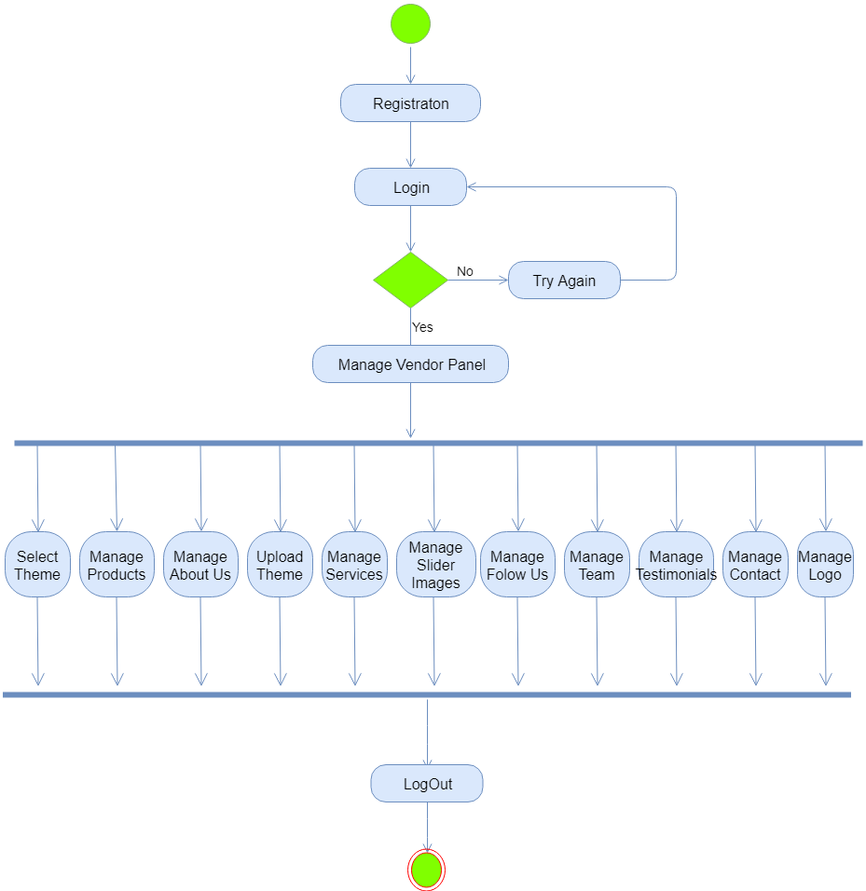

* **User**

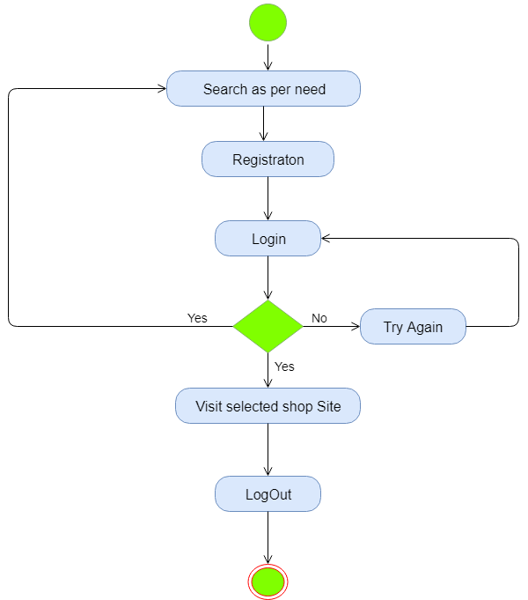

5.3 Entity Relationship Diagram

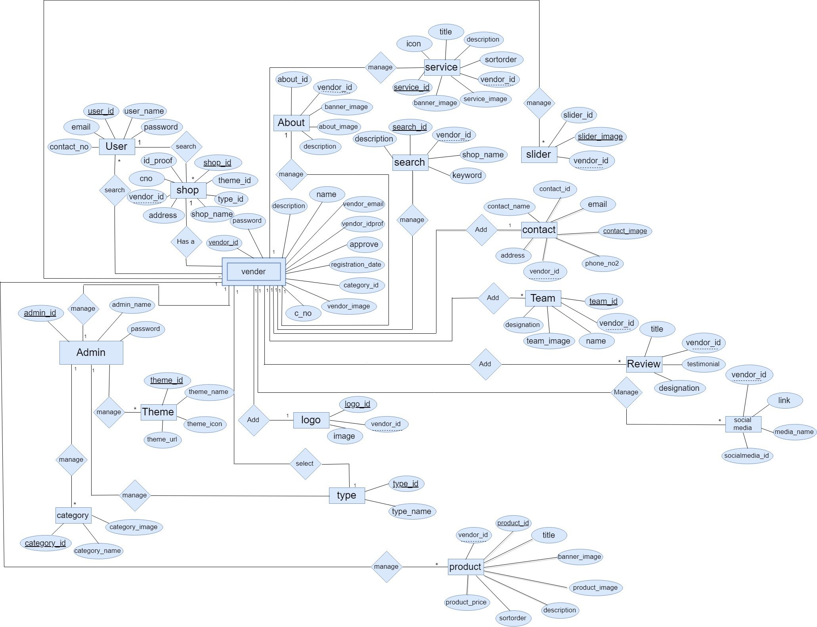

5.4 Data Flow Diagram

* **Level – 0**

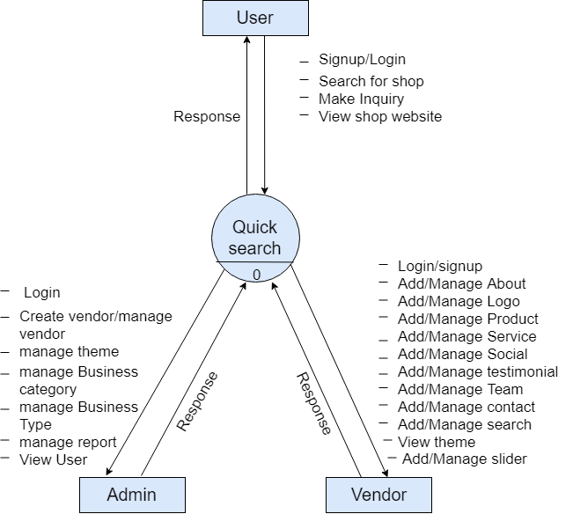

* **Level-1**
* **Admin**

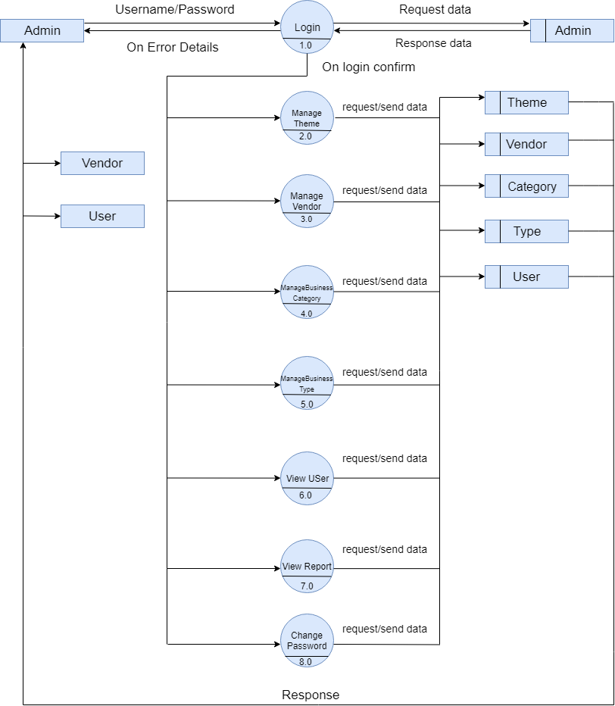

* **Vendor**

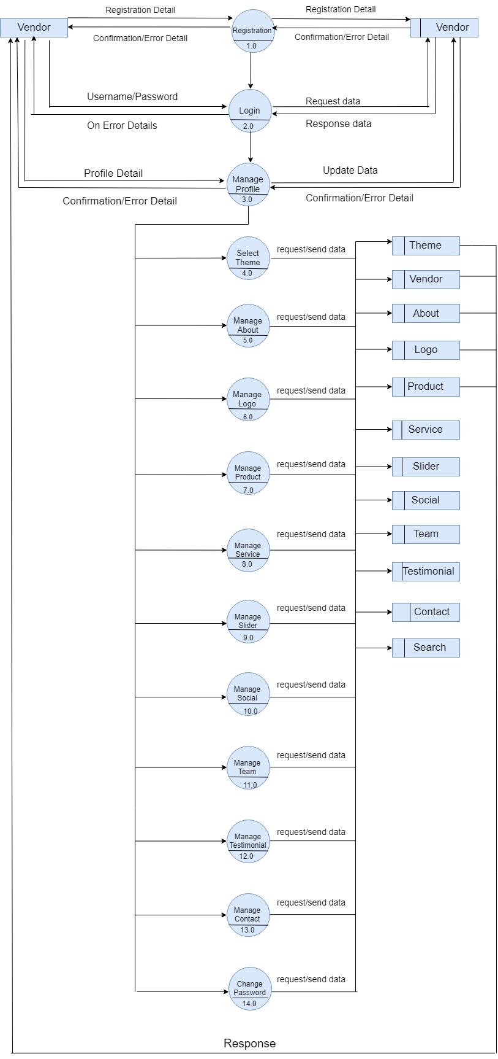

* **User**

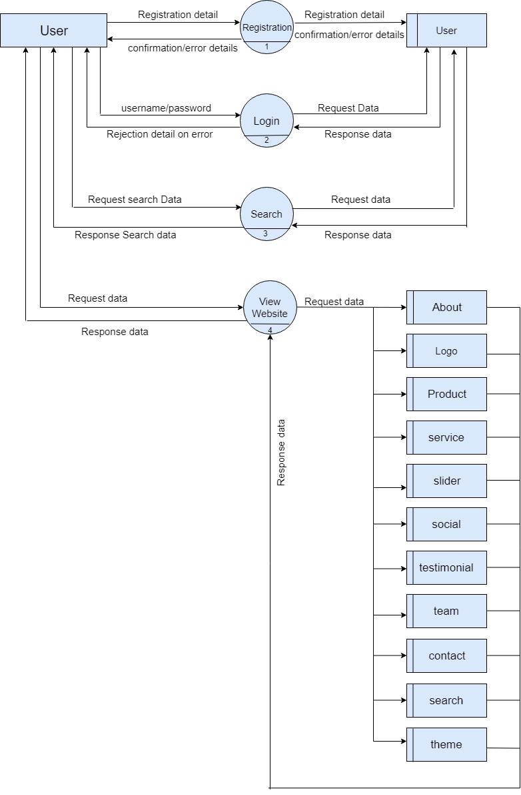

* **Level-2**
* **Admin**
* **Login Process**

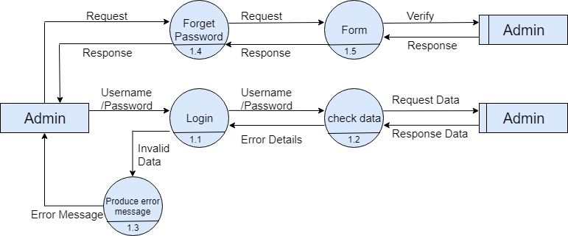

* **Manage Theme**

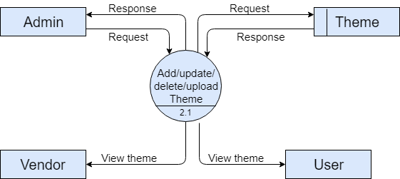

* **Manage Vendor**

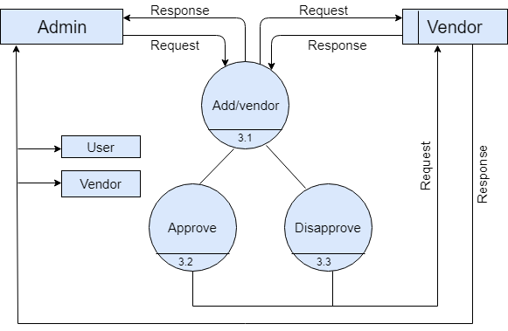

* **Manage Category**

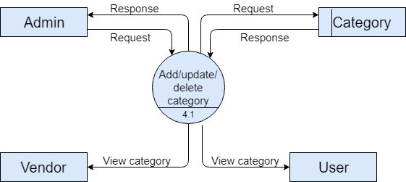

* **Manage Type**

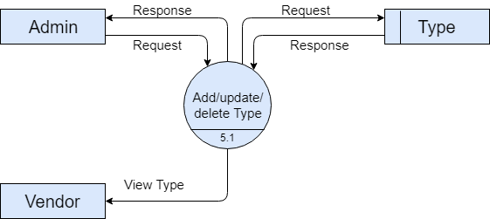

* **View User**

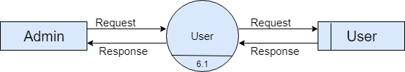

* **View Report**

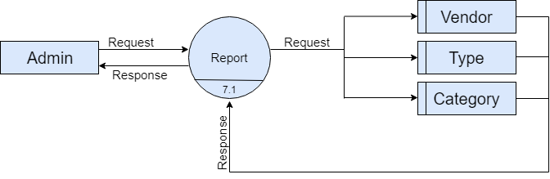

* **Change Password**

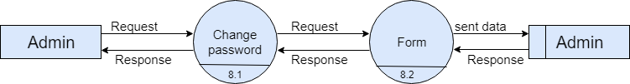

* **Vendor**
* **Registration**



* **Login**

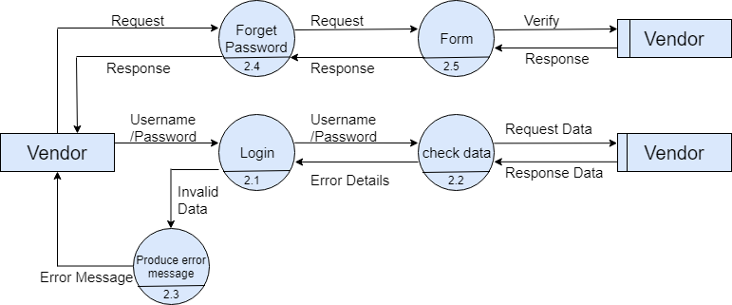

* **Manage Profile**

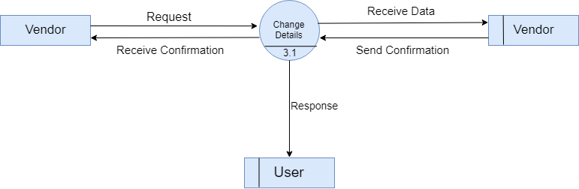

* **Select Theme**

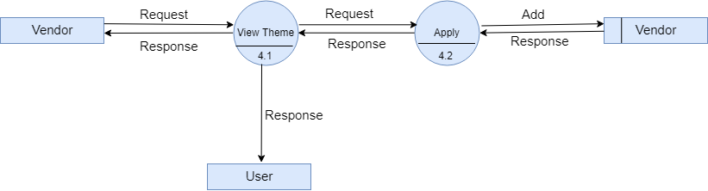

* **Manage About Us**

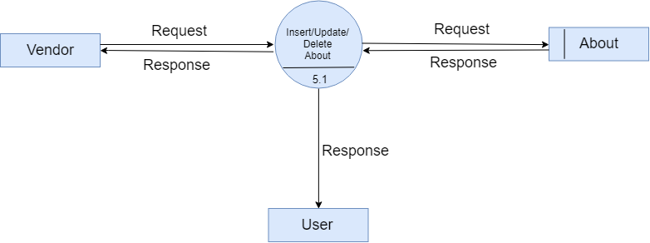

* **Manage Logo**

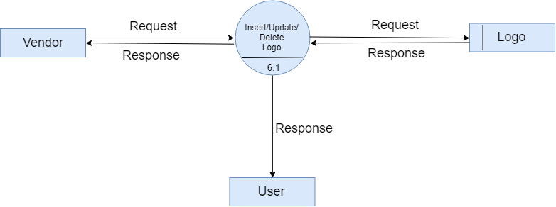

* **Manage Product**

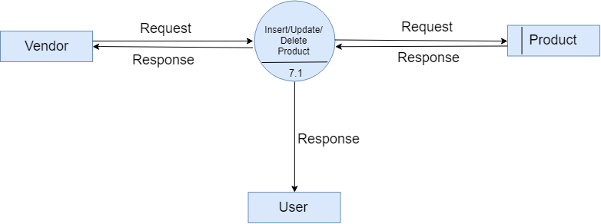

* **Manage Service**

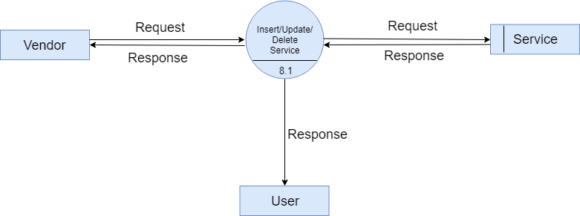

* **Manage Slider**

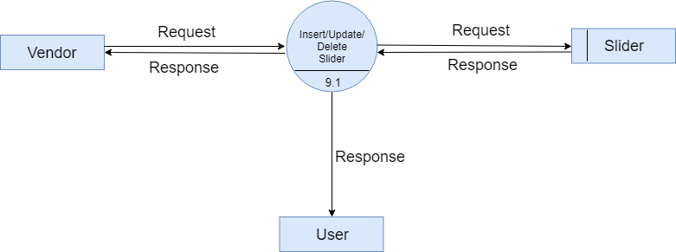

* **Manage Follow Us**

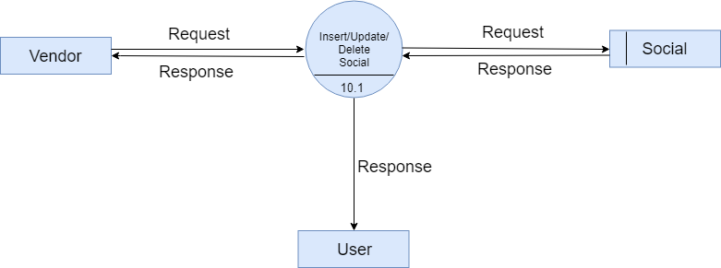

* **Manage Team**

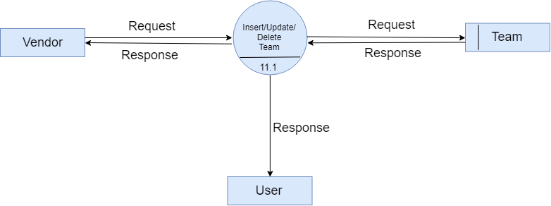

* **Manage Testimonials**

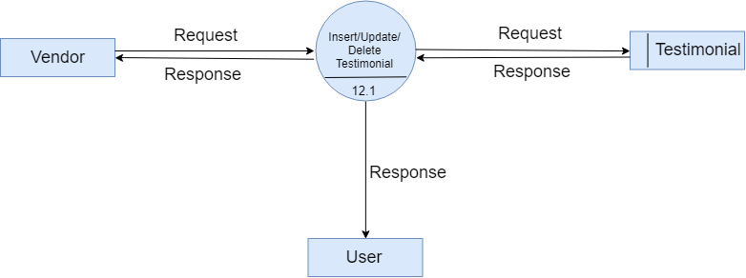

* **Manage Contact**

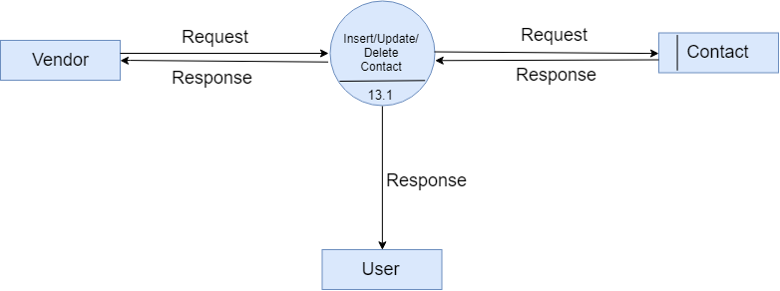

* **Change Password**

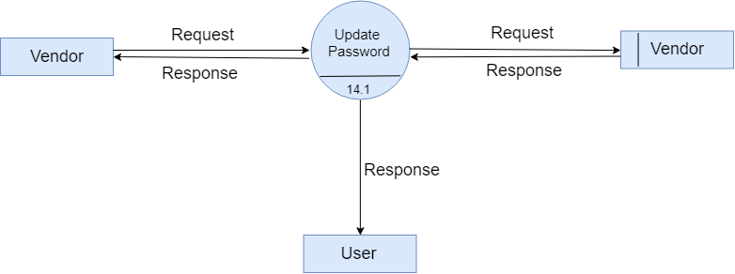

* **User**
* **Registration Process**

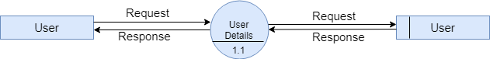

* **Login Process**

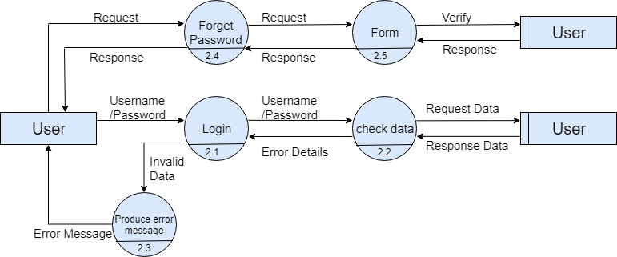

* **Search Shop**

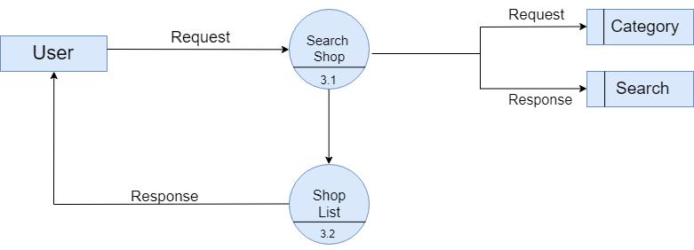

5.5 Data Dictionary

1. **admin**

|  |  |
| --- | --- |
| **Name** | **Admin Detail** |
| Alias Name | None |
| Where and How used? | - Store the details of admin.  - verify the data at the time of admin login and forgot password. |
| Description | admin_id(Primary Key)+ admin_name + admin_password + admin_email |

1. **theme**

|  |  |
| --- | --- |
| **Name** | **Theme Detail** |
| Alias Name | Website |
| Where and How used? | - Store the details of theme.  - It is use by vendor to select theme for his/her shop.  - Theme folder is upload by admin.  - Admin can add/update/delete and view theme data. |
| Description | theme_id(Primary Key)+ theme_name + theme_url + theme_icon |

1. **type**

|  |  |
| --- | --- |
| **Name** | **Business Type Detail** |
| Alias Name | None |
| Where and How used? | - Store the details of business type.  - It is use by vendor to select his/her business type.  - Admin can add/update/delete and view data. |
| Description | type_id(Primary Key)+ type_name |

1. **category**

|  |  |
| --- | --- |
| **Name** | **Category Detail** |
| Alias Name | None |
| Where and How used? | - Store the details of business category.  - Admin can add/update/delete and view data.  - It is use by vendor to select his/her business category.  - It is also use by user to search shop through the category. |
| Description | category_id(Primary Key)+ category_name + category_image |

1. **vendor**

|  |  |
| --- | --- |
| **Name** | **Vendor Detail** |
| Alias Name | Shop |
| Where and How used? | - Store the details of vendor and his/her shop.  - Admin can approved or disapproved vendor.  - Add data when vendor register for his/her shop.  - It is use by the user when user search for the shop details. |
| Description | vendor_id(Primary Key)+ shop_name + vendor_image + vendor_name + vendor_email + vendor_contactno + vendor_company_idproof + description + address + password + registration_date + category_id + type_id + approve + theme_id |

1. **about**

|  |  |
| --- | --- |
| **Name** | **About Detail** |
| Alias Name | None |
| Where and How used? | - Store the about details of vendor’s shop.  - Vendor can add/update/delete and view data.  - The data is display in the vendor’s shop website. |
| Description | about_id(Primary Key)+ vendor_id + baner_image + about_image + description + about_mission + about_vision + about_success |

1. **contact**

|  |  |
| --- | --- |
| **Name** | **Contact Detail** |
| Alias Name | None |
| Where and How used? | - Store the contact details of vendor’s shop.  - Vendor can add/update/delete and view data.  - The data is display in the vendor’s shop website. |
| Description | contact_id(Primary Key)+ vendor_id + phone_no1 + phone_no2 + email + address + contact_image + contact_name |

1. **logo**

|  |  |
| --- | --- |
| **Name** | **Logo Detail** |
| Alias Name | None |
| Where and How used? | - Store the logo of vendor’s shop.  - Vendor can add/update/delete and view data.  - The data is display in the vendor’s shop website. |
| Description | logo_id(Primary Key)+ vendor_id + image |

1. **Product**

|  |  |
| --- | --- |
| **Name** | **Product Detail** |
| Alias Name | None |
| Where and How used? | - Store the product details of vendor’s shop.  - Vendor can add/update/delete and view data.  - The data is display in the vendor’s shop website. |
| Description | product_id(Primary Key)+ vendor_id + title + product_price + banner_image + product_image + description + short_description |

1. **Search**

|  |  |
| --- | --- |
| **Name** | **Search Detail** |
| Alias Name | None |
| Where and How used? | - Store the keyword of vendor’s shop.  - Vendor can add/update/delete and view data.  - The data is use when the user search the shop via keyword. |
| Description | search_id(Primary Key)+ vendor_id + shop_name + description + keyword |

1. **service**

|  |  |
| --- | --- |
| **Name** | **Service Detail** |
| Alias Name | None |
| Where and How used? | - Store the service details of vendor’s shop.  - Vendor can add/update/delete and view data.  - The data is display in the vendor’s shop website. |
| Description | service_id(Primary Key)+ vendor_id + title + icon + banner_image + service_image + description + short_description |

1. **slider**

|  |  |
| --- | --- |
| **Name** | **Slider Detail** |
| Alias Name | None |
| Where and How used? | - Store the slider image for vendor’s shop website.  - Vendor can add/update/delete and view data.  - The data is display in the vendor’s shop website. |
| Description | slider_id(Primary Key)+ vendor_id + slider_image |

1. **social_media**

|  |  |
| --- | --- |
| **Name** | **Social Media Detail** |
| Alias Name | Follow_us |
| Where and How used? | - Store the follow us details of vendor’s shop.  - Vendor can add/update/delete and view data.  - The data is display in the vendor’s shop website. |
| Description | socialmedia_id(Primary Key)+ vendor_id + media_name + link |

1. **team**

|  |  |
| --- | --- |
| **Name** | **Team Detail** |
| Alias Name | None |
| Where and How used? | - Store the team members details of vendor’s shop.  - Vendor can add/update/delete and view data.  - The data is display in the vendor’s shop website. |
| Description | team_id(Primary Key)+ vendor_id + team_image + name + designation + short_description |

1. **testimonials**

|  |  |
| --- | --- |
| **Name** | **Testimonials Detail** |
| Alias Name | review |
| Where and How used? | - Store the reviews of vendor’s shop.  - Vendor can add/update/delete and view data.  - The data is display in the vendor’s shop website. |
| Description | testimonial_id(Primary Key)+ vendor_id + title + designation + review |

1. **user**

|  |  |
| --- | --- |
| **Name** | **User Detail** |
| Alias Name | client |
| Where and How used? | - Store the user details.  - verify the data at the time of login and forgot password.  - Add data through user registration. |
| Description | user_id(Primary Key)+ user_name + password + contact_no + email |

5.6 Process Specification

* **Admin Side**

**Process :** 1

|  |  |
| --- | --- |
| **Name** | Login |
| **Description** | This process will take login information as input from admin and will compare that information with data stored in admin table. If provided data is correct then system will create a session else will show an error. |
| **Input Data Flow** | Admin name and password from admin |
| **Output Data Flow** | Send request to dashboard or Error Message |

**Process :** 2

|  |  |
| --- | --- |
| **Name** | Manage Theme |
| **Description** | In this process admin can add,update and delete theme in database.Admin can also upload the theme folder. |
| **Input Data Flow** | Admin can manage theme name,url and icon and upload theme folder. |
| **Output Data Flow** | If the admin insert/update/delete the theme information then it will reflect to the database and also in admin panel. |

**Process :** 3

|  |  |
| --- | --- |
| **Name** | View User |
| **Description** | In this process admin can view the user data from the database. |
| **Input Data Flow** | Admin sent request to the database. |
| **Output Data Flow** | Receive user data from the database. |

**Process :** 4

|  |  |
| --- | --- |
| **Name** | Manage Vendor |
| **Description** | In this process admin can register vendor.Admin can view vendor and can approve and disapprove vendor. |
| **Input Data Flow** | Admin add vendors information for registration or give approval or disapproval to vendor. |
| **Output Data Flow** | When vendor gets approval rom client they can login for their panel using password sent via email. |

**Process :** 5

|  |  |
| --- | --- |
| **Name** | Manage Business Category |
| **Description** | In this process admin can add category and also can view,update and delete data from the database. |
| **Input Data Flow** | Admin can manage category name and image. |
| **Output Data Flow** | If the admin insert/update/delete the category information then it will reflect to the database and also in admin panel. |

**Process :** 6

|  |  |
| --- | --- |
| **Name** | Manage Business Type |
| **Description** | In this process admin can add business type and also can view,update and delete from the database. |
| **Input Data Flow** | Admin can manage business type. |
| **Output Data Flow** | If the admin insert/update/delete the business type then it will reflect to the database and also in admin panel. |

**Process :** 7

|  |  |
| --- | --- |
| **Name** | View report |
| **Description** | In this process admin can view report based on the business category wise shop and business type wise shop. |
| **Output Data Flow** | Admin will get the data from the database and it will reflect in the admin panel |

**Process :** 8

|  |  |
| --- | --- |
| **Name** | Forgot Password |
| **Description** | In this process admin can get the new password through the email. |
| **Input Data Flow** | Forget password accepts as input Email ID entered by the admin. |
| **Output Data Flow** | If Email ID is valid then Admin can get the new password. |

**Process :** 9

|  |  |
| --- | --- |
| **Name** | Change Password |
| **Description** | In this process admin can change the password if he/she know his/her current password. |
| **Input Data Flow** | change password accepts as input current password and new password and re-entry of new password entered by the admin. |
| **Output Data Flow** | If current password is match and new password and reset password is same then new password is reflect in the database. |

* **Vendor Side**

**Process :** 1

|  |  |
| --- | --- |
| **Name** | Registration |
| **Description** | This process will let vendor register his/her shop on web.so that user can search for his/her shop and view his/her shop website. |
| **Input Data Flow** | Vendor Registration modules accepts the vendor information for registration. |
| **Output Data Flow** | When client is registered with their Information then they can redirect to success page. |

**Process :** 2

|  |  |
| --- | --- |
| **Name** | Login |
| **Description** | This process will take login information as input from vendor and will compare that information with data stored in vendor table. If provided data is correct then system will create a session else will show an error. |
| **Input Data Flow** | Vendor name and password from vendor. |
| **Output Data Flow** | Send request to dashboard or Error Message |

**Process :** 3

|  |  |
| --- | --- |
| **Name** | Forgot Password |
| **Description** | In this process vendor can get the new password through the email. |
| **Input Data Flow** | Forget password accepts as input Email ID entered by the vendor. |
| **Output Data Flow** | If Email ID is valid then vendor can get the new password. |

**Process :** 4

|  |  |
| --- | --- |
| **Name** | Change Password |
| **Description** | In this process vendor can change the password if he/she know his/her current password. |
| **Input Data Flow** | change password accepts as input current password and new password and re-entry of new password entered by the vendor. |
| **Output Data Flow** | If current password is match and new password and reset password is same then new password is reflect in the database. |

**Process :** 5

|  |  |
| --- | --- |
| **Name** | Manage About Us |
| **Description** | In this process vendor can add details and can view,update and delete the about us details. |
| **Input Data Flow** | vendor can manage banner image,about image,description,mission,vision and success for his/her shop’s website. |
| **Output Data Flow** | If the vendor insert/update/delete the about us information then it will reflect to the database and also in their panel. |

**Process :** 6

|  |  |
| --- | --- |
| **Name** | Manage Logo |
| **Description** | In this process vendor can add,view,update and delete logo for his/her shop website. |
| **Input Data Flow** | vendor can manage logo for his/her shop’s website. |
| **Output Data Flow** | If the vendor insert/update/delete the logo then it will reflect to the database and also in their panel. |

**Process :** 7

|  |  |
| --- | --- |
| **Name** | Manage Products |
| **Description** | In this process vendor can add,view and update product details,which he/she wants to display in his/her shop website. Vendor can active or deactive the product.Vendor can also manage the product history through the deactivated product. |
| **Input Data Flow** | vendor can manage product title,price,bannerimage,product image,description,sortorder and short description for his/her shop’s website. |
| **Output Data Flow** | If the vendor insert/update/deactive/active the product information then it will reflect to the database and also in their panel. |

**Process :** 8

|  |  |
| --- | --- |
| **Name** | Manage Services |
| **Description** | In this process vendor can add,view and update service details,which he/she wants to display in his/her shop website. Vendor can active or deactive the service.Vendor can also manage the service history through the deactivated service. |
| **Input Data Flow** | vendor can manage service title,icon,banner image,service image,description,sortorder and short description for his/her shop’s website. |
| **Output Data Flow** | If the vendor insert/update/deactive/active the service information then it will reflect to the database and also in their panel. |

**Process :** 9

|  |  |
| --- | --- |
| **Name** | Manage Slider |
| **Description** | In this process vendor can add slider image and can view,update and delete the slider image. |
| **Input Data Flow** | vendor can manage slider image for his/her shop’s website. |
| **Output Data Flow** | If the vendor insert/update/delete the slider image then it will reflect to the database and also in their panel. |

**Process :** 10

|  |  |
| --- | --- |
| **Name** | Manage Follow Us |
| **Description** | In this process vendor can add follow details and can view,update and delete the follow us details. |
| **Input Data Flow** | vendor can manage media name and link for his/her shop’s website. |
| **Output Data Flow** | If the vendor insert/update/delete the follow us details then it will reflect to the database and also in their panel. |

**Process :** 11

|  |  |
| --- | --- |
| **Name** | Manage Team |
| **Description** | In this process vendor can add team members and can view,update and delete the team members details. |
| **Input Data Flow** | vendor can manage team name,image,designation and short description for his/her shop’s website. |
| **Output Data Flow** | If the vendor insert/update/delete the team details then it will reflect to the database and also in their panel. |

**Process :** 12

|  |  |
| --- | --- |
| **Name** | Manage Tesimonials |
| **Description** | In this process vendor can add reviews and can view,update and delete the reviews for his/her shop website testimonials. |
| **Input Data Flow** | vendor can manage person name,designation and review for his/her shop’s website. |
| **Output Data Flow** | If the vendor insert/update/delete the testimonals details then it will reflect to the database and also in their panel. |

**Process :** 13

|  |  |
| --- | --- |
| **Name** | Manage Contact |
| **Description** | In this process vendor can add contact details and can view,update and delete the contact details. |
| **Input Data Flow** | vendor can manage contact name,image,address,phone no and email for his/her shop’s website. |
| **Output Data Flow** | If the vendor insert/update/delete the contact details then it will reflect to the database and also in their panel. |

**Process :** 14

|  |  |
| --- | --- |
| **Name** | Manage Keyword |
| **Description** | In this process vendor can add keyword for search his/her shop and can view,update and delete the keyword for his/her shop. |
| **Input Data Flow** | vendor can manage description and keyword for his/her shop’s website. |
| **Output Data Flow** | If the vendor insert/update/delete the search details then it will reflect to the database and also in their panel. |

**Process :** 15

|  |  |
| --- | --- |
| **Name** | Select theme |
| **Description** | In this process vendor can view all the themes provided by the admin and can select the theme for his/her shop website. |
| **Input Data Flow** | vendor can view all the themes and apply one of them. |
| **Output Data Flow** | If the vendor applied theme then it will reflect to the database and also in their panel. |

**Process :** 16

|  |  |
| --- | --- |
| **Name** | Edit Profile |
| **Description** | In this process vendor can view all his/her personal and shop details and can update his/her personal and shop details. |
| **Input Data Flow** | vendor can edit his/her information for his/her shop’s website. |
| **Output Data Flow** | If the vendor edit information then it will reflect to the database and also in their panel. |

* **Client Side**

**Process :** 1

|  |  |
| --- | --- |
| **Name** | Search Shop |
| **Description** | In this process User can search for the shops as per their needs and view the list of the shops as per search.User can search through the category and keyword. |
| **Input Data Flow** | User can search shop via category and keyword. |
| **Output Data Flow** | Display all shop of selected category or keyword to the user. |

**Process :** 2

|  |  |
| --- | --- |
| **Name** | Registration |
| **Description** | This process will let user register himself/herself on web.so that user can view the website of selected shop. |
| **Input Data Flow** | User Registration modules accepts the user information for registration. |
| **Output Data Flow** | When user is registered with their Information then they can redirect to login page. |

**Process :** 3

|  |  |
| --- | --- |
| **Name** | Login |
| **Description** | This process will take login information as input from user and will compare that information with data stored in user table. If provided data is correct then system will create a session else will show an error. |
| **Input Data Flow** | User name and password from user. |
| **Output Data Flow** | Send request to home page or Error Message |

**Process :** 4

|  |  |
| --- | --- |
| **Name** | Forgot Password |
| **Description** | In this process user can get the new password through the email. |
| **Input Data Flow** | Forget password accepts as input Email ID entered by the user. |
| **Output Data Flow** | If Email ID is valid then user can get the new password. |

**Process :** 5

|  |  |
| --- | --- |
| **Name** | Change Password |
| **Description** | In this process user can change the password if he/she know his/her current password. |
| **Input Data Flow** | change password accepts as input current password and new password and re-entry of new password entered by the user. |
| **Output Data Flow** | If current password is match and new password and reset password is same then new password is reflect in the database. |

**Process :** 6

|  |  |
| --- | --- |
| **Name** | View Website |
| **Description** | In this process user can view website of selected shop and can contact vendor through the inquiry form and shop details.User can also view the map for a selected shop in shop’s website. |
| **Input Data Flow** | Select shop to view website of that shop. |
| **Output Data Flow** | Redirect page to the selected shop’s website. |

5.7 Usecase Diagram

* **Admin**

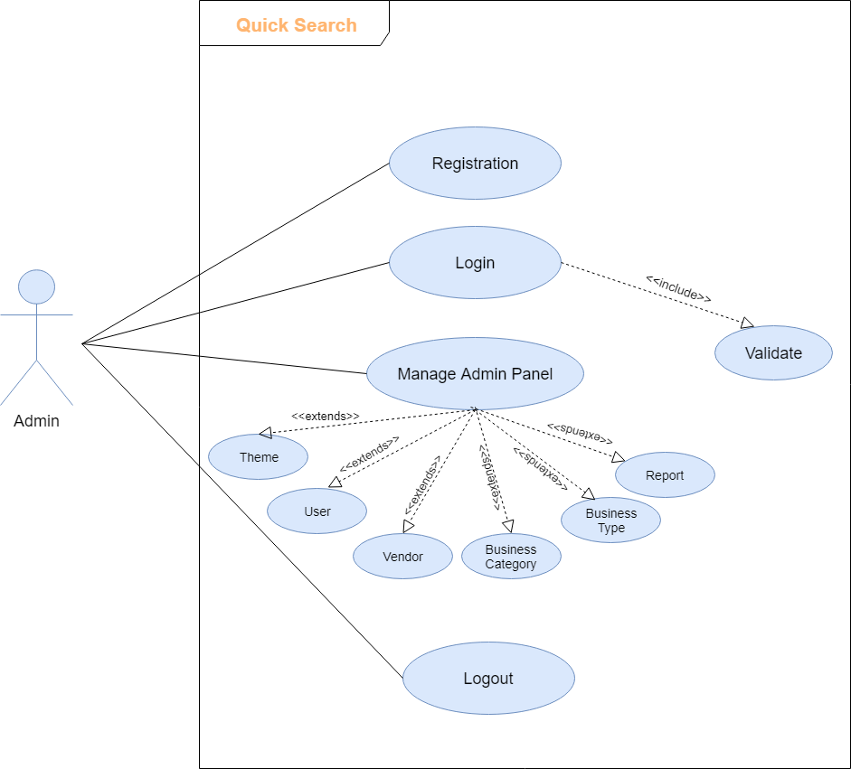

* **Vendor**

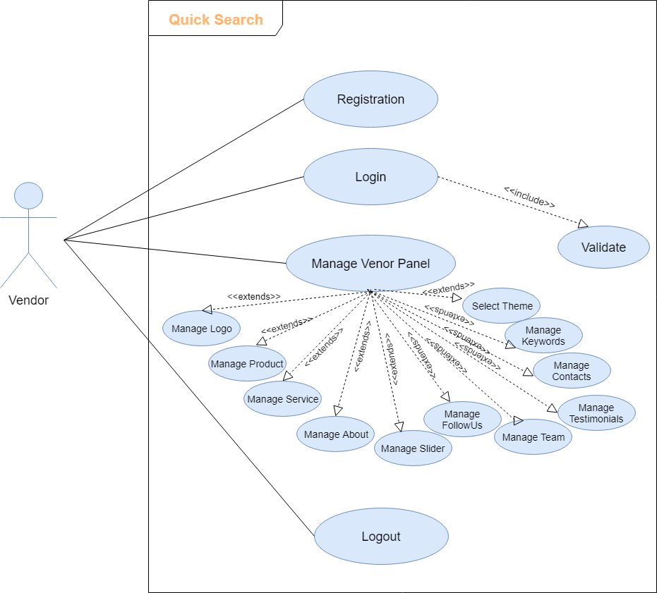

* **User**

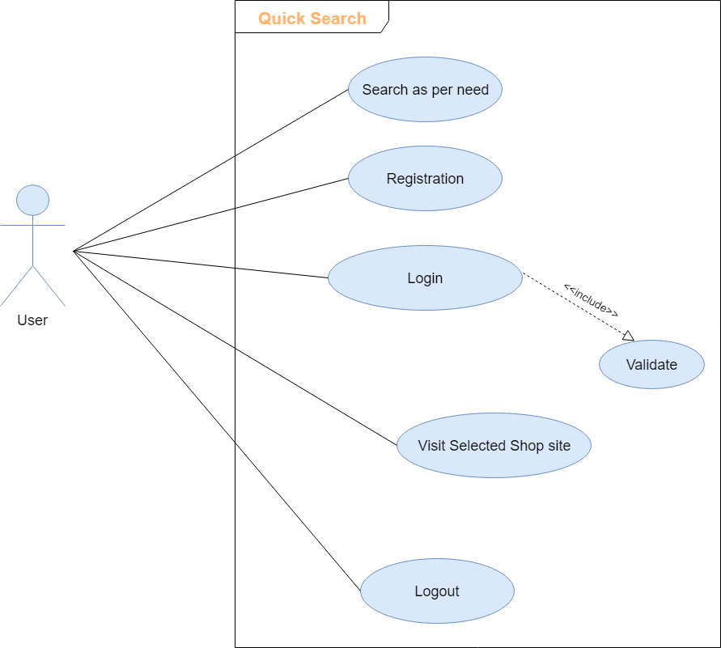

5.8 Class Diagram

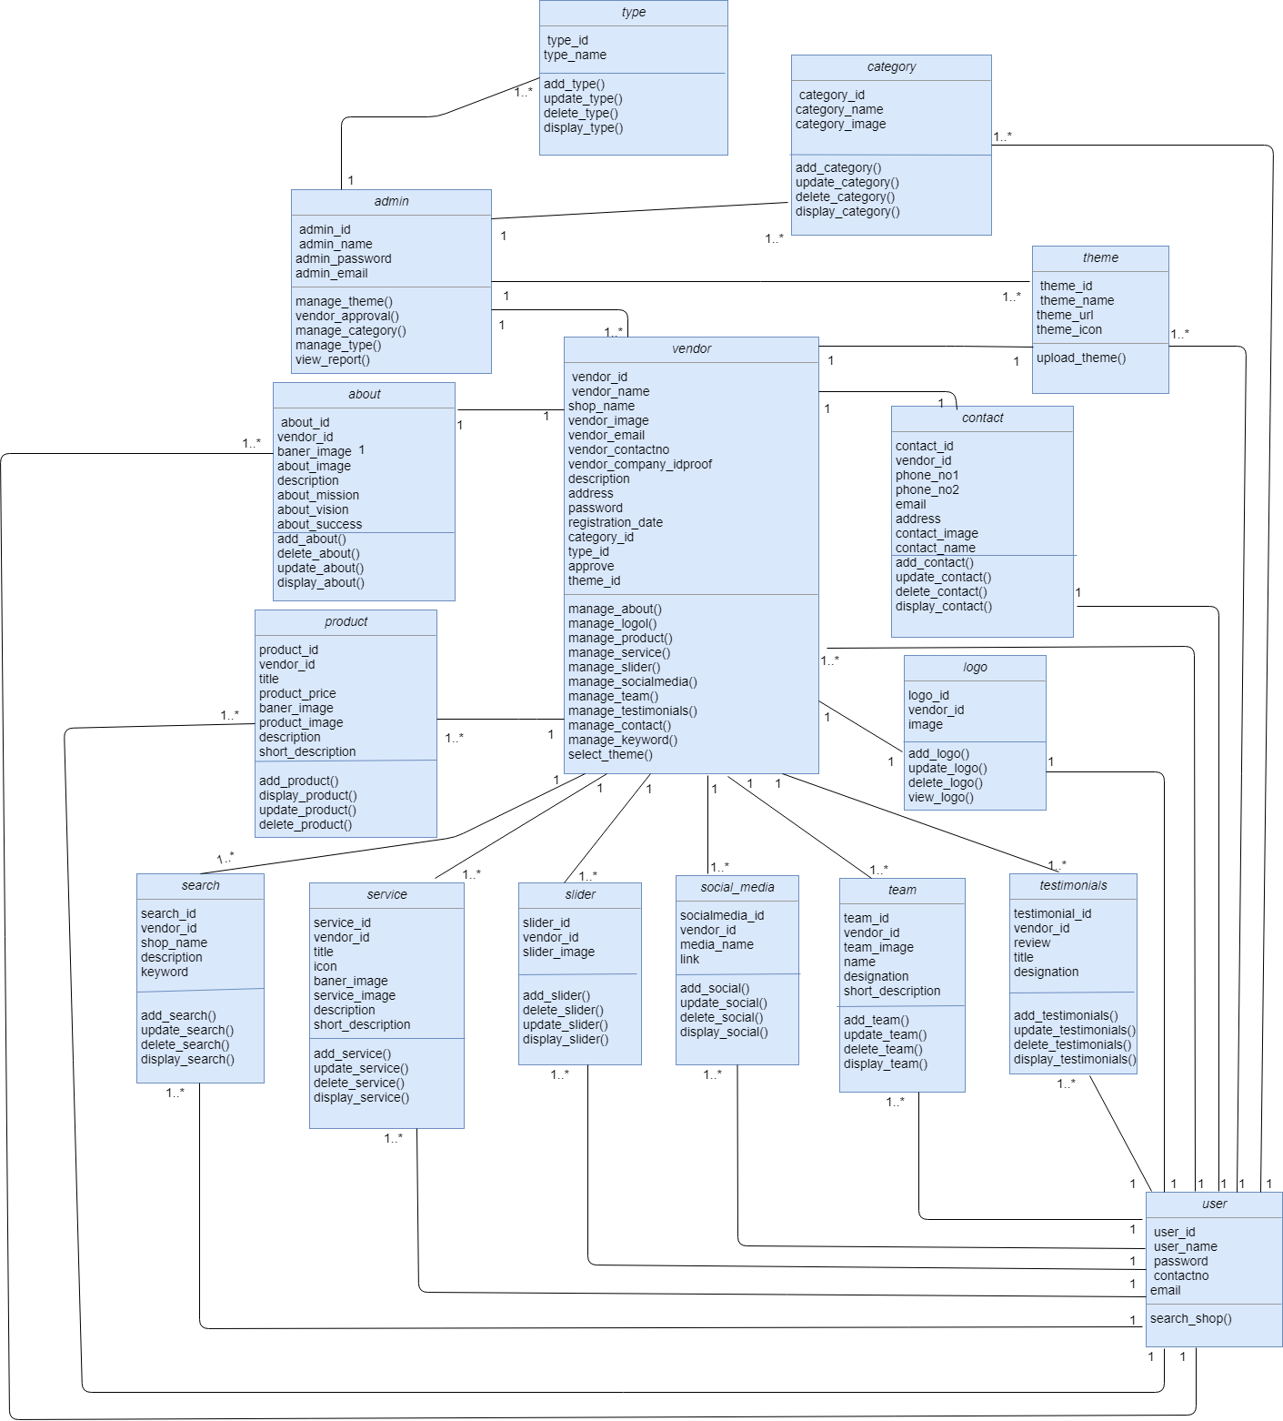

5.9 Sequence Diagram

* **Admin**

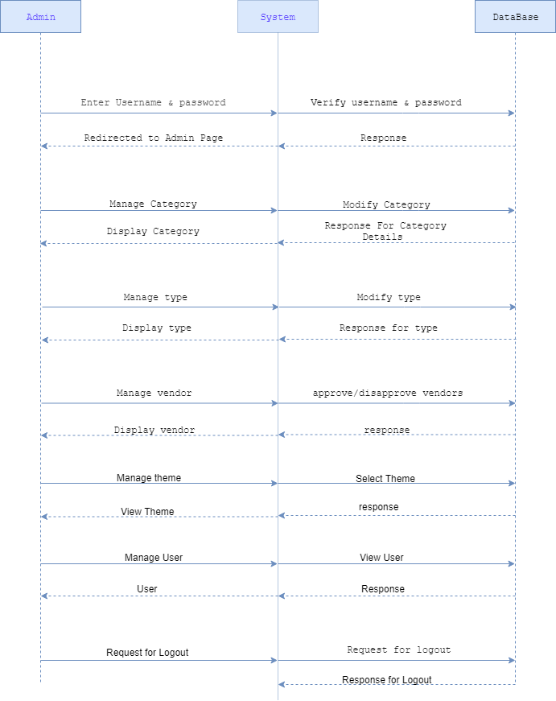

* **Vendor**

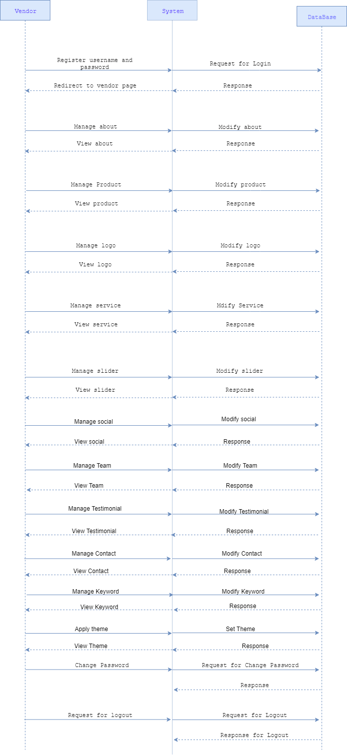

* **User**

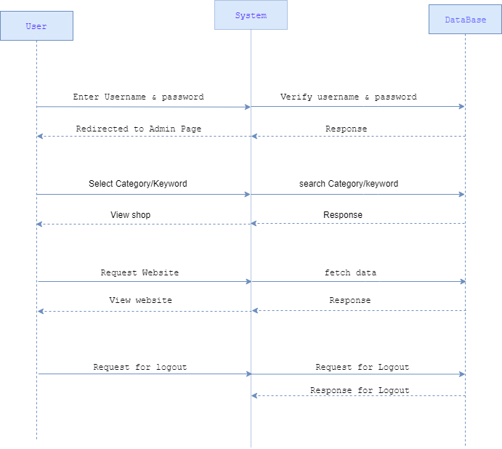

1. **DESIGNING**

6.1 Database Design

6.2 Interface Design

6.1 Database Design

**Table Name:** about

|  |  |  |  |  |
| --- | --- | --- | --- | --- |
| **Field** | **DataType** | **Size** | **Key** | **Description** |
| About_id | Int | 11 | Primary Key | Stores id of about us. |
| Vendor_id | Int | 11 | Foreign Key | Stores id of vendor |
| Banner_image | Text | - | - | Stores image path. |
| About_image | Text | - | - | Stores image path. |
| Description | Text | - | - | Stores the goal of vendor`s shop |
| About_mission | Text | - | - | Stores the mission of  vendor`s shop. |
| About_vision | Text | - | - | Stores the vision of vendor`s shop |
| About_success | Text | - | - | Stores the success of vendor`s shop. |

**Table Name:** admin

|  |  |  |  |  |
| --- | --- | --- | --- | --- |
| **Field** | **DataType** | **Size** | **Key** | **Description** |
| admin_id | Int | 11 | Primary key | Stores id of Admin |
| admin_name | Varchar | 255 | Unique Key | Stores name of admin |
| admin_password | Varchar | 255 | - | Stores password of admin |
| admin_email | varchar | 255 | Unique Key | Stores admin email id |

**Table Name:** category

|  |  |  |  |  |
| --- | --- | --- | --- | --- |
| **Field** | **DataType** | **Size** | **Key** | **Description** |
| category_id | Int | 11 | Primary Key | Stores id of category |
| category_name | Varchar | 255 | Unique Key | Stores name of category |
| category_image | Text | - | - | Stores image path |

**Table Name:** contact

|  |  |  |  |  |
| --- | --- | --- | --- | --- |
| **Field** | **DataType** | **Size** | **Key** | **Description** |
| contact_id | Int | 11 | Primary Key | Stores id of contact. |
| vendor_id | Int | 11 | Foreign Key | Stores id of Vendor |
| phone_no1 | Bigint | 10 | - | Stores mobile no. of vendor. |
| phone_no2 | Bigint | 10 | - | Stores mobile no. of vendor. |
| Email | Varchar | 255 | - | Stores email id of vendor. |
| Address | Varchar | 255 | - | Stores address of vendor`s shop. |
| contact_image | Text | - | - | Stores path of image |
| contact_name | Varchar | 255 | - | Stores name of contacted vendor. |
| Latitude | double | - | - | Stores geometric latitude value of shop address |
| Longitude | double | - | - | Stores geometric longitude value of shop  address |

**Table Name:** logo

|  |  |  |  |  |
| --- | --- | --- | --- | --- |
| **Field** | **DataType** | **Size** | **Key** | **Description** |
| logo_id | Int | 11 | Primary Key | Stores id of logo |
| vendor_id | Int | 11 | Foreign Key | Stores id of vendor |
| image | Text | - | - | Stores image path |

**Table Name:** product

|  |  |  |  |  |
| --- | --- | --- | --- | --- |
| **Field** | **DataType** | **Size** | **Key** | **Description** |
| product_id | Int | 11 | Primary Key | Stores vendor`s product id |
| vendor_id | Int | 11 | Foreign Key | Stores vendor id |
| Title | Varchar | 255 | - | Stores title of product. |
| product_image | Text | - | - | Stores image path of product. |
| banner_image | Text | - | - | Stores image path |
| product_price | Int | 11 | - | Stores price of product. |
| Description | Text | - | - | Stores description of product. |
| Sortorder | Int | 11 | - | Stores sort no. of product. |
| short_description | Varchar | 255 | - | Stores short description of product. |

**Table Name:** search

|  |  |  |  |  |
| --- | --- | --- | --- | --- |
| **Field** | **DataType** | **Size** | **Key** | **Description** |
| search_id | Int | 11 | Primary Key | Stores id of search. |
| shop_name | varchar | 255 | - | Stores name of shop . |
| description | text | - | - | Stores description of shop. |
| keyword | Varchar | 255 | - | Stores the key words of shop |
| vendor_id | int | 11 | - | Stores vendor id |

**Table Name:** service

|  |  |  |  |  |
| --- | --- | --- | --- | --- |
| **Field** | **DataType** | **Size** | **Key** | **Description** |
| service_id | Int | 11 | Primary Key | Stores id of services. |
| Title | varchar | 255 | - | Stores title (name) of service. |
| Description | text | - | - | Stores description of service. |
| banner_image | text | - | - | Stores path of banner image |
| service_image | Text | - | - | Stores path of service image |
| Sortorder | int | 11 | - | Stores sort no. of service. |
| vendor_id | int | 11 | Foreign Key | Stores id of vendor |
| Icon | Text | - | - | Stores icon path for service |
| short_description | Varchar | 255 | - | Stores short description of service |

**Table Name:** slider

|  |  |  |  |  |
| --- | --- | --- | --- | --- |
| **Field** | **DataType** | **Size** | **Key** | **Description** |
| slider_id | Int | 11 | Primary Key | Stores id of slider |
| vendor_id | Int | 11 | Foreign Key | Stores id of vendor |
| slider_image | Text | - | - | Stores path of image |

**Table Name:** social_media

|  |  |  |  |  |
| --- | --- | --- | --- | --- |
| **Field** | **DataType** | **Size** | **Key** | **Description** |
| socialmedia_id | Int | 11 | Primary Key | Stores id of social media |
| vendor_id | Int | 11 | Foreign Key | Stores id of vendor |
| Link | Varchar | 255 | - | Stores link of social media |
| media_name | Varchar | 255 | - | Stores name of social media |

**Table Name:** team

|  |  |  |  |  |
| --- | --- | --- | --- | --- |
| **Field** | **DataType** | **Size** | **Key** | **Description** |
| team_id | Int | 11 | Primary Key | Stores id of team |
| Designation | Varchar | 255 | - | Stores designation of team member |
| team_image | text | - | - | Stores image path |
| Name | Varchar | 255 | - | Stores name of team member |
| short_description | Varchar | 255 | - | Stores short description of team member |
| vendor_id | int | 11 | Foreign Key | Stores id of vendor |

**Table Name:** testimonials

|  |  |  |  |  |
| --- | --- | --- | --- | --- |
| **Field** | **DataType** | **Size** | **Key** | **Description** |
| testimonial_id | Int | 11 | Primary Key | Stores id of testimonials |
| Designation | Varchar | 255 | - | Stores designation of person |
| Title | Varchar | 255 | - | Stores name of person |
| Review | Varchar | 255 | - | Stores review of person |
| vendor_id | int | 11 | - | Stores id of vendor |

**Table Name:** theme

|  |  |  |  |  |
| --- | --- | --- | --- | --- |
| **Field** | **DataType** | **Size** | **Key** | **description** |
| theme_id | Int | 11 | Primary Key | Stores id of theme |
| theme_name | Varchar | 255 | - | Stores name of theme |
| theme_url | Text | - | Unique Key | Stores path of theme. |
| theme_icon | Text | - | - | Stores path of theme icon. |

**Table Name:** type

|  |  |  |  |  |
| --- | --- | --- | --- | --- |
| **Field** | **DataType** | **Size** | **Key** | **Description** |
| type_id | Int | 11 | Primary Key | Stores d of type |
| type_name | Varchar | 255 | Unique Key | Stores the type of business |

**Table Name:** user

|  |  |  |  |  |
| --- | --- | --- | --- | --- |
| **Field** | **DataType** | **Size** | **Key** | **Description** |
| user_id | Int | 11 | Primary Key | Stores id of user |
| user_name | Varchar | 255 | Unique Key | Stores name of user |
| Password | Varchar | 255 | - | Stores password of user |
| contact_no | Bigint | 10 | - | Stores contact number of user |
| Email | Varchar | 255 | Unique Key | Stores email of user |

**Table Name:** vendor

|  |  |  |  |  |
| --- | --- | --- | --- | --- |
| **Field** | **DataType** | **Size** | **Key** | **description** |
| vendor_id | Int | 11 | Primary Key | Stores vendor (Shopkeeper) ID. |
| shop_name | Varchar | 255 | Unique Key | Stores name of vendor`s shop. |
| vendor_image | Text | - | - | Stores path of vendor image |
| vendor_name | Varchar | 255 | - | Stores name of vendor. |
| vendor_email | Varchar | 255 | - | Stores email id of vendor. |
| vendor_contacno | Bigint | 10 | - | Stores mobile no. of vendor. |
| vendor_company_idproof | Text | - | - | Stores path of company idproof |
| Description | Text | - | - | Stores short description of vendor`s shop |
| Address | Varchar | 255 | - | Stores address of vendor`s shop. |
| Password | Varchar | 255 | - | Stores password of vendor. |
| registration_date | Date | - | - | Stores registration date of vendor. |
| category_id | Int | 11 | Foreign Key | Stores business category of vendor`s shop |
| type_id | Int | 11 | Foreign Key | Stores business type of vendor`s shop |
| Approve | Int | 11 | - | Stores vendor’s approval notification |
| theme_id | Int | 11 | Foreign Key | Stores vendor`s selected theme id. |

6.2 Interface Design

* **Admin Side**
* **Login Page**

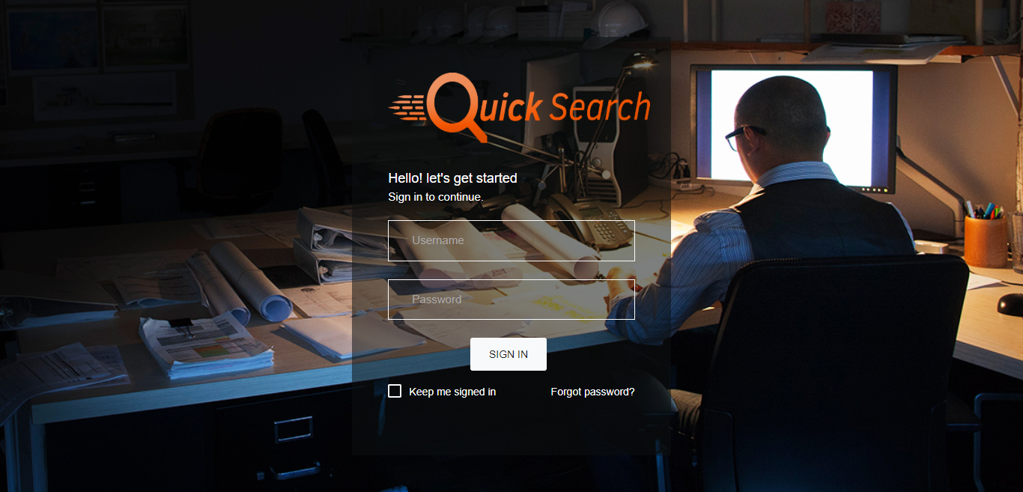

* **Dashboard**

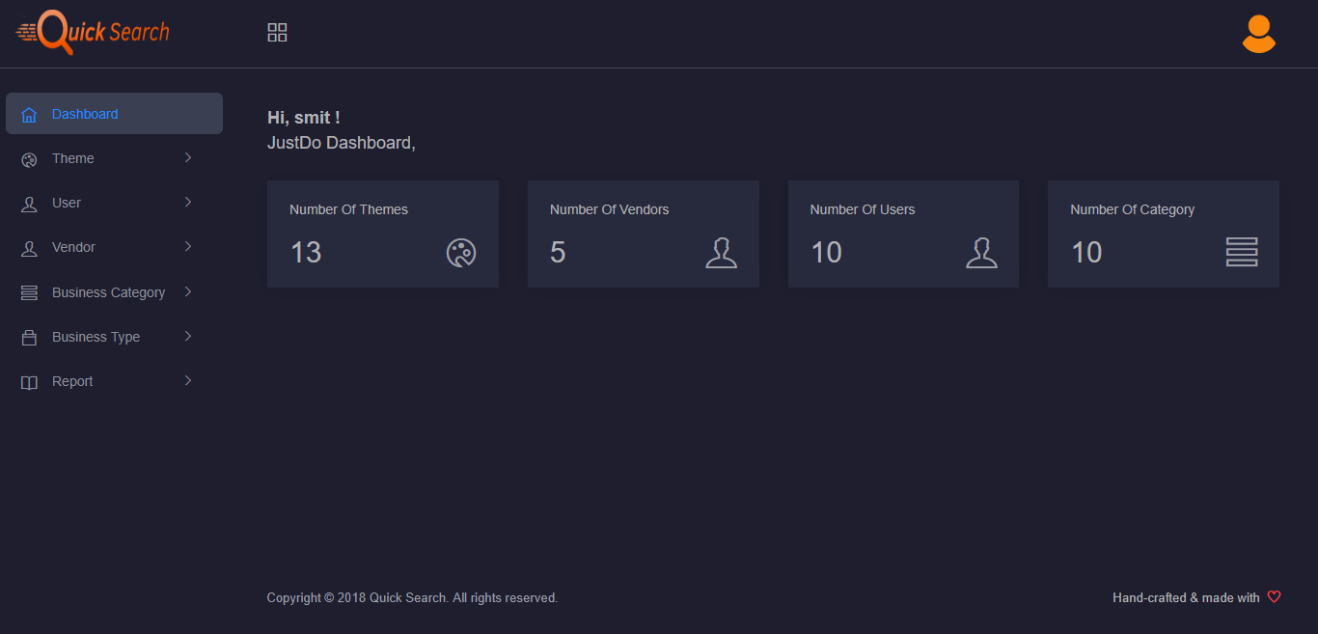

* **Change Password**

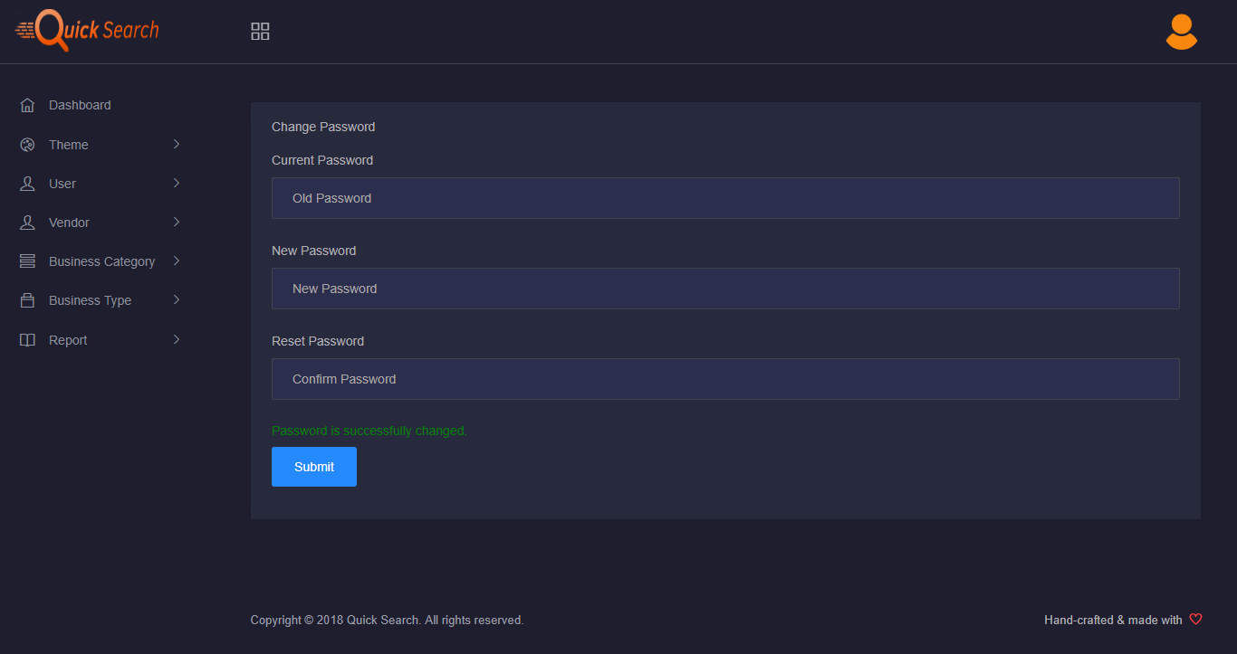

* **Add Theme**

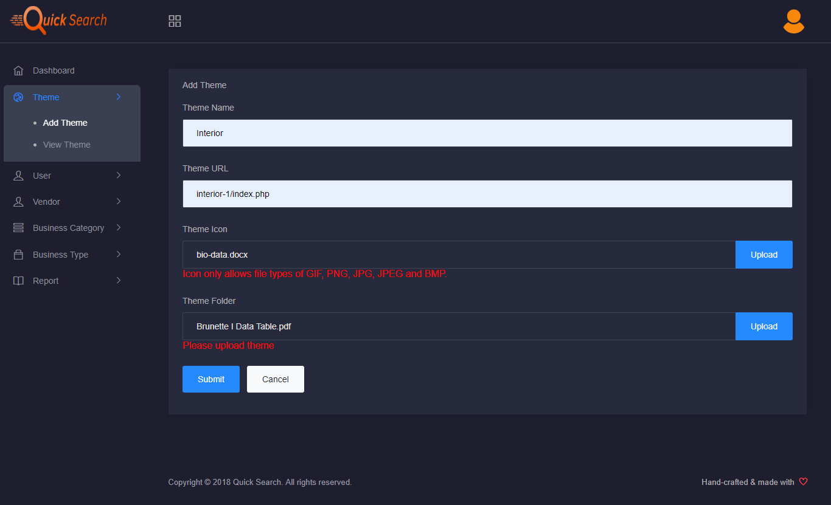

* **View Theme**

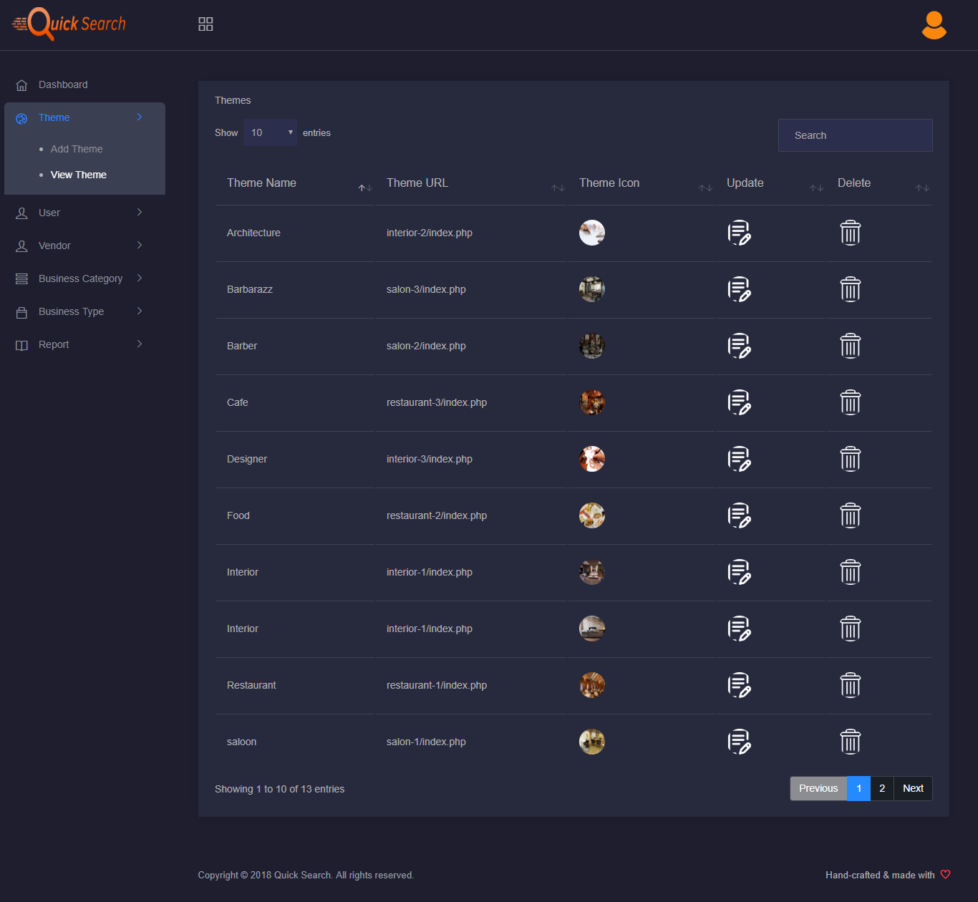

* **View User**

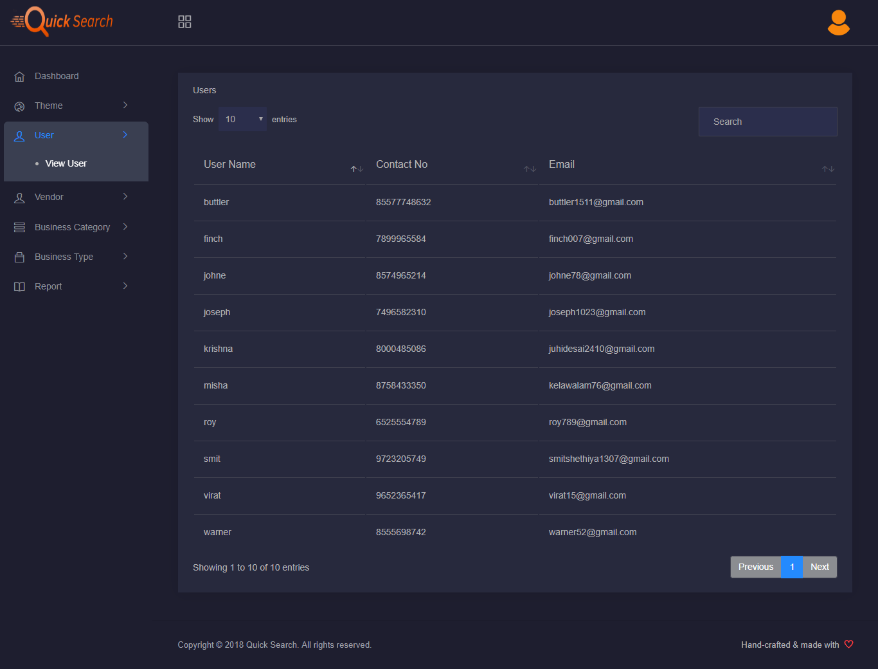

* **Add Vendor**

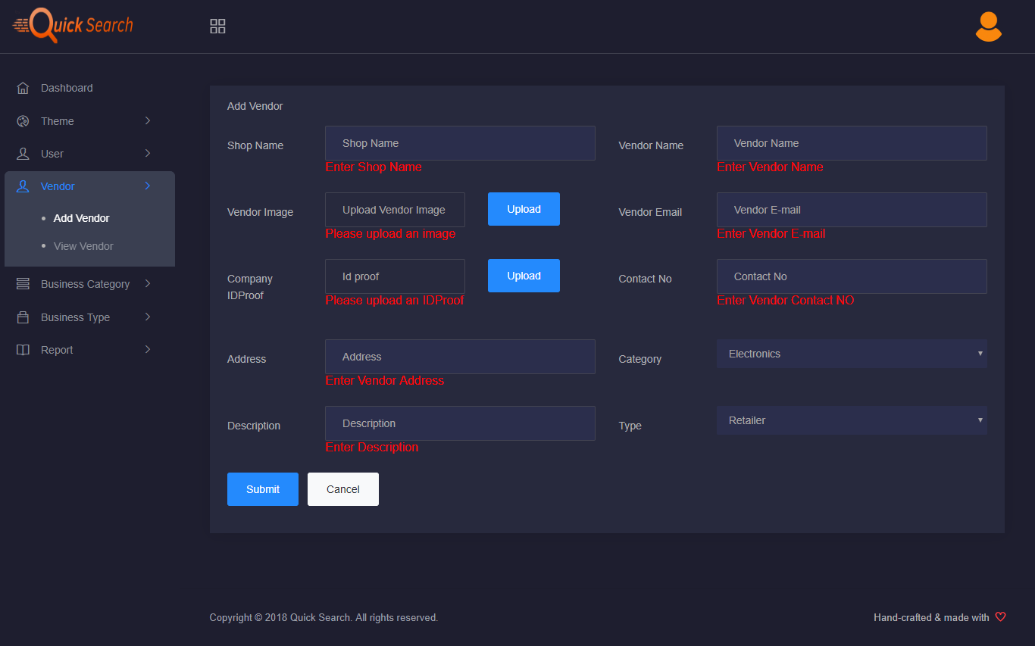

* **View Vendor**

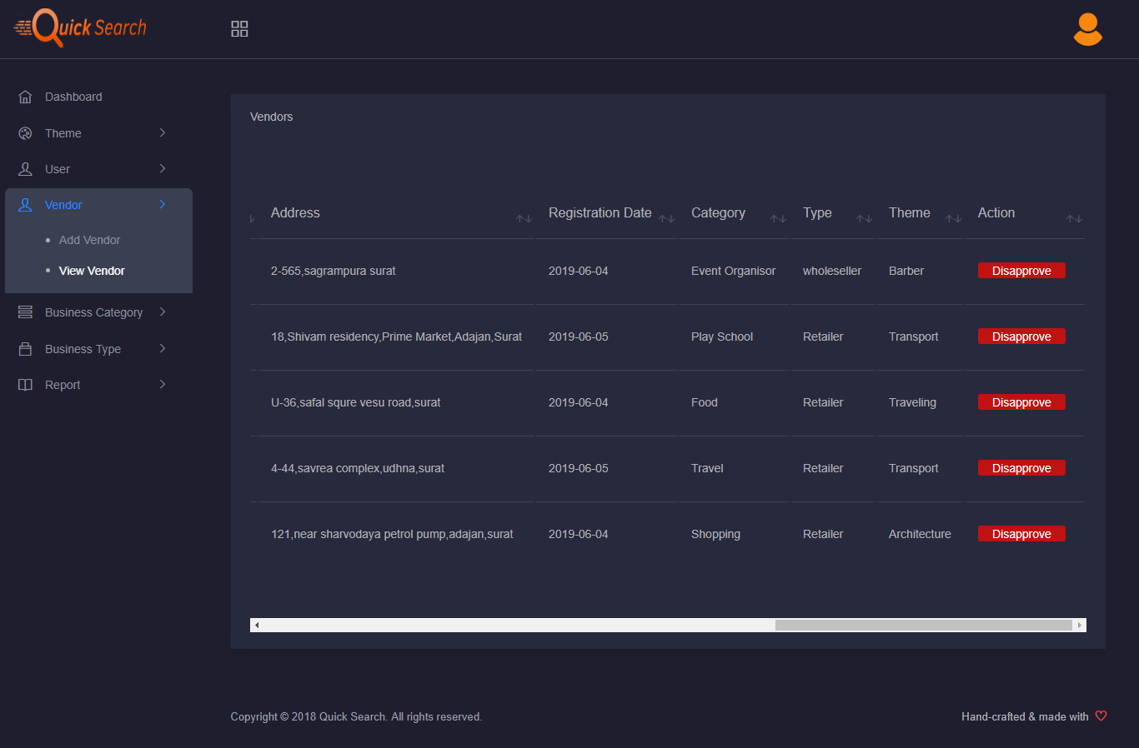

* **Add Business Category**

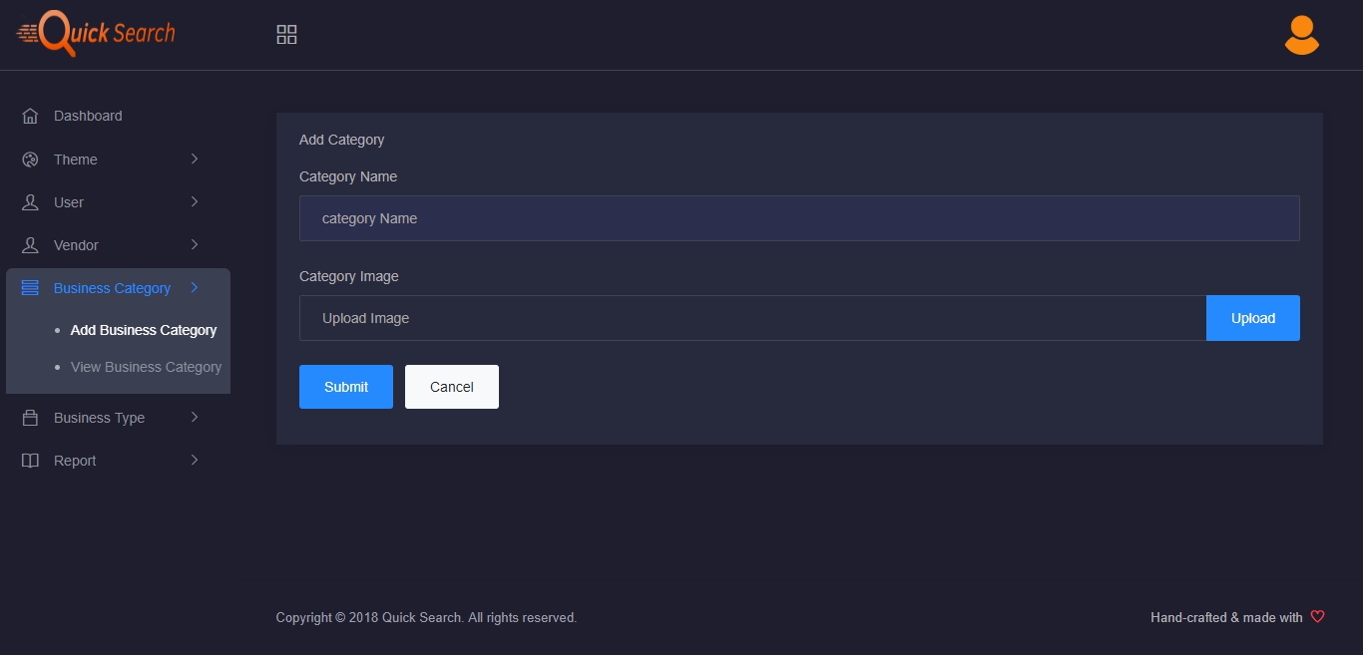

* **View Business Category**

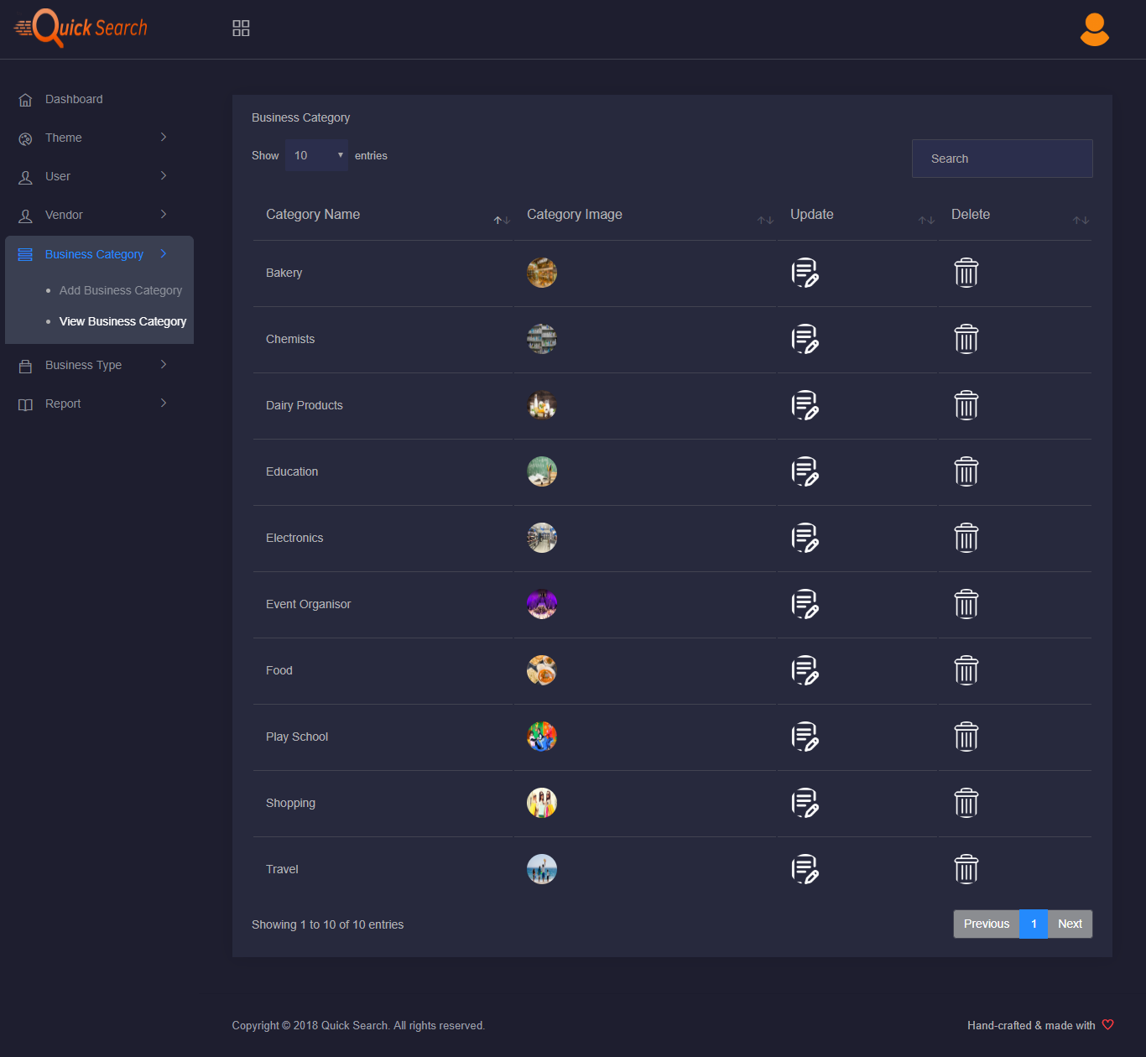

* **Update Business Type**

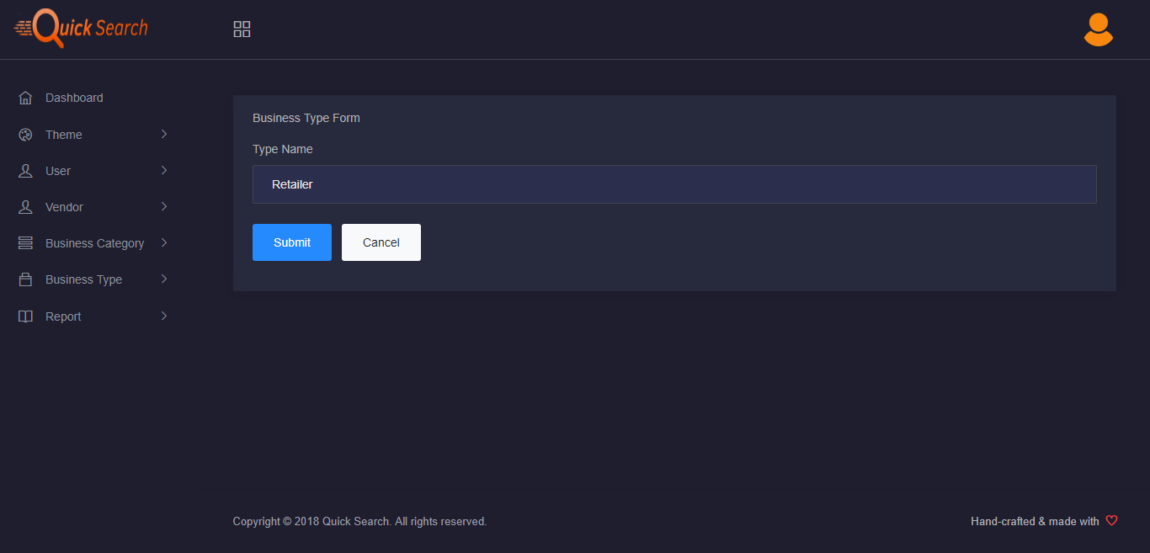

* **Categorywise Report**

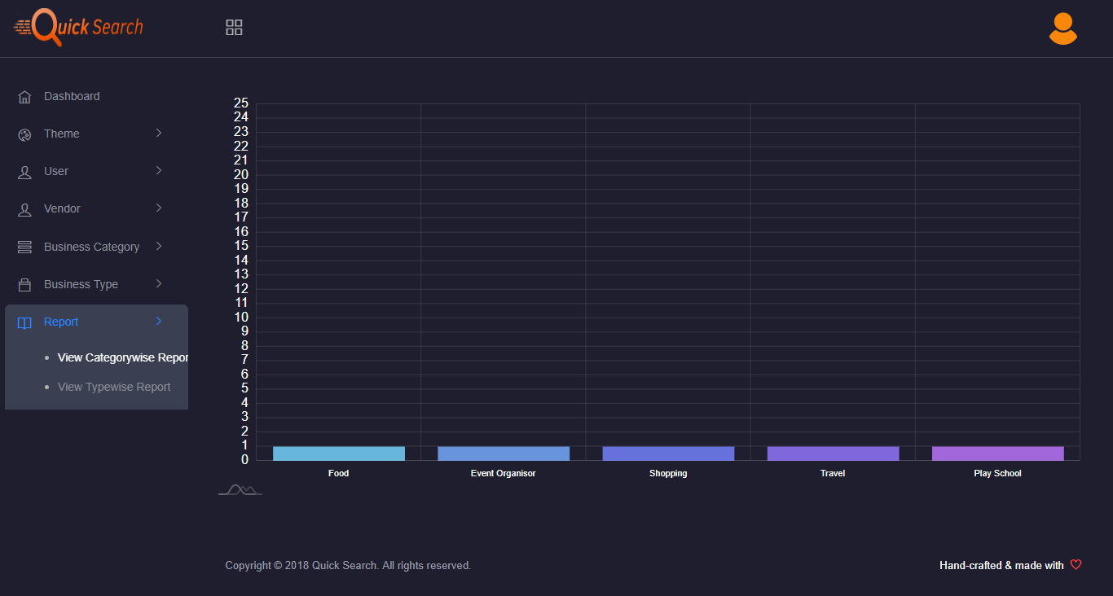

* **Business Typewise Report**

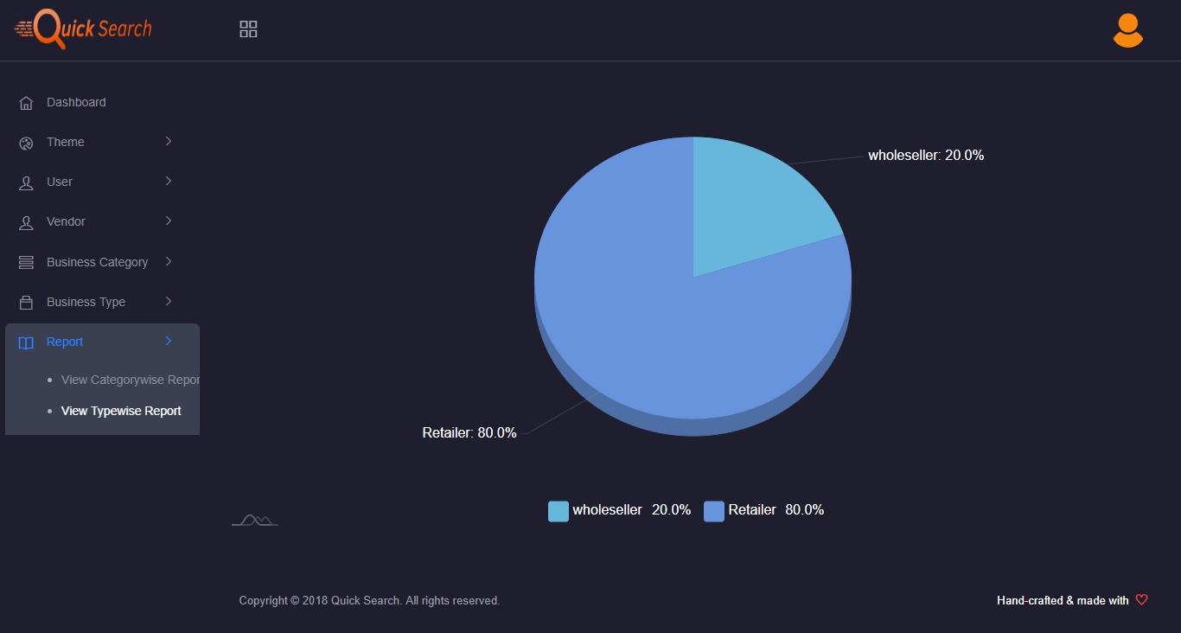

* **Vendor Side**
* **Vendor login**

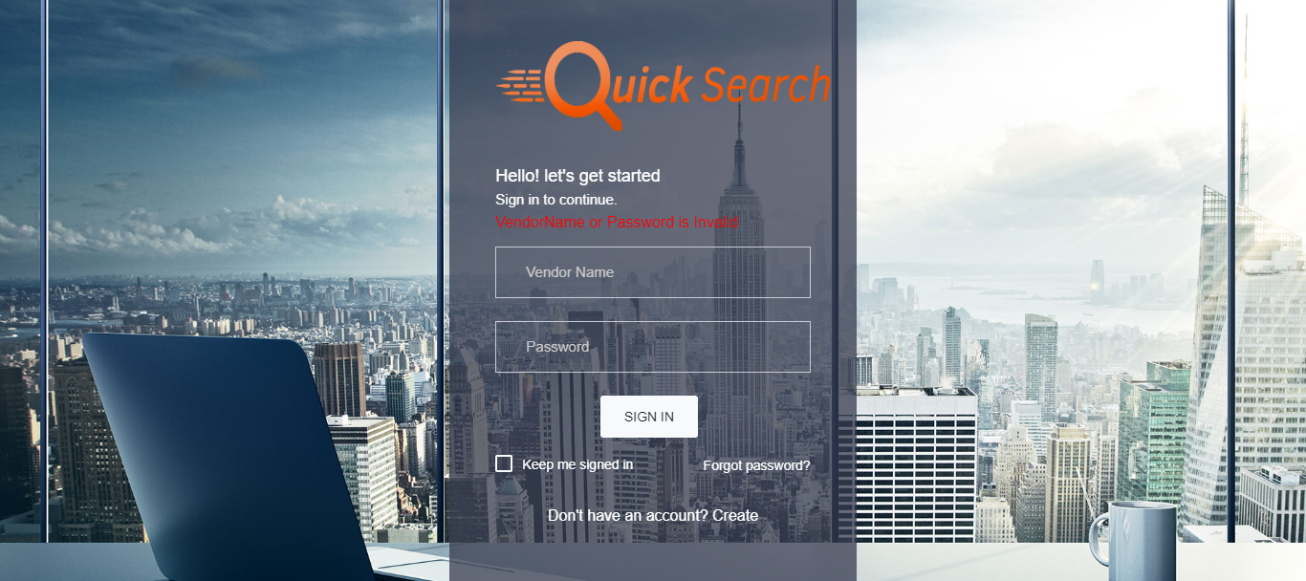

* **Forgot Password**

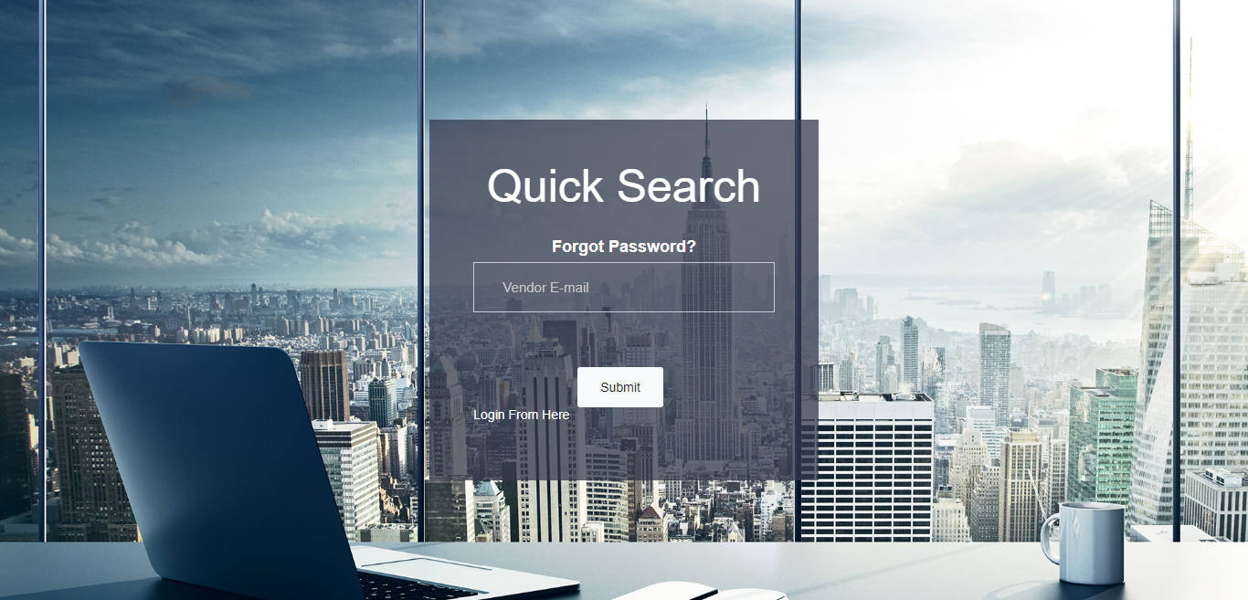

* **Vendor Register**

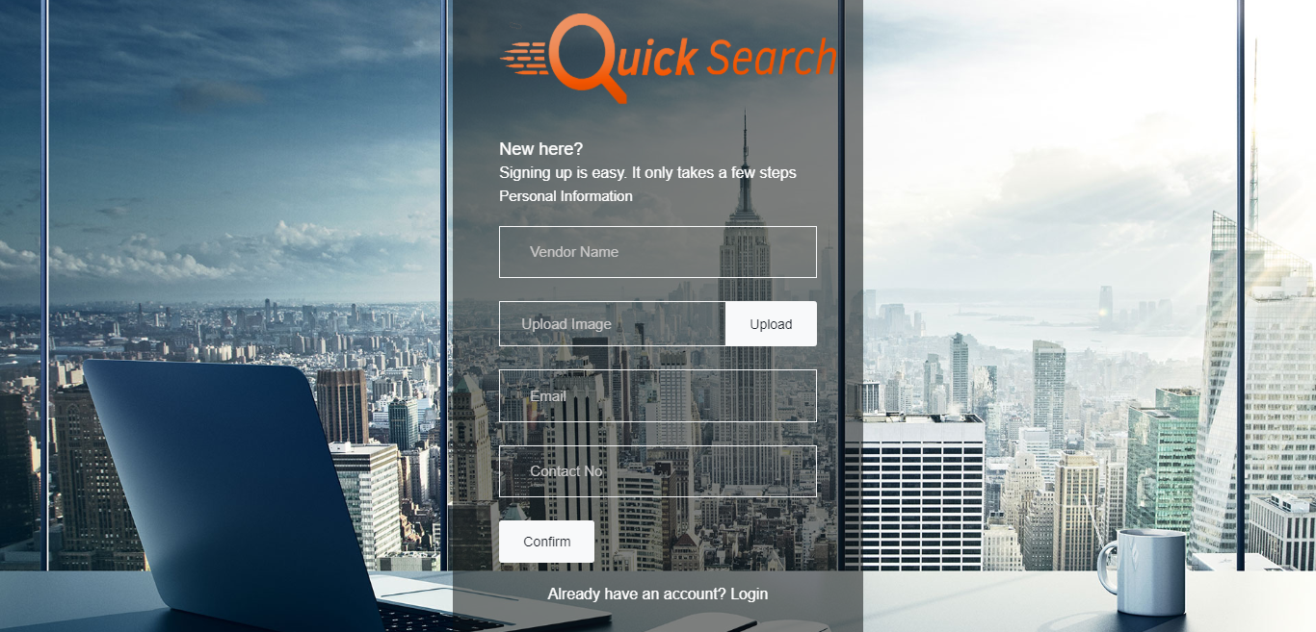

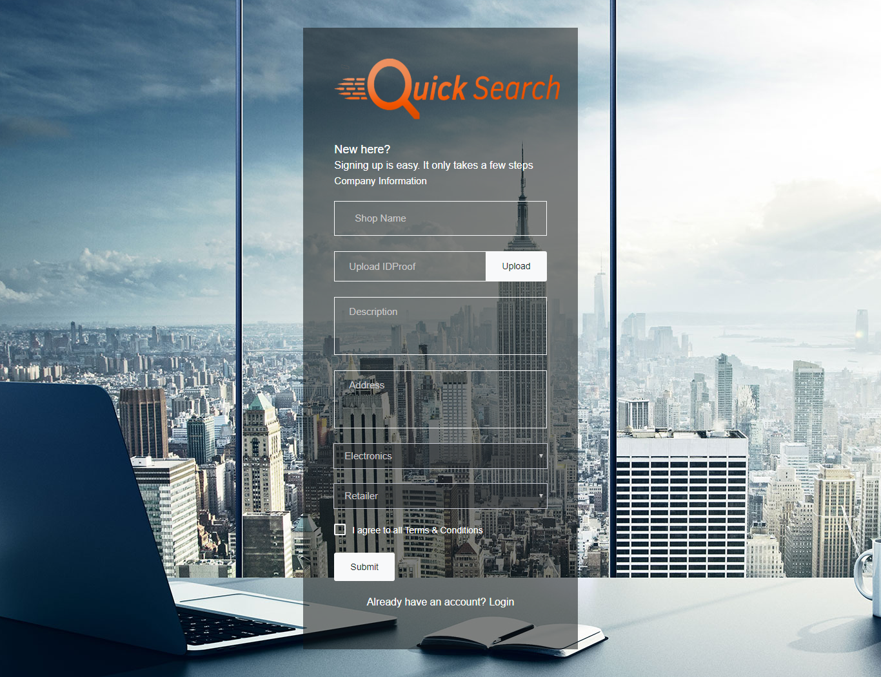

* **Vendor Dashboard**

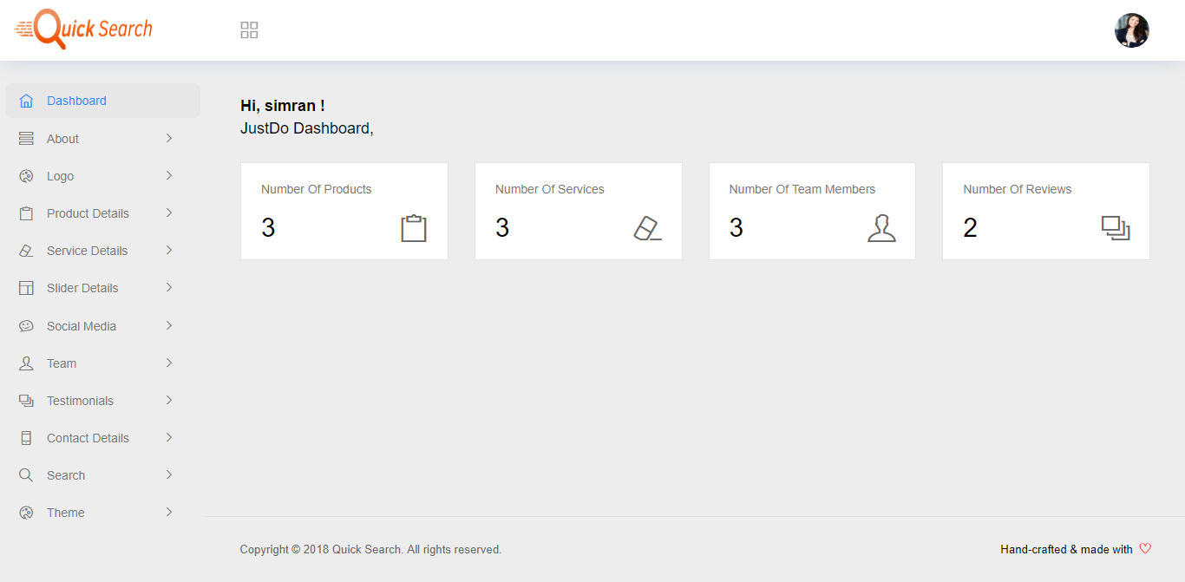

* **Change Password**

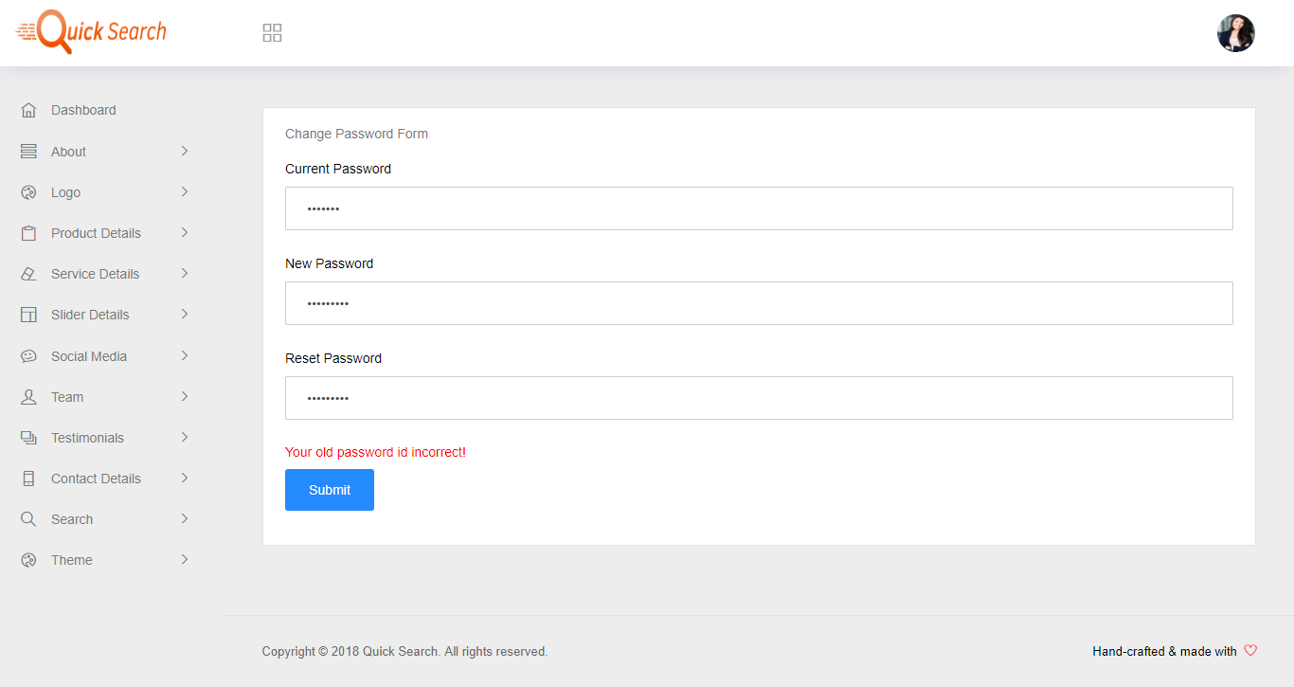

* **Edit Profile**

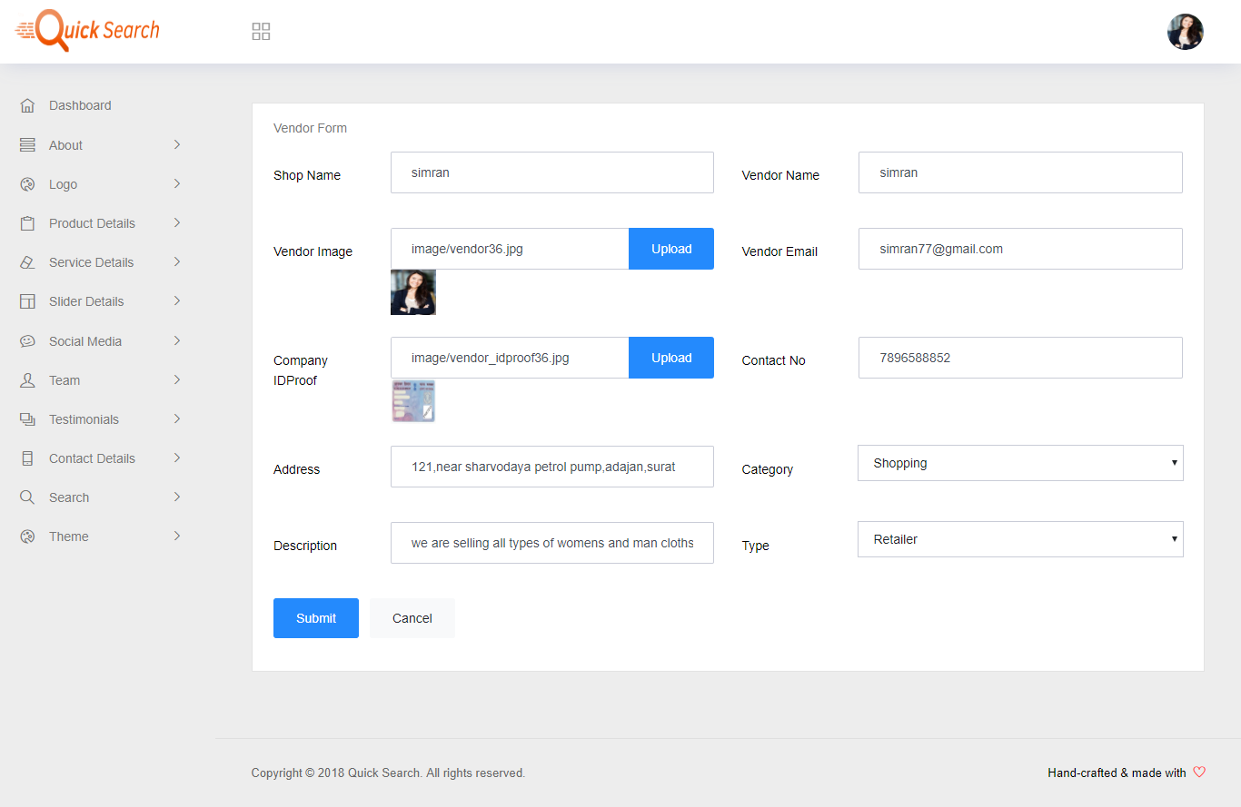

* **Update About**

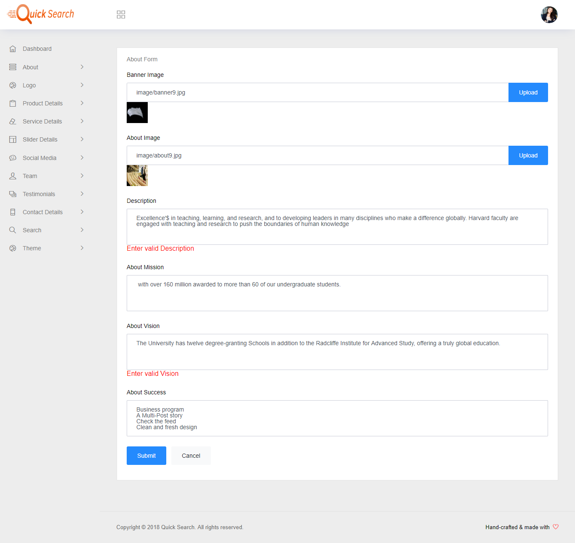

* **View About**

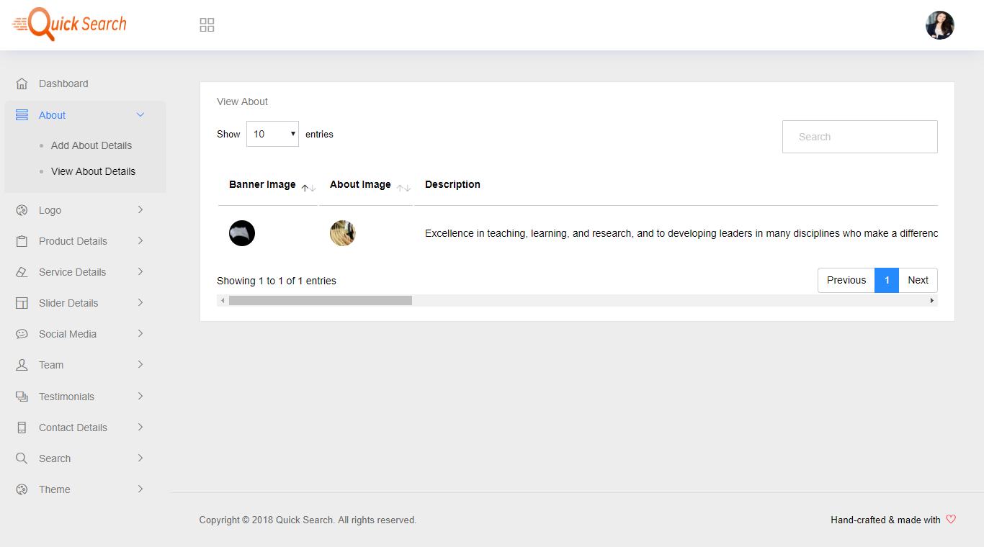

* **Update Logo**

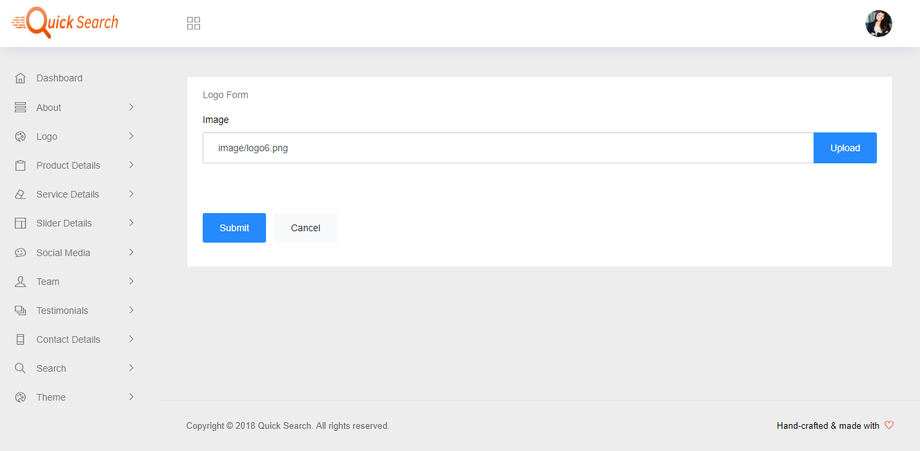

* **Add Product**

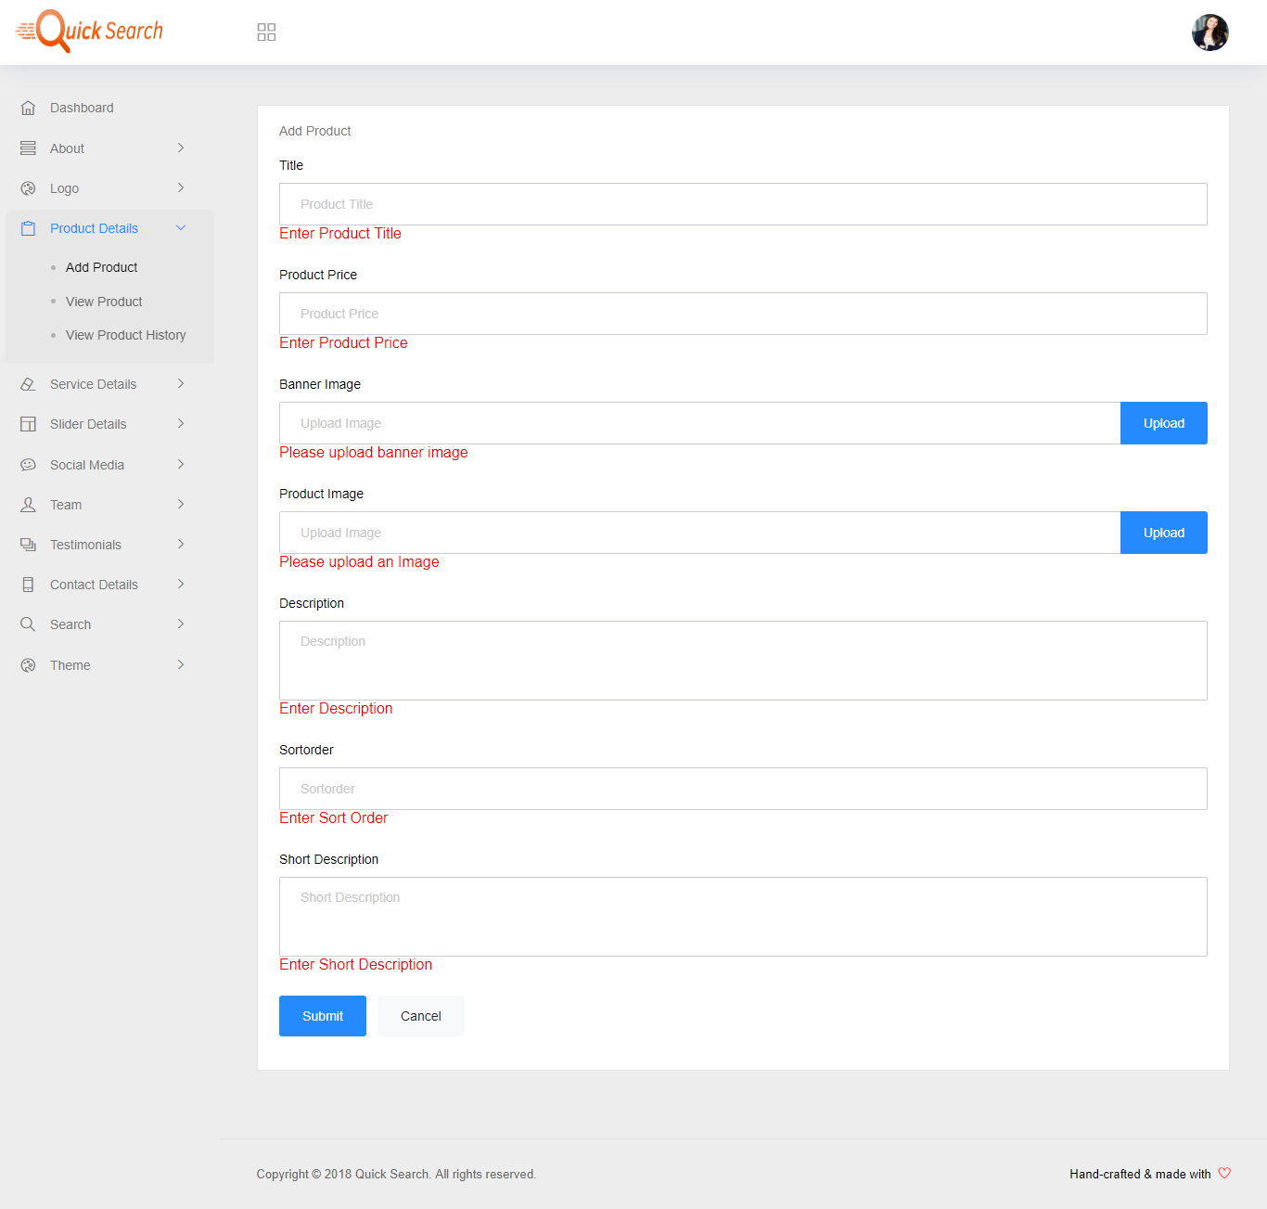

* **View Product**

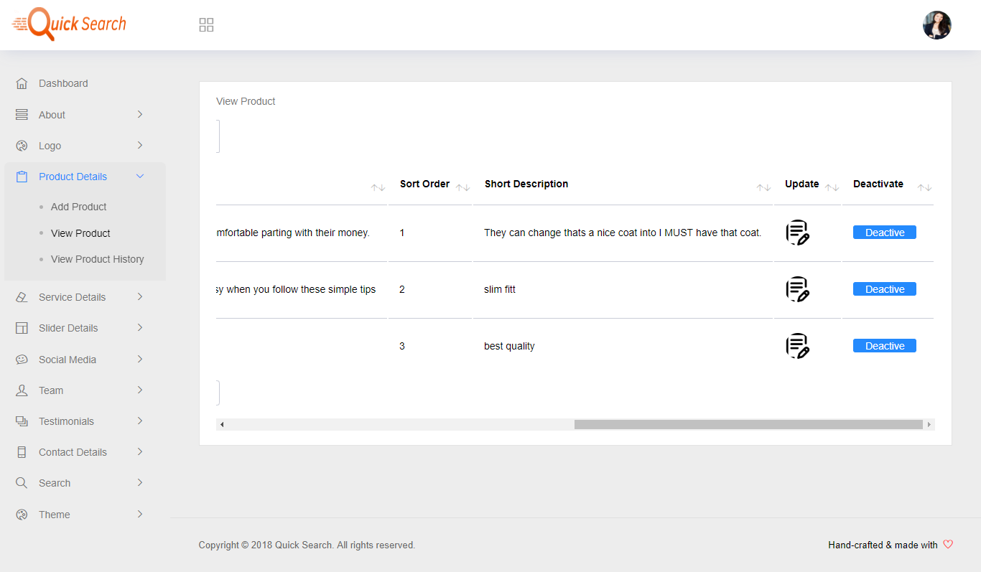

* **View Product History**

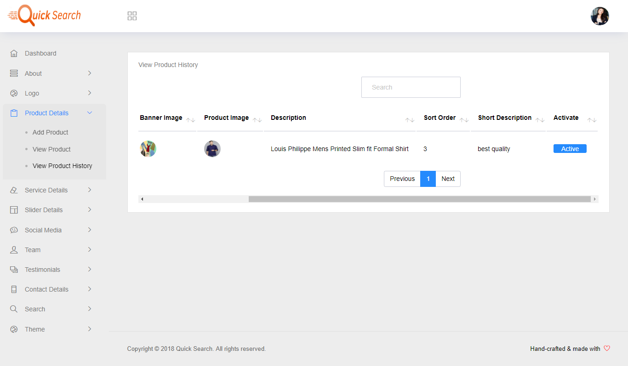

* **Update Service**

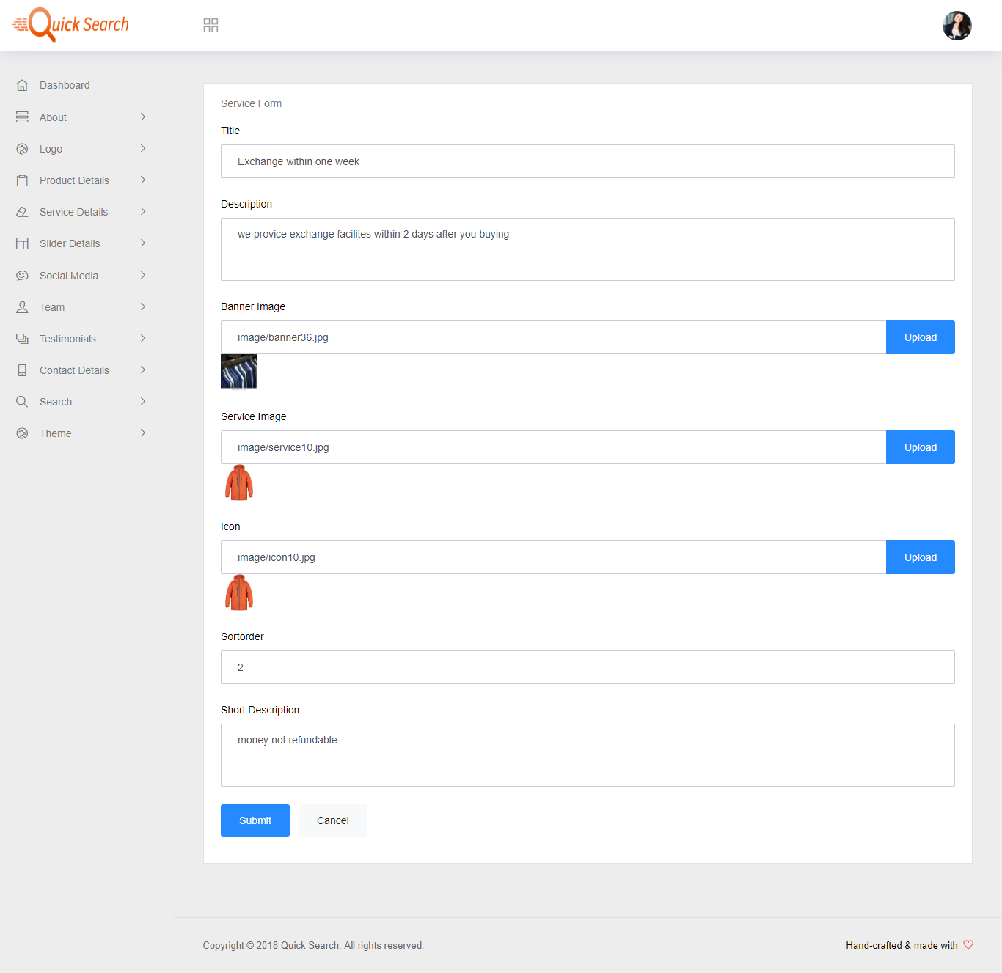

* **View Service**

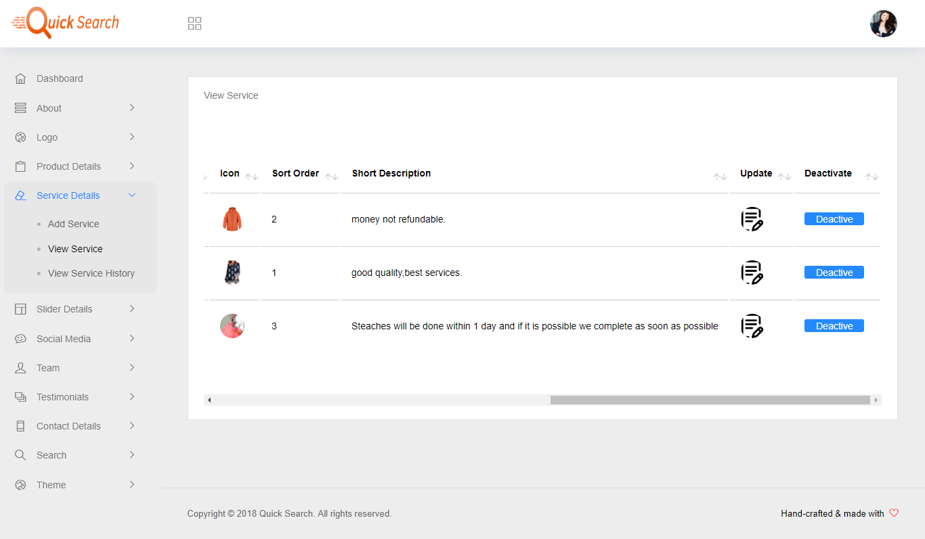

* **View Service History**

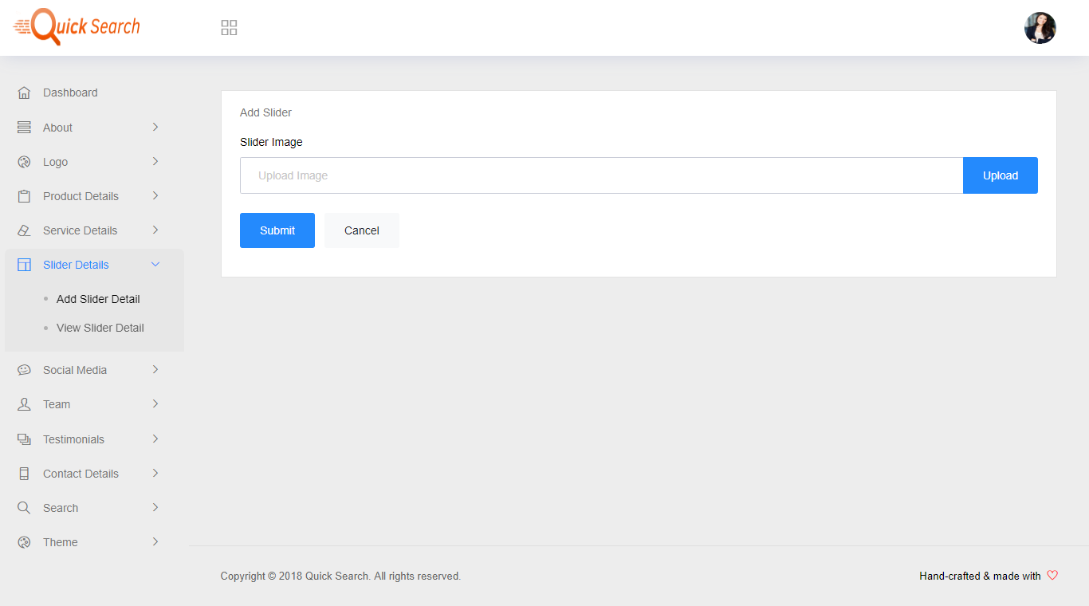

* **Update Social Media**

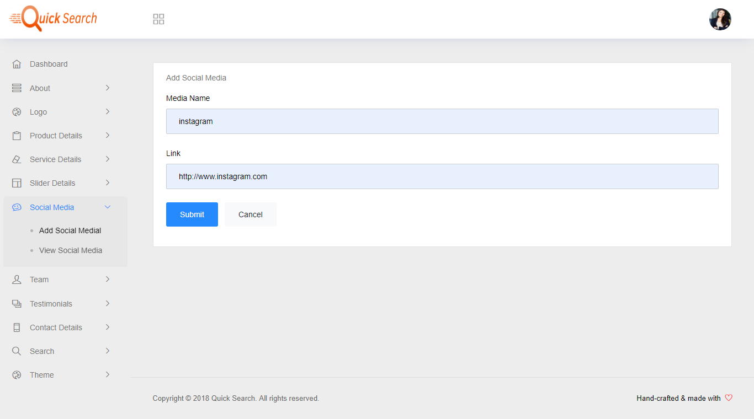

* **View Social Media**

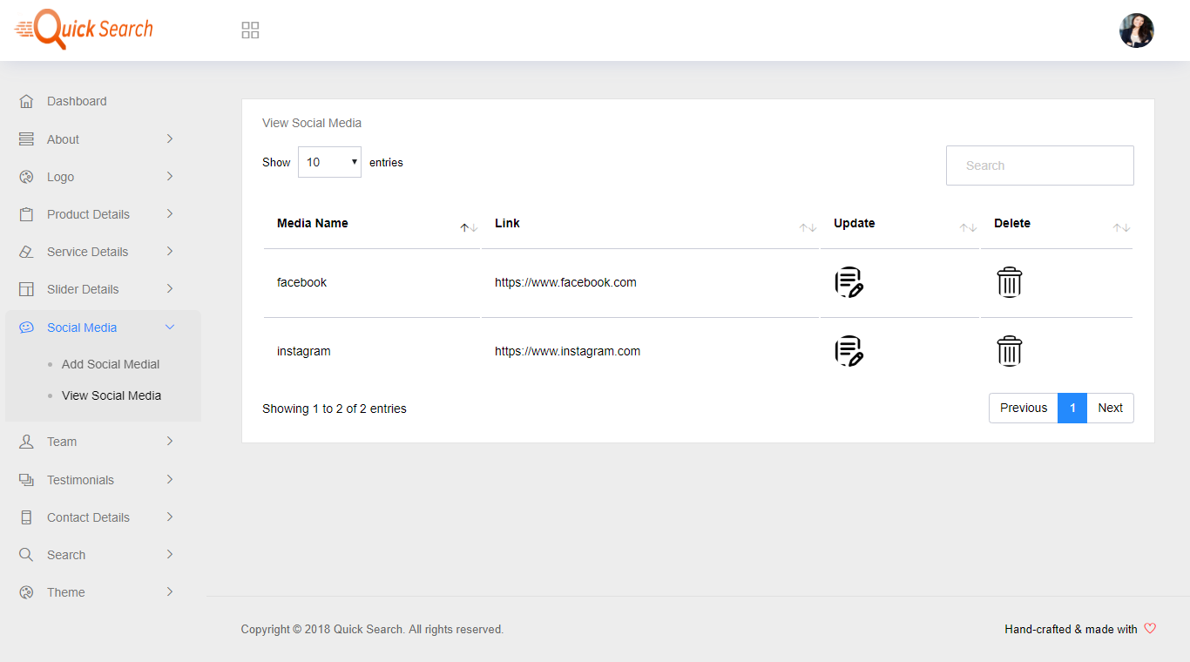

* **Update Team**

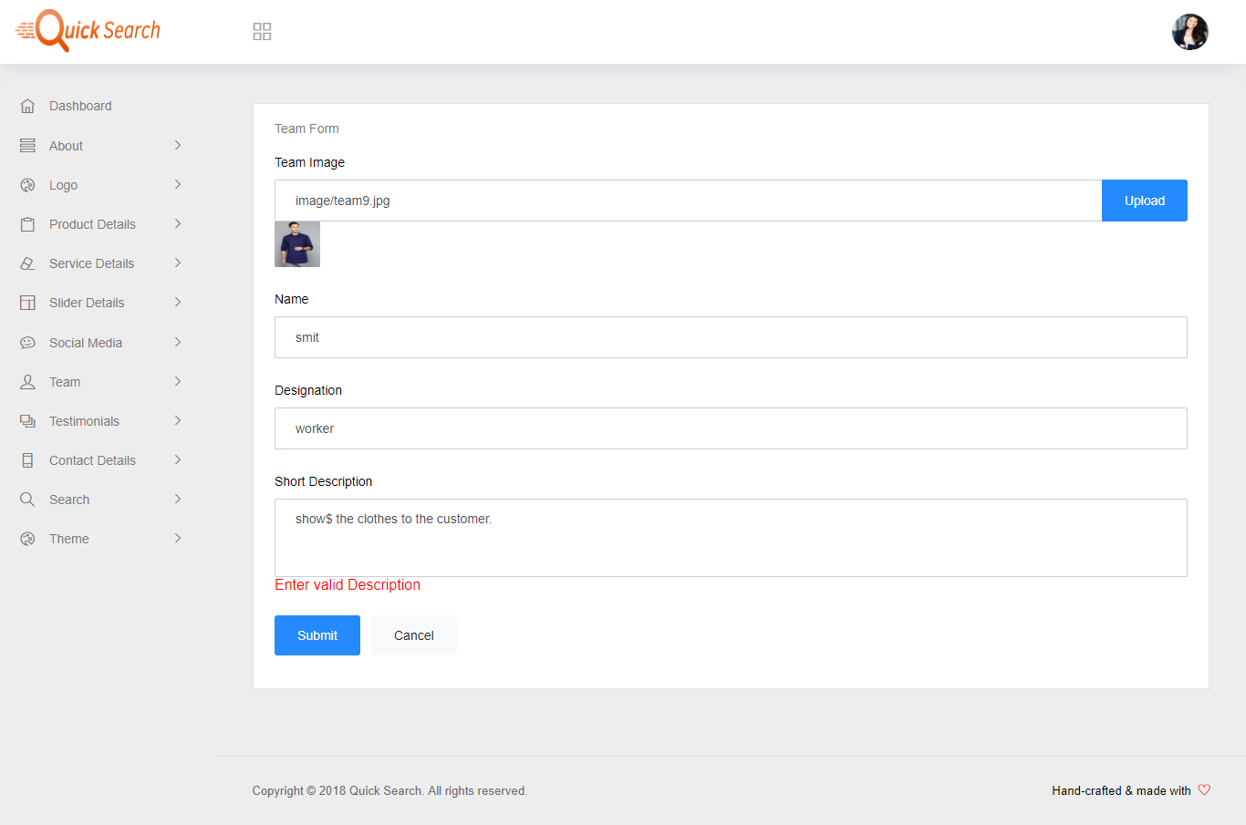

* **View Team**

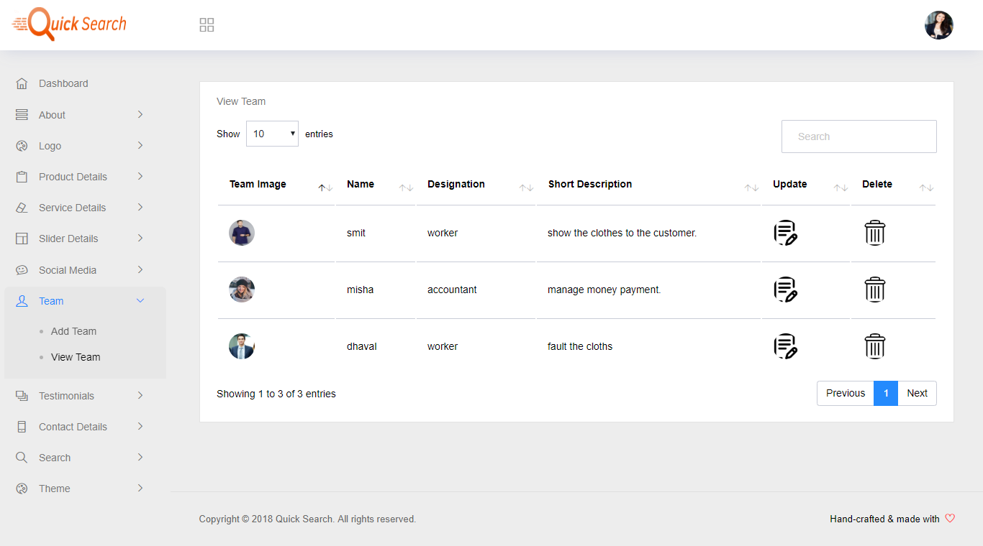

* **Add Testimonials**

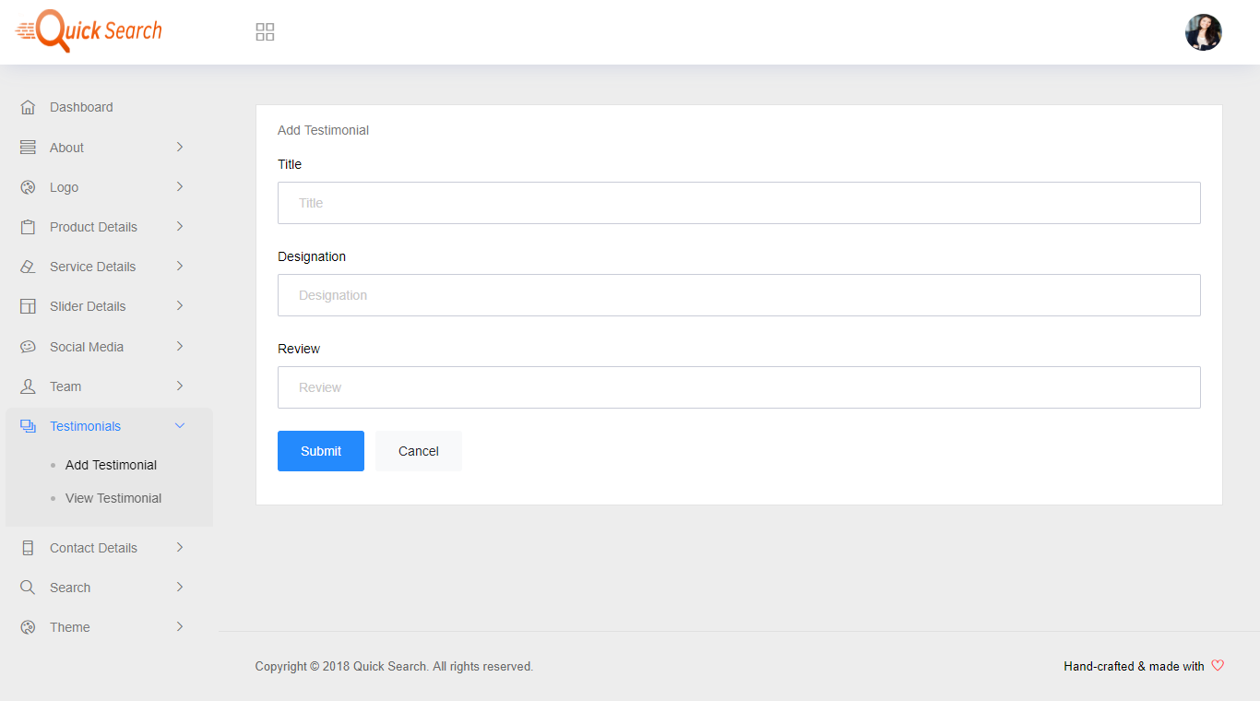

* **View Testimonials**

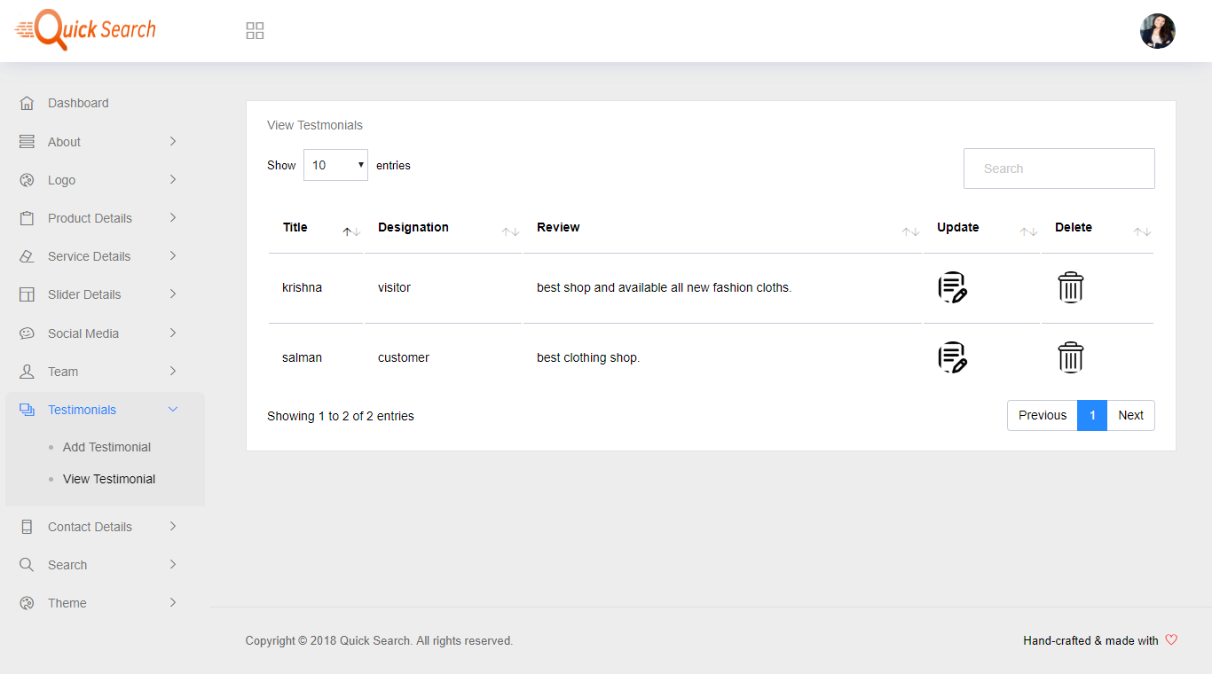

* **Add Contact**

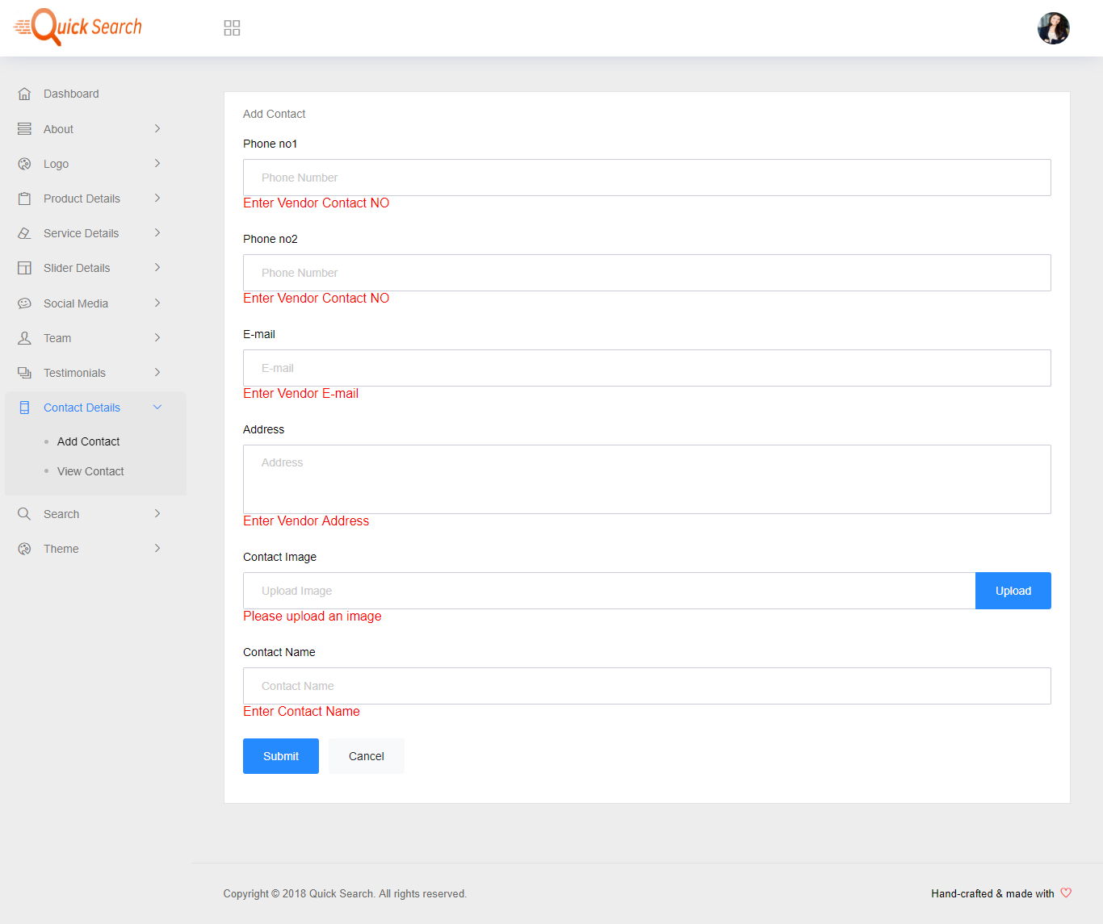

* **View Contact**

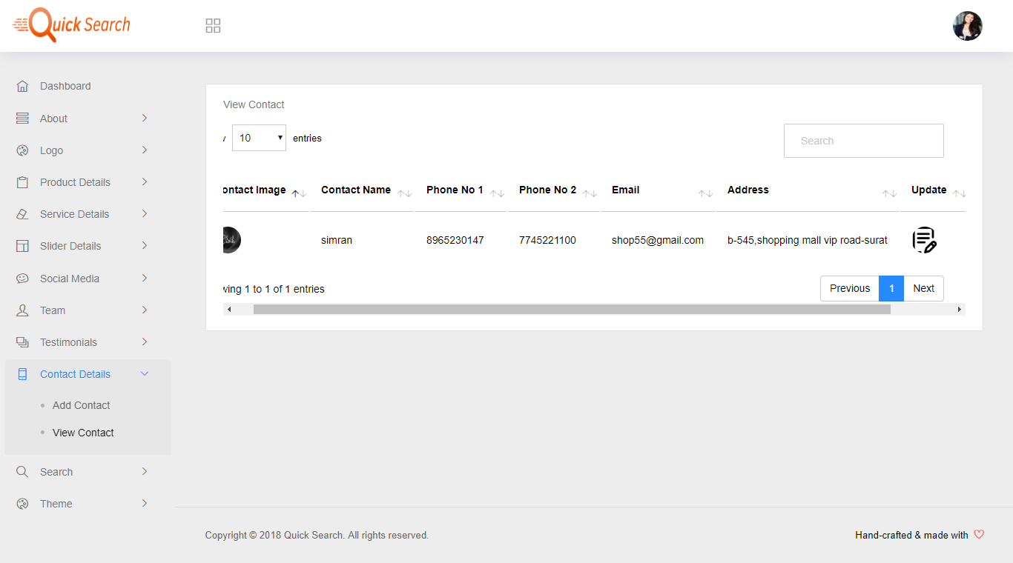

* **Add Search Details**

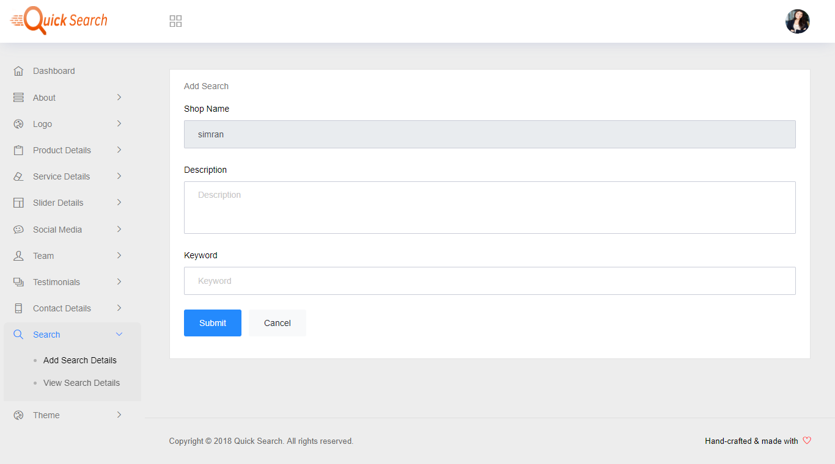

* **View Search Details**

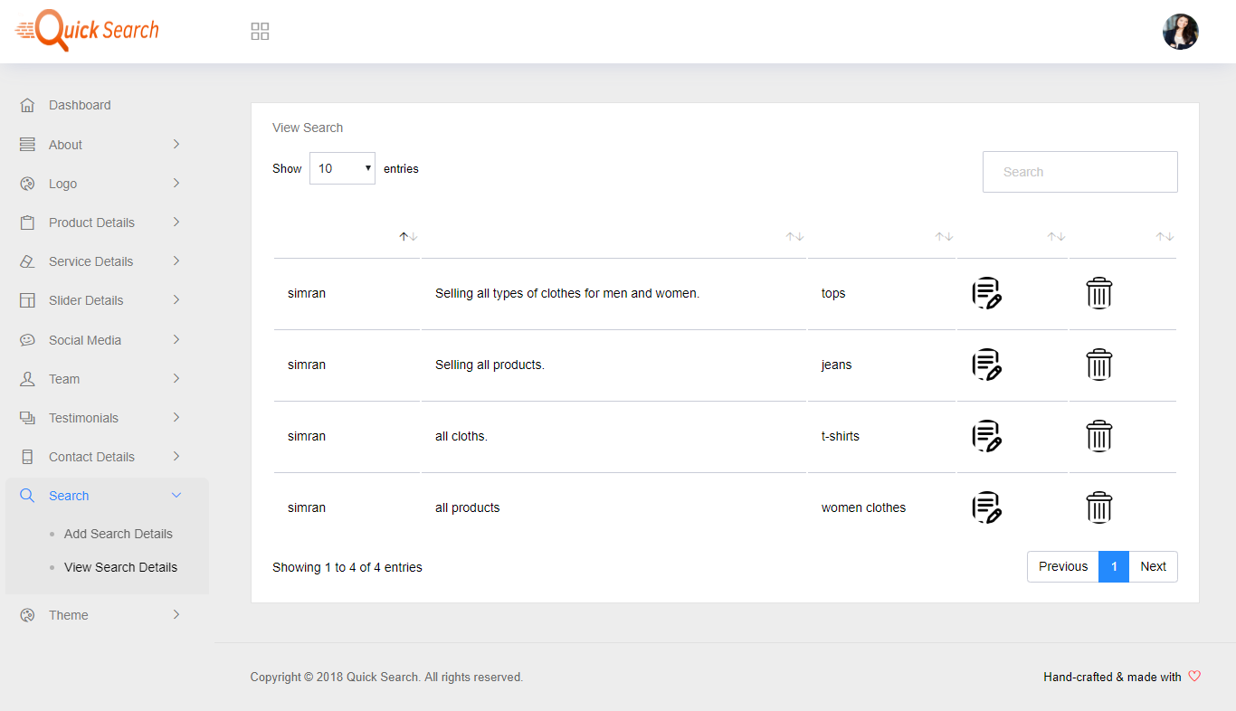

* **View Theme**

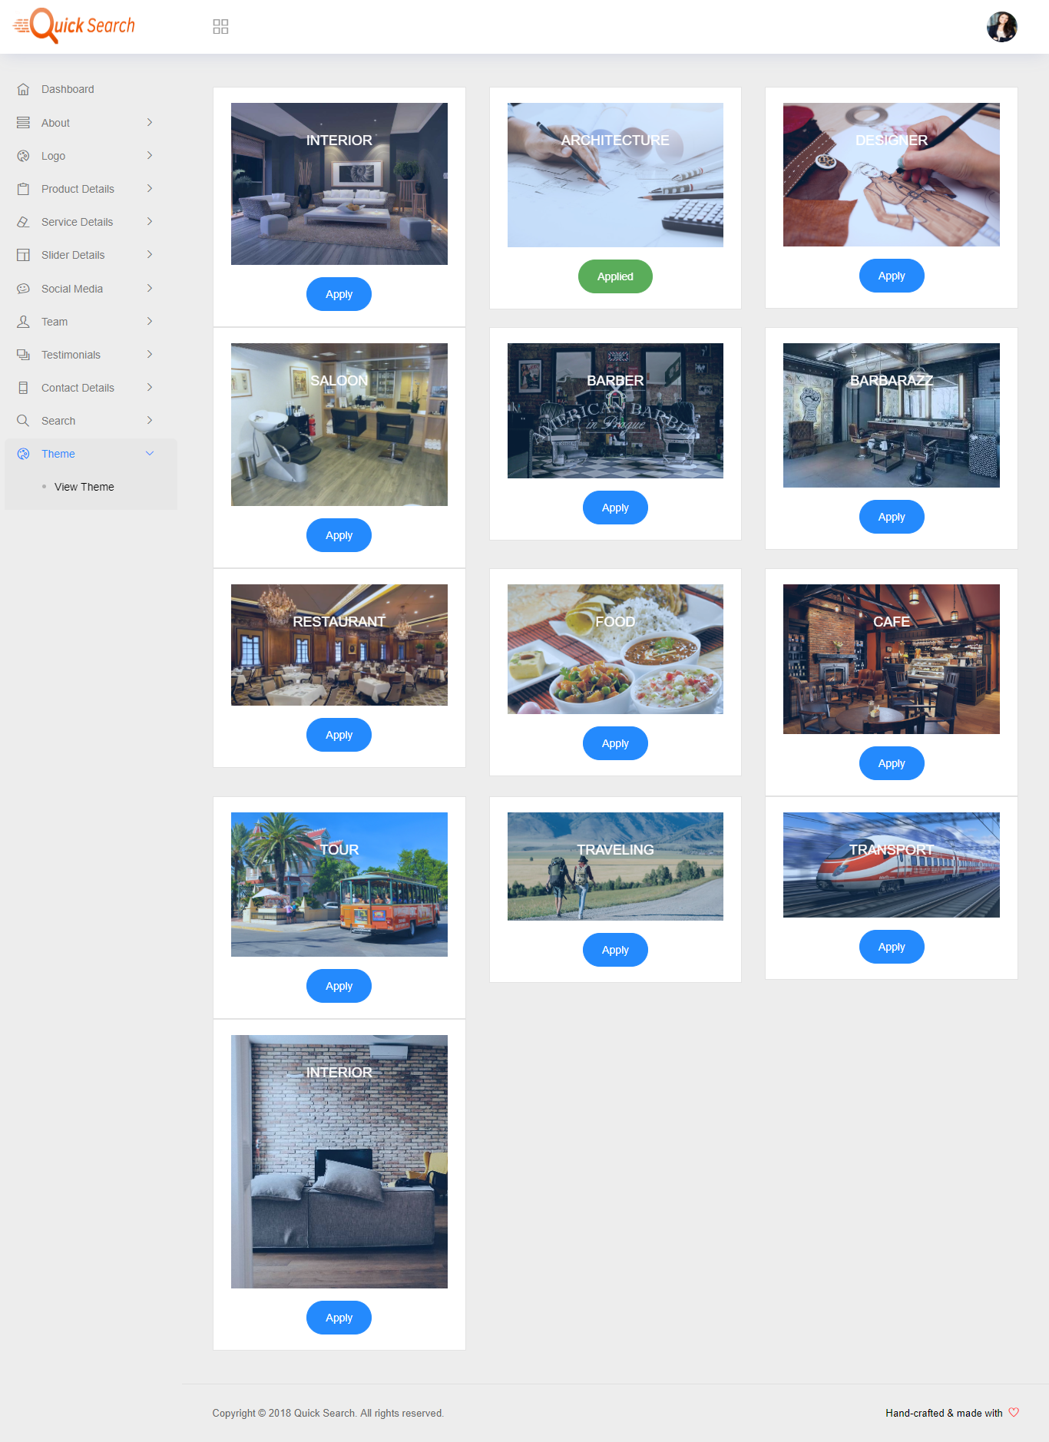

* **Client-Side**
* **User Registration**

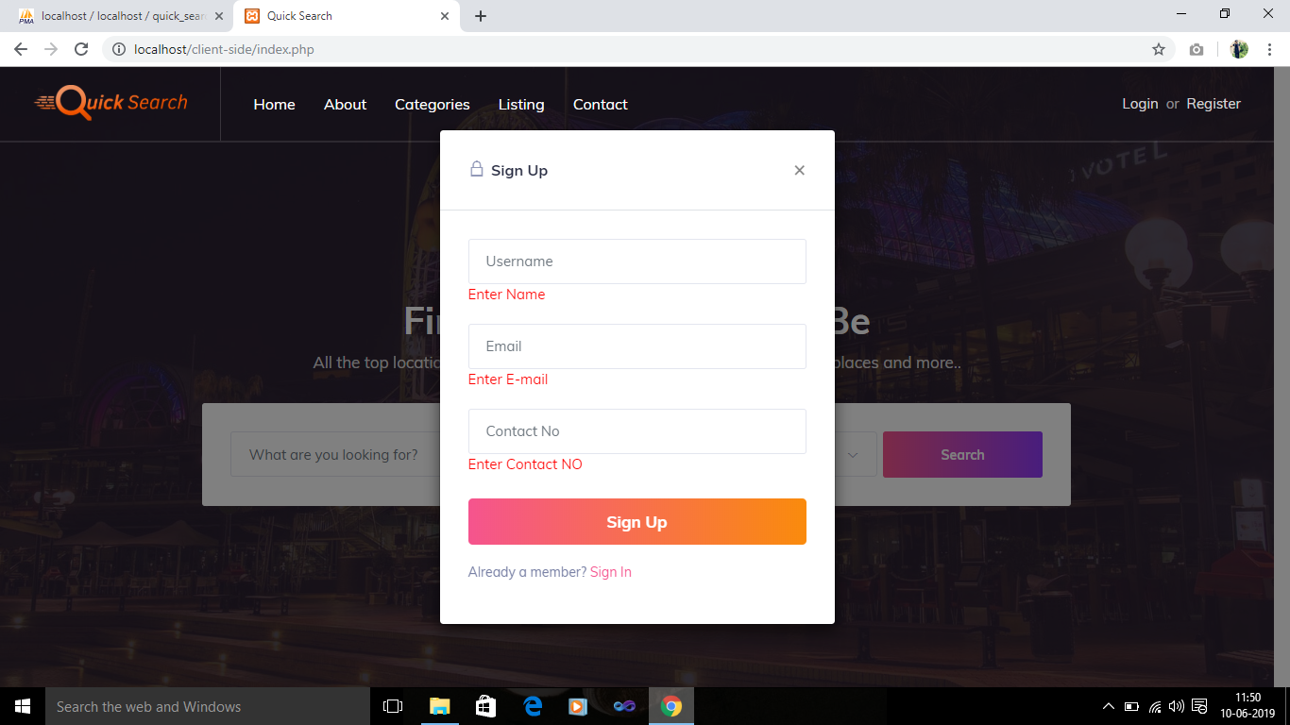

* **Login**

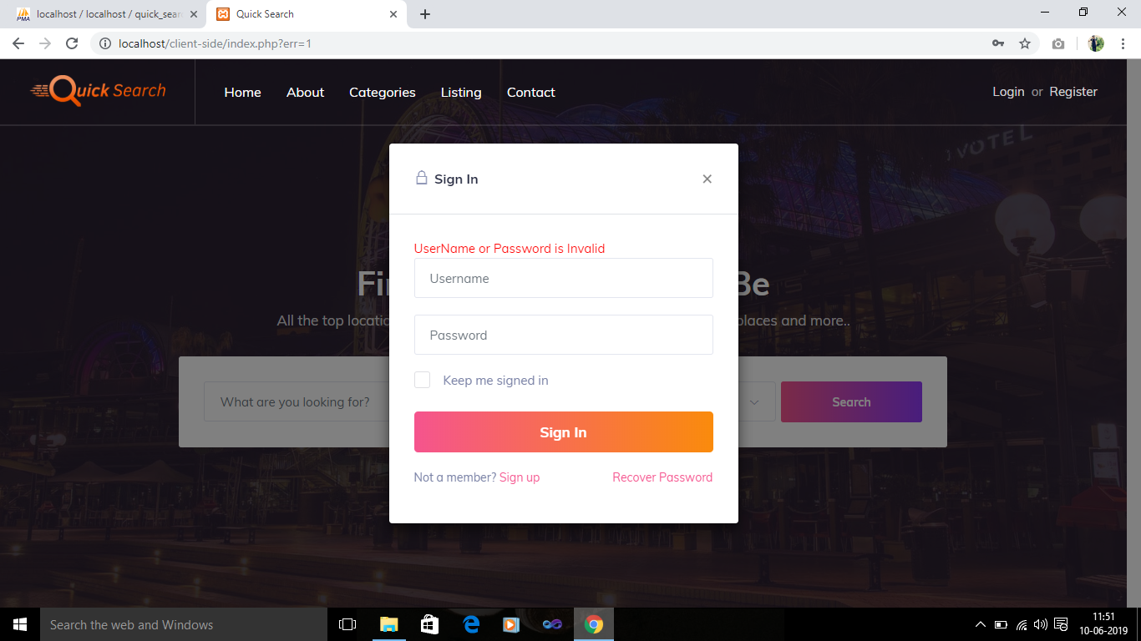

* **Forgot Password**

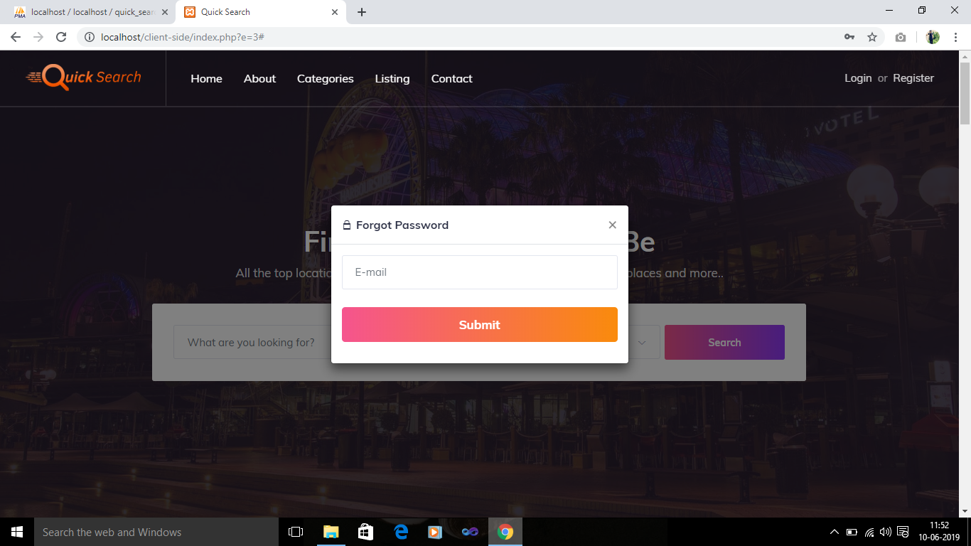

* **Home Page**

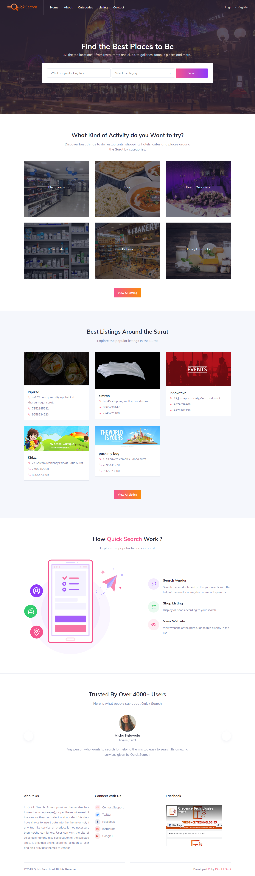

* **About Page**

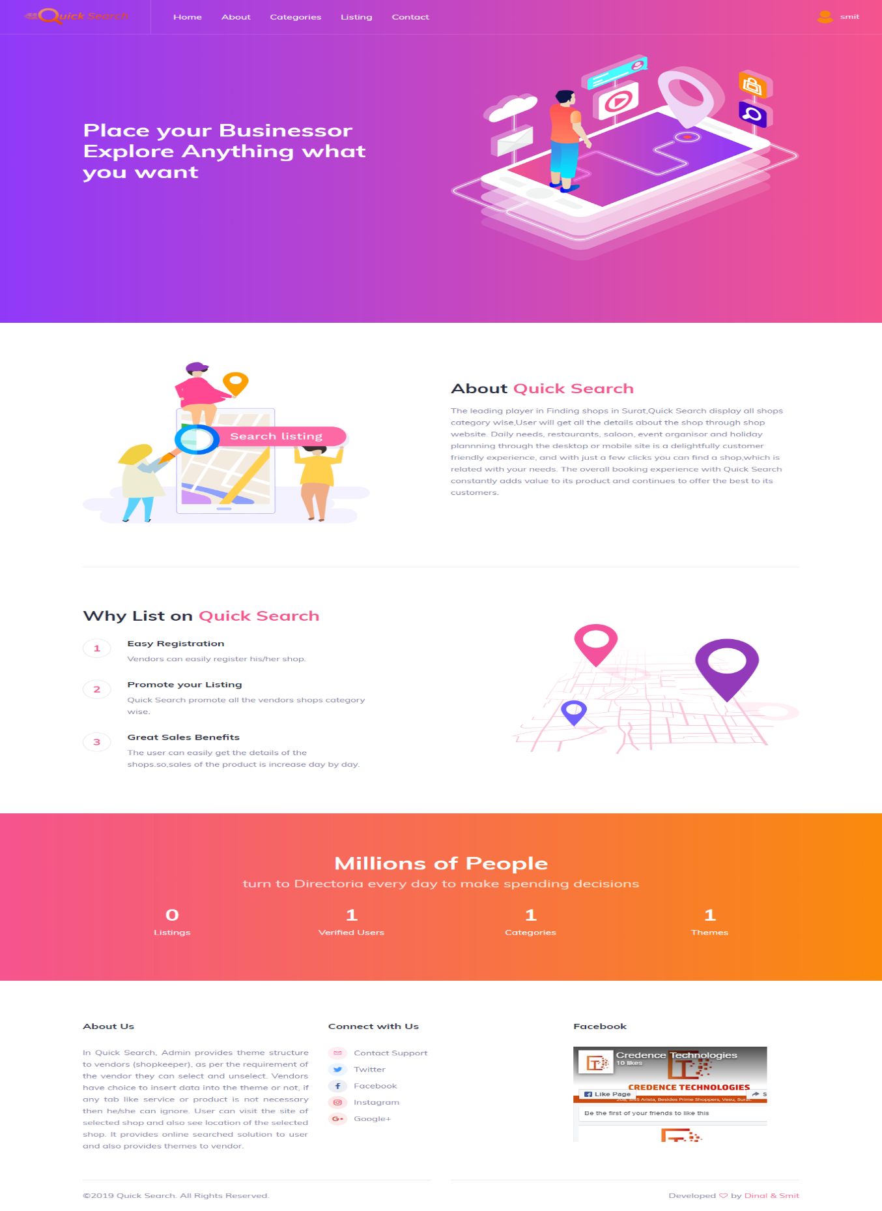

* **Category page**

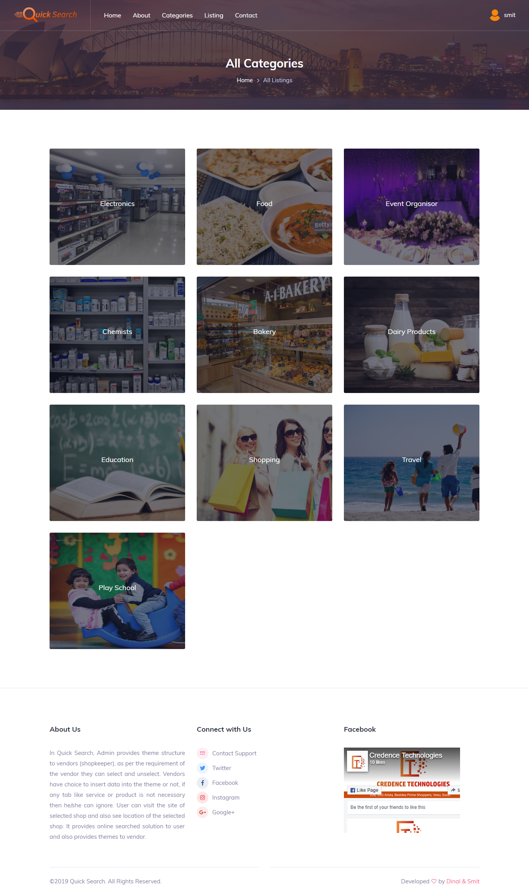

* **All Listings**

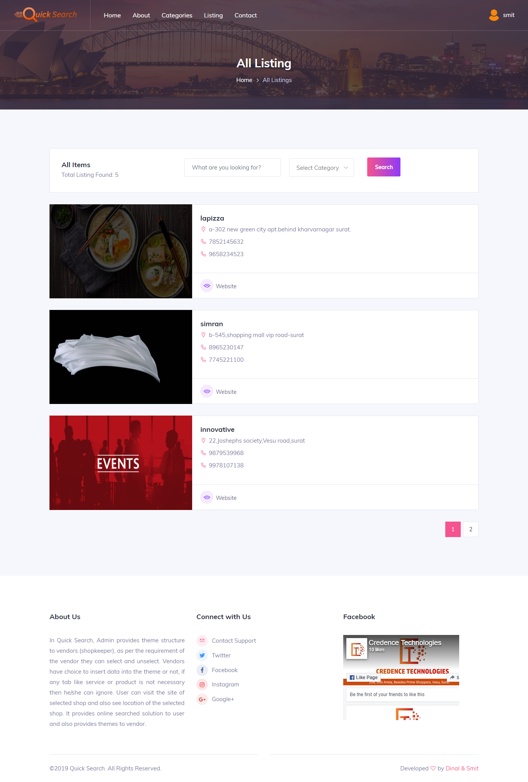

* **Search Listing**

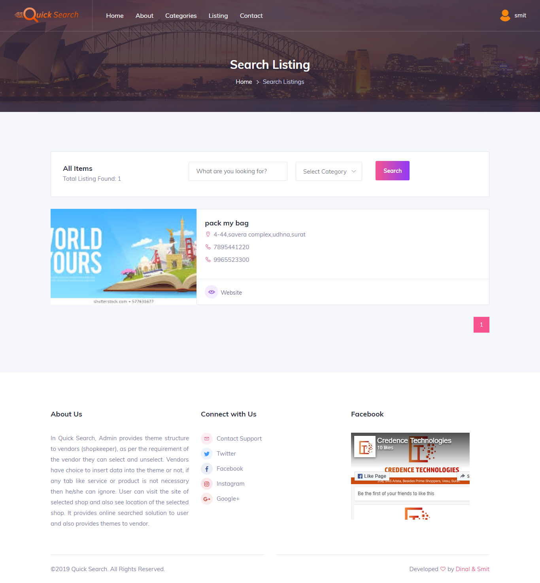

* **Vendor’s website home page**

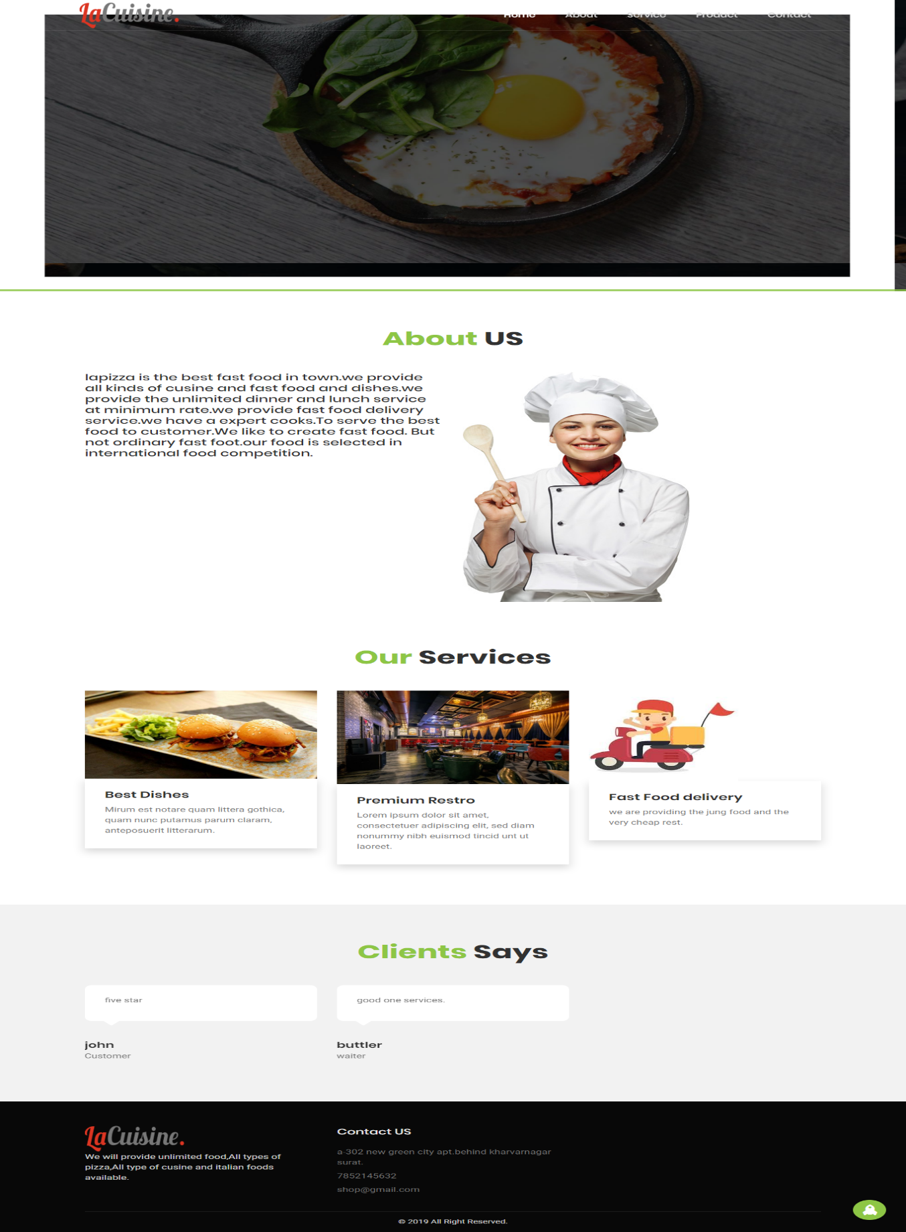

* **Vendor’s website about page**

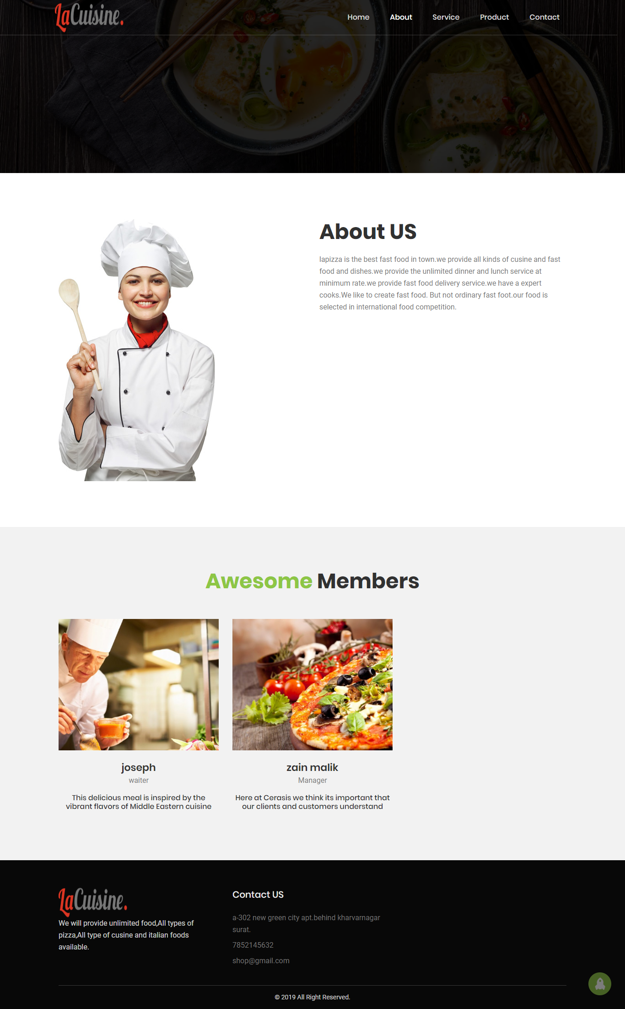

* **Vendor’s website service page**

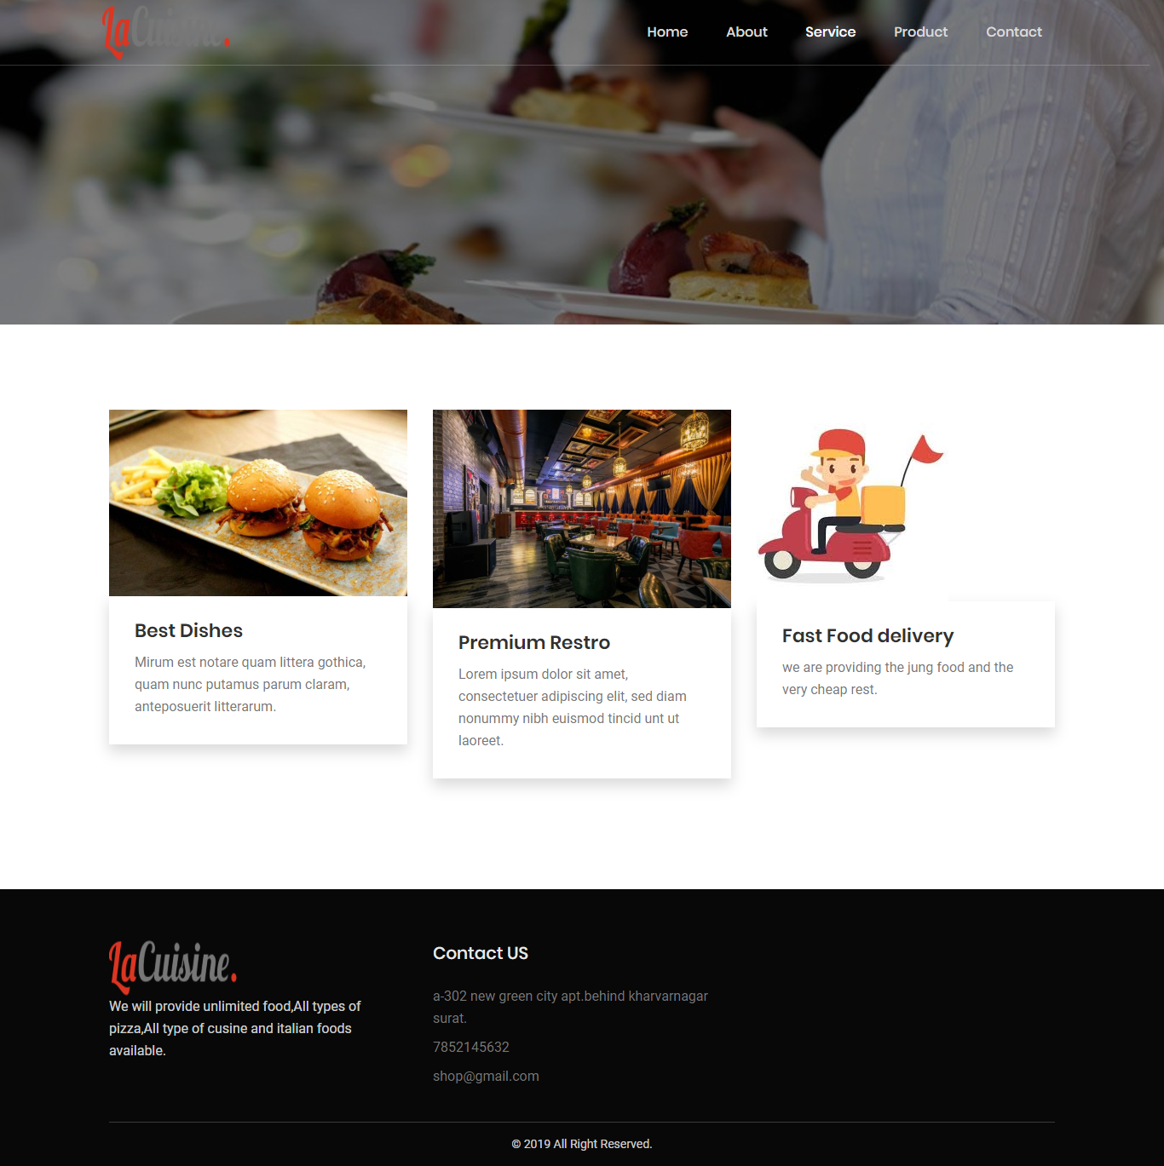

* **Vendor’s website product page**

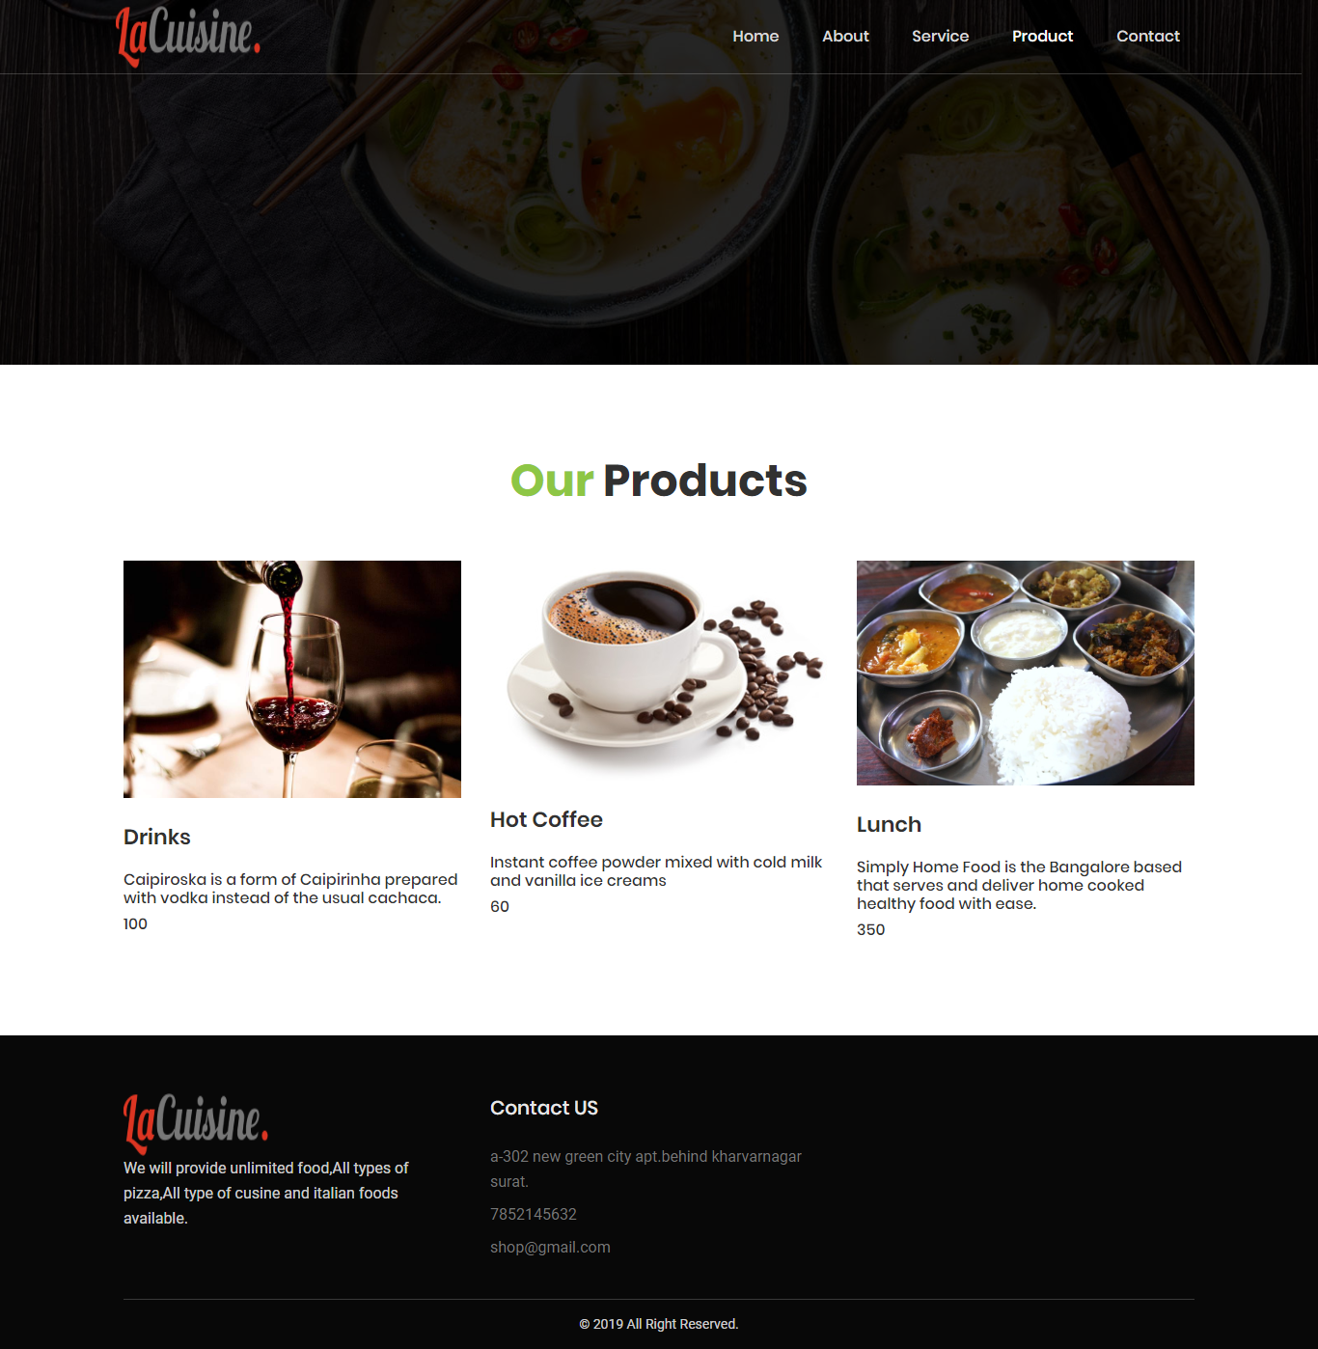

* **Vendor’s website contact page**

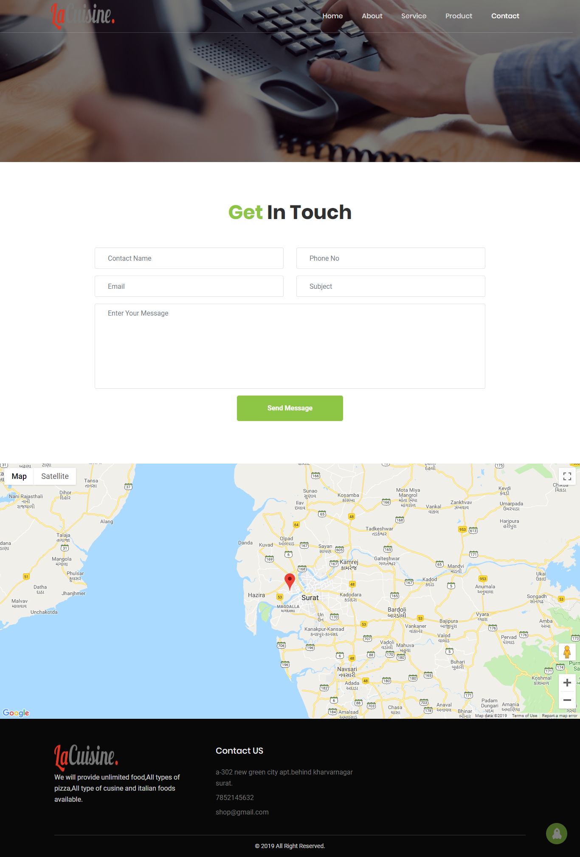

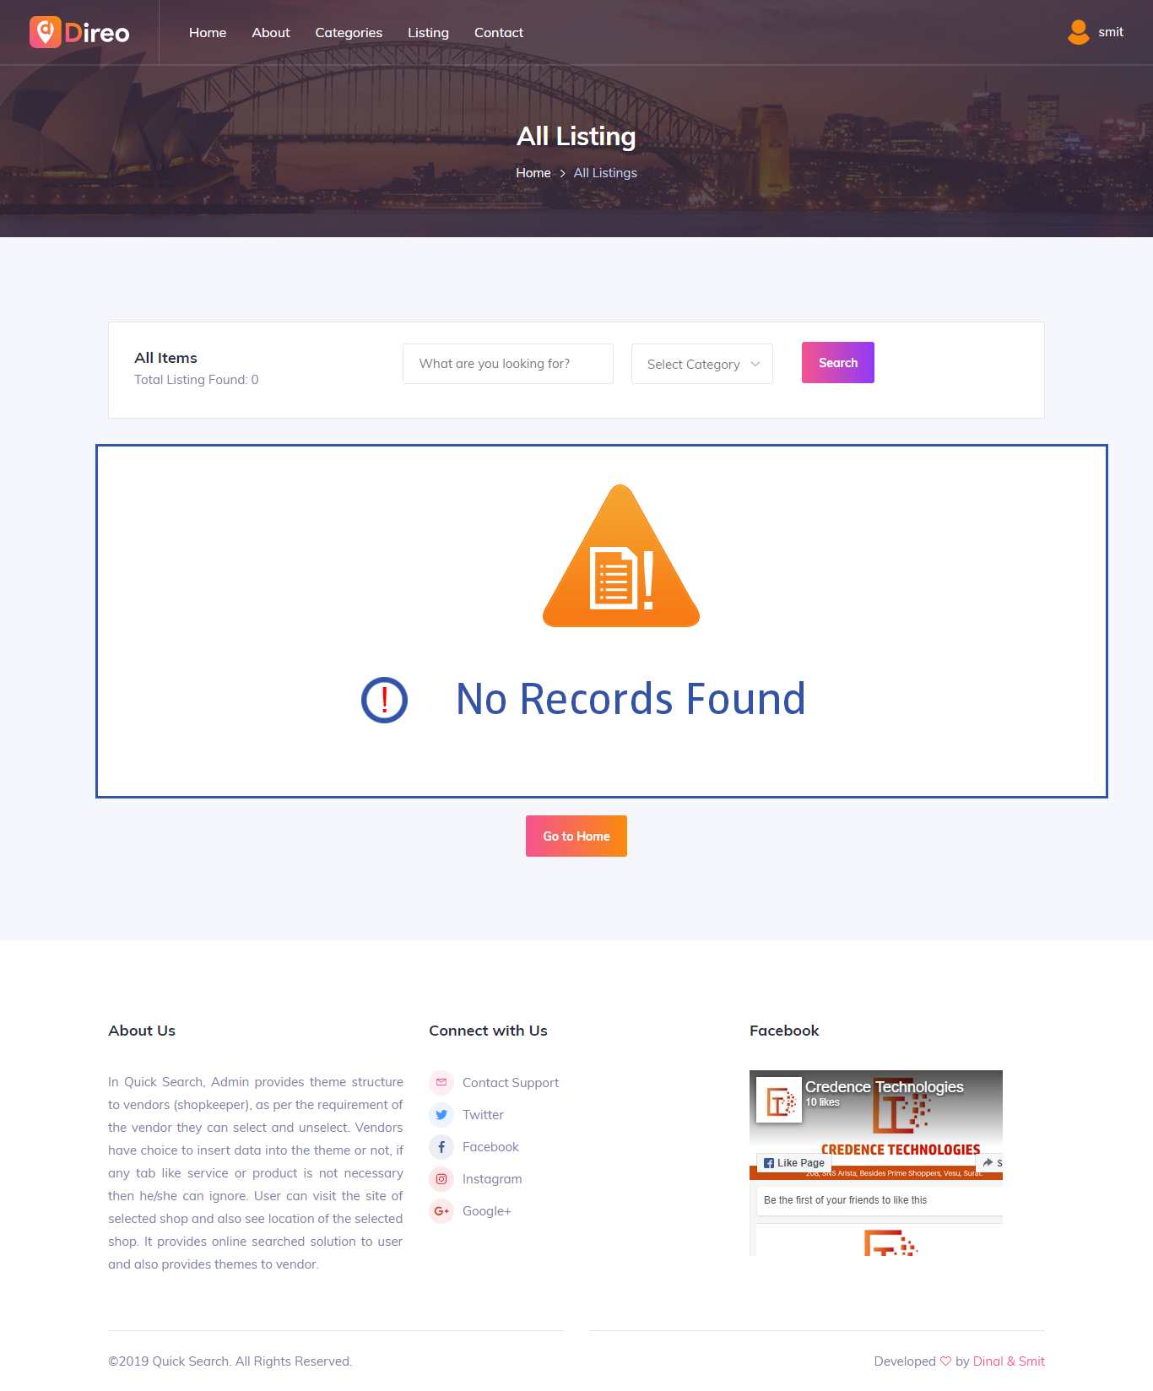

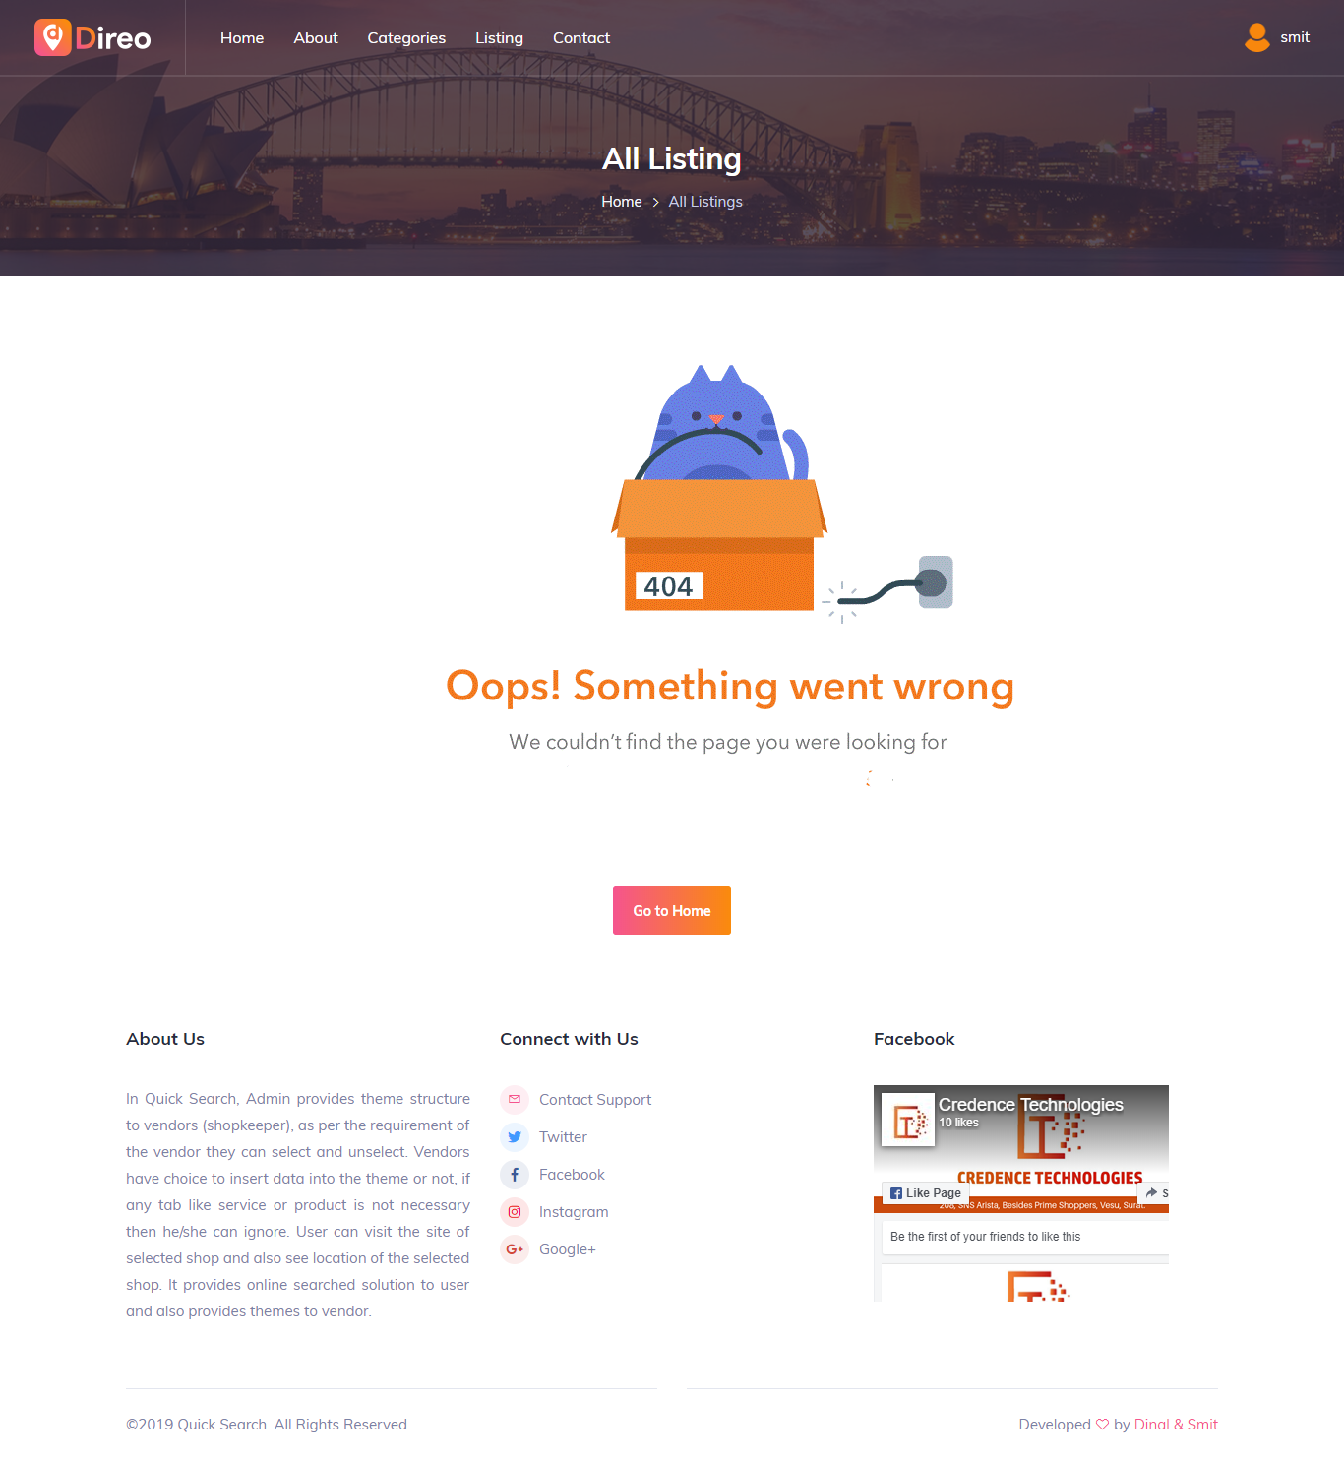

* **Contact Page**

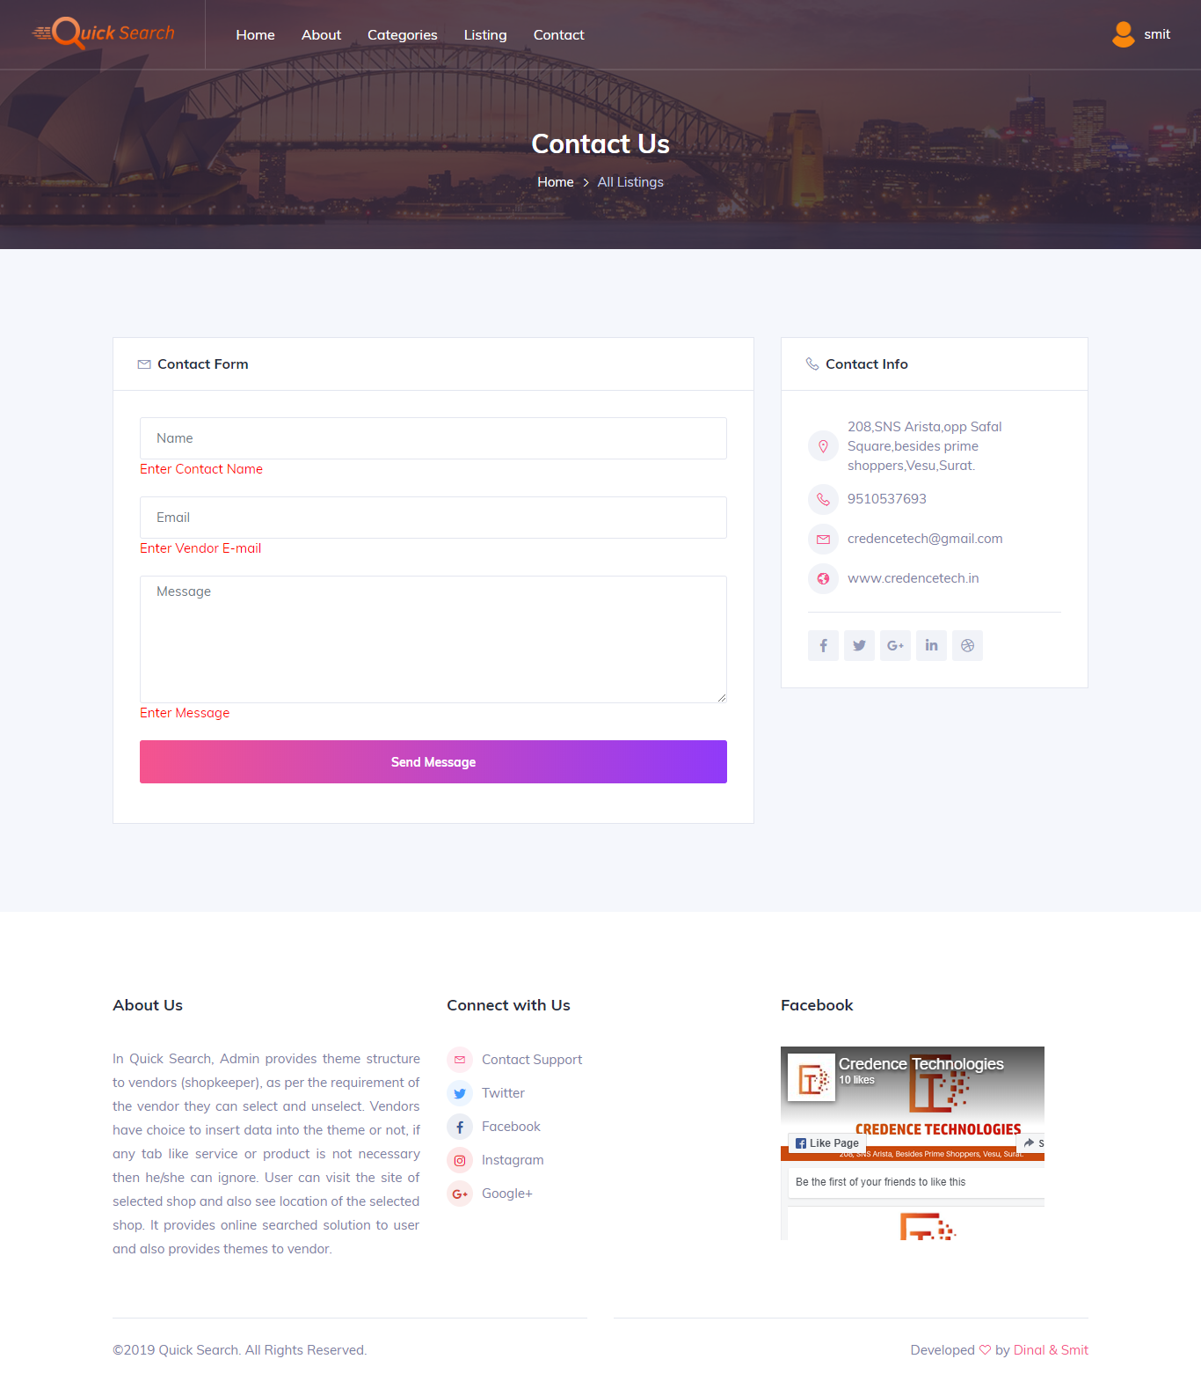

1. **TESTING**

7.1 Test Cases

7.1 Test Cases

* **Admin Side**
* **Login Page**

|  |  |  |  |  |
| --- | --- | --- | --- | --- |
| Sr.No. | Field Name | Valid | Invalid | Error Message |
| 1 | admin_name | Hita | Null | Enter admin name |
| 2 | admin_password | Hita123 | Null | Enter admin password |

* **Change Password**

|  |  |  |  |  |
| --- | --- | --- | --- | --- |
| **Sr.No.** | **Field Name** | **Valid** | **Invalid** | **Error Message** |
| 1 | Old password | Hita123 | Null | Enter password |
| 2 | New Password | Hita123 | Null | Enter Password |
| hita@12 | Enter valid password |
| 3 | Reset password | Hita | Null | Enter password |
| hita@12 | Enter valid password |

* **Add Theme**

|  |  |  |  |  |
| --- | --- | --- | --- | --- |
| **Sr.No.** | **Field Name** | **Valid** | **Invalid** | **Error Message** |
| 1 | Theme name | Restaurant | Restaurant123 | Enter valid theme |
| Null | Enter theme name |
| 2 | Theme url | Theme-1/index.php | Null | Enter theme url |
| theme@12 | Enter valid theme url |
| 3 | Theme icon | A1.jpg/png/jpeg/svg | Null | Please upload an icon |
| A1.xml | Icons only allow file types of gif,png,jpg,jpeg and bmp |
| 4 | Theme folder | Theme1.zip | Null | Please upload theme |
| Theme1.php |

* **Update Theme**

|  |  |  |  |  |
| --- | --- | --- | --- | --- |
| **Sr.No.** | **Field Name** | **Valid** | **Invalid** | **Error Message** |
| 1 | Theme name | Restaurant | Restaurant123 | Enter valid theme |
| Null | Enter theme name |
| 2 | Theme url | Theme-1/index.php | Null | Enter theme url |
| theme@12 | Enter valid theme url |
| 3 | Theme icon | A1.jpg/png/jpeg/svg | Null | Please upload an icon |
| A1.xml | Icons only allow file types of gif,png,jpg,jpeg and bmp |

* **Add Vendor**

|  |  |  |  |  |
| --- | --- | --- | --- | --- |
| **Sr.No.** | **Field Name** | **Valid** | **Invalid** | **Error Message** |
| 1 | Shop name | Pizza plaza | Pizza123 | Enter valid shop name |
| Null | Enter shop name |
| 2 | Vendor name | Ajay | Null | Enter vendor name |
| ajay@12 | Enter valid vendor name |
| 3 | Vendor image | A1.jpg/png/jpeg/svg | Null | Please upload an image |
| A1.xml | image only allow file types of gif,png,jpg,jpeg and bmp |
| 4 | Vendor email | [ajay@gmail.com](mailto:ajay@gmail.com) | Null | Enter vendor email |
| [123@abc.pqr](mailto:123@abc.pqr) | Enter valid vendor e-mail |
| 5 | Company IDproof | id.jpg/png/jpeg/svg | Null | Please upload an image |
| Id.zip | image only allow file types of gif,png,jpg,jpeg and bmp |
| 6 | Contact No | 8511870099 | Null | Enter vendor contact no |
| 123456 | Enter valid vendor contact no |
| 7 | Address | 2-565 shivam residency,surat | 2/12@bung” | Enter valid vendor address |
| Null | Enter vendor address |
| 8 | Description | We include all types of pizza | Null | Enter Description |
| We $$%%^^^ | Enter valid description |

* **Update Vendor**

|  |  |  |  |  |
| --- | --- | --- | --- | --- |
| **Sr.No.** | **Field Name** | **Valid** | **Invalid** | **Error Message** |
| 1 | Shop name | Pizza plaza | Pizza123 | Enter valid shop name |
| Null | Enter shop name |
| 2 | Vendor name | Ajay | Null | Enter vendor name |
| ajay@12 | Enter valid vendor name |
| 3 | Vendor image | A1.jpg/png/jpeg/svg | Null | Please upload an image |
| A1.xml | image only allow file types of gif,png,jpg,jpeg and bmp |
| 4 | Vendor email | [ajay@gmail.com](mailto:ajay@gmail.com) | Null | Enter vendor email |
| [123@abc.pqr](mailto:123@abc.pqr) | Enter valid vendor e-mail |
| 5 | Company IDproof | id.jpg/png/jpeg/svg | Null | Please upload an image |
| Id.zip | image only allow file types of gif,png,jpg,jpeg and bmp |
| 6 | Contact No | 8511870099 | Null | Enter vendor contact no |
| 123456 | Enter valid vendor contact no |
| 7 | Address | 2-565 shivam residency,surat | 2/12@bung” | Enter valid vendor address |
| Null | Enter vendor address |
| 8 | Description | We include all types of pizza | Null | Enter Description |
| We $$%%^^^ | Enter valid description |

* **Add Business Category**

|  |  |  |  |  |
| --- | --- | --- | --- | --- |
| **Sr.No.** | **Field Name** | **Valid** | **Invalid** | **Error Message** |
| 1 | category name | food | food123 | Enter valid category |
| Null | Enter category name |
| 2 | Category image | A1.jpg/png/jpeg/svg | Null | Enter category image |
| A1.xml | image only allow file types of gif,png,jpg,jpeg and bmp |

* **Update Business Category**

|  |  |  |  |  |
| --- | --- | --- | --- | --- |
| **Sr.No.** | **Field Name** | **Valid** | **Invalid** | **Error Message** |
| 1 | category name | food | food123 | Enter valid category |
| Null | Enter category name |
| 2 | Category image | A1.jpg/png/jpeg/svg | Null | Enter category image |
| A1.xml | image only allow file types of gif,png,jpg,jpeg and bmp |

* **Add Business Type**

|  |  |  |  |  |
| --- | --- | --- | --- | --- |
| **Sr.No.** | **Field Name** | **Valid** | **Invalid** | **Error Message** |
| 1 | Business type | retailer | wholesale123 | Enter valid business type |
| Null | Enter business type |

* **Update Business Type**

|  |  |  |  |  |
| --- | --- | --- | --- | --- |
| **Sr.No.** | **Field Name** | **Valid** | **Invalid** | **Error Message** |
| 1 | Business type | retailer | wholesale123 | Enter valid business type |
| Null | Enter business type |

* **Vendor side**
* **Registration Page**

|  |  |  |  |  |
| --- | --- | --- | --- | --- |
| **Sr.No.** | **Field Name** | **Valid** | **Invalid** | **Error Message** |
| 1 | Shop name | Pizza plaza | Pizza123 | Enter valid shop name |
| Null | Enter shop name |
| 2 | Vendor name | Ajay | Null | Enter vendor name |
| ajay@12 | Enter valid vendor name |
| 3 | Vendor image | A1.jpg/png/jpeg/svg | Null | Please upload an image |
| A1.xml | image only allow file types of gif,png,jpg,jpeg and bmp |
| 4 | Vendor email | [ajay@gmail.com](mailto:ajay@gmail.com) | Null | Enter vendor email |
| [123@abc.pqr](mailto:123@abc.pqr) | Enter valid vendor e-mail |
| 5 | Company IDproof | id.jpg/png/jpeg/svg | Null | Please upload an image |
| Id.zip | image only allow file types of gif,png,jpg,jpeg and bmp |
| 6 | Contact No | 8511870099 | Null | Enter vendor contact no |
| 123456 | Enter valid vendor contact no |
| 7 | Address | 2-565 shivam residency,surat | 2/12@bung” | Enter valid vendor address |
| Null | Enter vendor address |
| 8 | Description | We include all types of pizza | Null | Enter Description |
| We $$%%^^^ | Enter valid description |

* **Login Page**

|  |  |  |  |  |
| --- | --- | --- | --- | --- |
| **Sr.No.** | **Field Name** | **Valid** | **Invalid** | **Error Message** |
| 1 | Vendor name | Hita | Null | Enter vendor name |
| 2 | Vendor password | Hita123 | Null | Enter vendor password |

* **Change Password**

|  |  |  |  |  |
| --- | --- | --- | --- | --- |
| **Sr.No.** | **Field Name** | **Valid** | **Invalid** | **Error Message** |
| 1 | Old password | Hita123 | Null | Enter password |
| 2 | New Password | Hita123 | Null | Enter Password |
| hita@12 | Enter valid password |
| 3 | Reset password | Hita | Null | Enter password |
| hita@12 | Enter valid password |

* **Edit Profile**

|  |  |  |  |  |
| --- | --- | --- | --- | --- |
| **Sr.No.** | **Field Name** | **Valid** | **Invalid** | **Error Message** |
| 1 | Shop name | Pizza plaza | Pizza123 | Enter valid shop name |
| Null | Enter shop name |
| 2 | Vendor name | Ajay | Null | Enter vendor name |
| ajay@12 | Enter valid vendor name |
| 3 | Vendor image | A1.jpg/png/jpeg/svg | Null | Please upload an image |
| A1.xml | image only allow file types of gif,png,jpg,jpeg and bmp |
| 4 | Vendor email | [ajay@gmail.com](mailto:ajay@gmail.com) | Null | Enter vendor email |
| [123@abc.pqr](mailto:123@abc.pqr) | Enter valid vendor e-mail |
| 5 | Company IDproof | id.jpg/png/jpeg/svg | Null | Please upload an image |
| Id.zip | image only allow file types of gif,png,jpg,jpeg and bmp |
| 6 | Contact No | 8511870099 | Null | Enter vendor contact no |
| 123456 | Enter valid vendor contact no |
| 7 | Address | 2-565 shivam residency,surat | 2/12@bung” | Enter valid vendor address |
| Null | Enter vendor address |
| 8 | Description | We include all types of pizza | Null | Enter Description |
| We $$%%^^^ | Enter valid description |

* **Add About**

|  |  |  |  |  |
| --- | --- | --- | --- | --- |
| **Sr.No.** | **Field Name** | **Valid** | **Invalid** | **Error Message** |
| 1 | Banner image | Banner.jpg/png/jpeg/svg/gif | Banner.exe | image only allow file types of gif,png,jpg,jpeg and bmp |
| null | Please upload an image |
| 2 | About image | About.jpg | Null | Please upload an image |
| About.exe | image only allow file types of gif,png,jpg,jpeg and bmp |
| 3 | Description | Burgy is the best fast food in town. | Null | Enter Description |
| abc@$$## | Enter valid description |
| 4 | About mission | To serve the best food to customer. | Null | Enter Mission |
| 123@$%# | Enter valid mission |
| 5 | About vision | We like to create fast food. But not ordinary fast. | Null | Enter vision |
| 123@$%# | Enter valid vision |
| 6 | About success | our food is selected in international food completion. | Null | Enter success details |
| abc@$$## | Enter valid success details |

* **Update About**

|  |  |  |  |  |
| --- | --- | --- | --- | --- |
| **Sr.No.** | **Field Name** | **Valid** | **Invalid** | **Error Message** |
| 1 | Banner image | Banner.jpg/png/jpeg/svg/gif | Banner.exe | image only allow file types of gif,png,jpg,jpeg and bmp |
| null | Please upload an image |
| 2 | About image | About.jpg | Null | Please upload an image |
| About.exe | image only allow file types of gif,png,jpg,jpeg and bmp |
| 3 | Description | Burgy is the best fast food in town. | Null | Enter Description |
| abc@$$## | Enter valid description |
| 4 | About mission | To serve the best food to customer. | Null | Enter Mission |
| 123@$%# | Enter valid mission |
| 5 | About vision | We like to create fast food. But not ordinary fast. | Null | Enter vision |
| 123@$%# | Enter valid vision |
| 6 | About success | our food is selected in international food completion. | Null | Enter success details |
| abc@$$## | Enter valid success details |

* **Add Logo**

|  |  |  |  |  |
| --- | --- | --- | --- | --- |
| **Sr.No.** | **Field Name** | **Valid** | **Invalid** | **Error Message** |
| 1 | Logo | Logo.png | Logo.wtf | image only allow file types of gif,png,jpg,jpeg and bmp |
| null | Please upload an image |

* **Update Logo**

|  |  |  |  |  |
| --- | --- | --- | --- | --- |
| **Sr.No.** | **Field Name** | **Valid** | **Invalid** | **Error Message** |
| 1 | Logo | Logo.png | Logo.wtf | image only allow file types of gif,png,jpg,jpeg and bmp |
| null | Please upload an image |

* **Add Product**

|  |  |  |  |  |
| --- | --- | --- | --- | --- |
| **Sr.No.** | **Field Name** | **Valid** | **Invalid** | **Error Message** |
| 1 | Banner image | Banner.jpg/png/jpeg/svg/gif | Banner.exe | image only allow file types of gif,png,jpg,jpeg and bmp |
| null | Please upload an image |
| 2 | Product image | product.jpg | Null | Please upload an image |
| product.exe | image only allow file types of gif,png,jpg,jpeg and bmp |
| 3 | Description | All latest technology include | Null | Enter Description |
| abc@$$## | Enter valid description |
| 4 | Title | Computer | Null | Enter product title |
| Comp123 | Enter valid product title |
| 5 | Product price | 5000 | Null | Enter product price |
| 12,000 | Enter valid product price |
| 6 | Sortorder | 1 | Null | Enter sort order |
| abc | Enter valid sort order |
| 7 | Short description | Full hd screen included | Null | Enter short description |
| Abc$12%^ | Enter valid short description |

* **Update Product**

|  |  |  |  |  |
| --- | --- | --- | --- | --- |
| **Sr.No.** | **Field Name** | **Valid** | **Invalid** | **Error Message** |
| 1 | Banner image | Banner.jpg/png/jpeg/svg/gif | Banner.exe | image only allow file types of gif,png,jpg,jpeg and bmp |
| null | Please upload an image |
| 2 | Product image | product.jpg | Null | Please upload an image |
| product.exe | image only allow file types of gif,png,jpg,jpeg and bmp |
| 3 | Description | All latest technology include | Null | Enter Description |
| abc@$$## | Enter valid description |
| 4 | Title | Computer | Null | Enter product title |
| Comp123 | Enter valid product title |
| 5 | Product price | 5000 | Null | Enter product price |
| 12,000 | Enter valid product price |
| 6 | Sortorder | 1 | Null | Enter sort order |
| abc | Enter valid sort order |
| 7 | Short description | Full hd screen included | Null | Enter short description |
| Abc$12%^ | Enter valid short description |

* **Add Service**

|  |  |  |  |  |
| --- | --- | --- | --- | --- |
| **Sr.No.** | **Field Name** | **Valid** | **Invalid** | **Error Message** |
| 1 | Banner image | Banner.jpg/png/jpeg/svg/gif | Banner.exe | image only allow file types of gif,png,jpg,jpeg and bmp |
| null | Please upload an image |
| 2 | Icon | Icon.png | Null | Please upload an icon |
| Icon.exe | icon only allow file types of gif,png,jpg,jpeg and bmp |
| 3 | Service image | product.jpg | Null | Please upload an image |
| product.exe | image only allow file types of gif,png,jpg,jpeg and bmp |
| 4 | Description | All latest technology include | Null | Enter Description |
| abc@$$## | Enter valid description |
| 5 | Title | Computer | Null | Enter product title |
| Comp123 | Enter valid product title |
| 6 | Sortorder | 1 | Null | Enter sort order |
| abc | Enter valid sort order |
| 7 | Short description | Full hd screen included | Null | Enter short description |
| Abc$12%^ | Enter valid short description |

* **Update Service**

|  |  |  |  |  |
| --- | --- | --- | --- | --- |
| **Sr.No.** | **Field Name** | **Valid** | **Invalid** | **Error Message** |
| 1 | Banner image | Banner.jpg/png/jpeg/svg/gif | Banner.exe | image only allow file types of gif,png,jpg,jpeg and bmp |
| null | Please upload an image |
| 2 | Icon | Icon.png | Null | Please upload an icon |
| Icon.exe | icon only allow file types of gif,png,jpg,jpeg and bmp |
| 3 | Service image | product.jpg | Null | Please upload an image |
| product.exe | image only allow file types of gif,png,jpg,jpeg and bmp |
| 4 | Description | All latest technology include | Null | Enter Description |
| abc@$$## | Enter valid description |
| 5 | Title | Computer | Null | Enter product title |
| Comp123 | Enter valid product title |
| 6 | Sortorder | 1 | Null | Enter sort order |
| abc | Enter valid sort order |
| 7 | Short description | Full hd screen included | Null | Enter short description |
| Abc$12%^ | Enter valid short description |

* **Add Slider Image**

|  |  |  |  |  |
| --- | --- | --- | --- | --- |
| **Sr.No.** | **Field Name** | **Valid** | **Invalid** | **Error Message** |
| 1 | Slider image | slider.png | slider.wtf | image only allow file types of gif,png,jpg,jpeg and bmp |
| Null | Please upload an image |

* **Update Slider Image**

|  |  |  |  |  |
| --- | --- | --- | --- | --- |
| **Sr.No.** | **Field Name** | **Valid** | **Invalid** | **Error Message** |
| 1 | Slider image | slider.png | slider.wtf | image only allow file types of gif,png,jpg,jpeg and bmp |
| Null | Please upload an image |

* **Add Social Media**

|  |  |  |  |  |
| --- | --- | --- | --- | --- |
| **Sr.No.** | **Field Name** | **Valid** | **Invalid** | **Error Message** |
| 1 | media name | facebook | Facebook12 | Enter valid media name |
| null | Enter media name |
| 2 | link | <https://www.facebook.com> | Null | Enter media link |
| abc@gmail.com | Enter valid media link |

* **Update Social Media**

|  |  |  |  |  |
| --- | --- | --- | --- | --- |
| **Sr.No.** | **Field Name** | **Valid** | **Invalid** | **Error Message** |
| 1 | media name | facebook | Facebook12 | Enter valid media name |
| null | Enter media name |
| 2 | link | <https://www.facebook.com> | Null | Enter media link |
| abc@gmail.com | Enter valid media link |

* **Add Team**

|  |  |  |  |  |
| --- | --- | --- | --- | --- |
| **Sr.No.** | **Field Name** | **Valid** | **Invalid** | **Error Message** |
| 1 | Team  Image | Team.jpg | Team.exe | image only allow file types of gif,png,jpg,jpeg and bmp |
| Null | Please upload an image |
| 2 | Name | Natasha | Null | Enter team name |
| theme@12 | Enter valid team name |
| 3 | Designation | Designer | Null | Enter designation |
| Abc123 | Enter valid designation |
| 4 | Short description | Create design for the client | Designing $%^ 12 | Enter valid Description |
| Null | Enter short description |

* **Update Team**

|  |  |  |  |  |
| --- | --- | --- | --- | --- |
| **Sr.No.** | **Field Name** | **Valid** | **Invalid** | **Error Message** |
| 1 | Team  Image | Team.jpg | Team.exe | image only allow file types of gif,png,jpg,jpeg and bmp |
| Null | Please upload an image |
| 2 | Name | Natasha | Null | Enter team name |
| theme@12 | Enter valid team name |
| 3 | Designation | Designer | Null | Enter designation |
| Abc123 | Enter valid designation |
| 4 | Short description | Create design for the client | Designing $%^ 12 | Enter valid Description |
| Null | Enter short description |

* **Add Testimonials**

|  |  |  |  |  |
| --- | --- | --- | --- | --- |
| **Sr.No.** | **Field Name** | **Valid** | **Invalid** | **Error Message** |
| 1 | Title | Natasha | Null | Enter title |
| theme@12 | Enter valid title |
| 2 | Designation | Designer | Null | Enter designation |
| Abc123 | Enter valid designation |
| 3 | Review | Provide best services | Designing $%^ 12 | Enter valid review |
| Null | Enter review |

* **Update Testimonials**

|  |  |  |  |  |
| --- | --- | --- | --- | --- |
| **Sr.No.** | **Field Name** | **Valid** | **Invalid** | **Error Message** |
| 1 | Title | Natasha | Null | Enter title |
| theme@12 | Enter valid title |
| 2 | Designation | Designer | Null | Enter designation |
| Abc123 | Enter valid designation |
| 3 | Review | Provide best services | Designing $%^ 12 | Enter valid review |
| Null | Enter review |

* **Add Contact Details**

|  |  |  |  |  |
| --- | --- | --- | --- | --- |
| **Sr.No.** | **Field Name** | **Valid** | **Invalid** | **Error Message** |
| 1 | Contact image | contact.jpg/png/jpeg/svg/gif | contact.exe | image only allow file types of gif,png,jpg,jpeg and bmp |
| null | Please upload an image |
| 2 | Phone No1 | 8000485086 | Null | Enter vendor contact no |
| 12345 | Enter valid vendor contact no |
| 3 | Phone no2 | 8758433350 | Null | Enter vendor contact no |
| 1234 | Enter valid vendor contact no |
| 4 | E-mail | [abc@gmail.com](mailto:abc@gmail.com) | Null | Enter vendor email |
| 123#@gmail.pqr | Enter valid vendor email |
| 5 | Address | 24,Square one,althan,surat | Null | Enter vendor address |
| 123@$%# | Enter valid vendor address |
| 6 | Contact name | Virat | Null | Enter contact name |
| Virat123 | Enter valid contact name |

* **Update Contact Details**

|  |  |  |  |  |
| --- | --- | --- | --- | --- |
| **Sr.No.** | **Field Name** | **Valid** | **Invalid** | **Error Message** |
| 1 | Contact image | contact.jpg/png/jpeg/svg/gif | contact.exe | image only allow file types of gif,png,jpg,jpeg and bmp |
| null | Please upload an image |
| 2 | Phone No1 | 8000485086 | Null | Enter vendor contact no |
| 12345 | Enter valid vendor contact no |
| 3 | Phone no2 | 8758433350 | Null | Enter vendor contact no |
| 1234 | Enter valid vendor contact no |
| 4 | E-mail | [abc@gmail.com](mailto:abc@gmail.com) | Null | Enter vendor email |
| 123#@gmail.pqr | Enter valid vendor email |
| 5 | Address | 24,Square one,althan,surat | Null | Enter vendor address |
| 123@$%# | Enter valid vendor address |
| 6 | Contact name | Virat | Null | Enter contact name |
| Virat123 | Enter valid contact name |

* **Add Search Details**

|  |  |  |  |  |
| --- | --- | --- | --- | --- |
| **Sr.No.** | **Field Name** | **Valid** | **Invalid** | **Error Message** |
| 1 | Description | Best food provided by us | Best service #$% | Enter valid description |
| Null | Enter description |
| 2 | Keyword | Best food | Null | Enter keyword |
| Best123#@ | Enter valid keyword |

* **Update Search Details**

|  |  |  |  |  |
| --- | --- | --- | --- | --- |
| **Sr.No.** | **Field Name** | **Valid** | **Invalid** | **Error Message** |
| 1 | Description | Best food provided by us | Best service #$% | Enter valid description |
| Null | Enter description |
| 2 | Keyword | Best food | Null | Enter keyword |
| Best123#@ | Enter valid keyword |

* **User Side**
* **Login Page**

|  |  |  |  |  |
| --- | --- | --- | --- | --- |
| **Sr.No.** | **Field Name** | **Valid** | **Invalid** | **Error Message** |
| 1 | User name | Hita | Null | Enter vendor name |
| 2 | User password | Hita123 | Null | Enter vendor password |

* **Registration Page**

|  |  |  |  |  |
| --- | --- | --- | --- | --- |
| **Sr.No.** | **Field Name** | **Valid** | **Invalid** | **Error Message** |
| 1 | User Name | Karan | Karan122 | Enter valid name |
| null | Enter name |
| 2 | Contact No | 8758433350 | Null | Enter contact no |
| 1234 | Enter valid contact no |
| 3 | E-mail | [abc@gmail.com](mailto:abc@gmail.com) | Null | Enter email |
| 123#@gmail.pqr | Enter valid email |

* **Change Password**

|  |  |  |  |  |
| --- | --- | --- | --- | --- |
| **Sr.No.** | **Field Name** | **Valid** | **Invalid** | **Error Message** |
| 1 | Old password | Hita123 | Null | Enter password |
| 2 | New Password | Hita123 | Null | Enter Password |
| hita@12 | Enter valid password |
| 3 | Reset password | Hita | Null | Enter password |
| hita@12 | Enter valid password |

|  |  |
| --- | --- |
| **Working Task** | **Result** |
| Search box | Fine |
| View selected shop site | Fine |

1. **LIMITATION**

8.1 System Limitation

8.1 System Limitation

* The Quick Search cannot provide online payment system to the vendor.
* In theme,cannot provides online buying for particular shop and other shops like Travel Agency for that online booking.
* The Quick Search cannot provide the facility out of surat.
* This website cannot provide login via various application like facebook,google+ etc.

1. **FUTURE SCOPE**

9.1 Future Scope

9.1 Future Scope

* Quick Search will be providing online payment system to the vendor.
* And more facility likes as effective theme structure and for user more powerful search.
* In theme, provides online buying for particular shop and other shops like Travel Agency for that online booking.
* The Quick Search will provide the facility in the world.

1. **REFERENCES**

10.1 References

10.1 References

[www.themeforest.com](http://www.themeforest.com)

[www.justdial.com](http://www.justdial.com)

[www.indiamart.com](http://www.indiamart.com)

[www.google.com](http://www.google.com)

[www.w3school.com](http://www.w3school.com)

[www.stackoverflow.com](http://www.stackoverflow.com)